**July/August 2001**

e Bastions Tom Schwarzkopf, CML i Piotrkowski, CPL

**^Convention Nostalgia A Prince of the City iALOA Anniversaries Big Plans from Federal Lock ' High-powered Dispatchin^Software And Enough Tech Help for&ou to Key,**

**I Pick, Manipulate, Electrif/ and Master Everything But the Harbor**

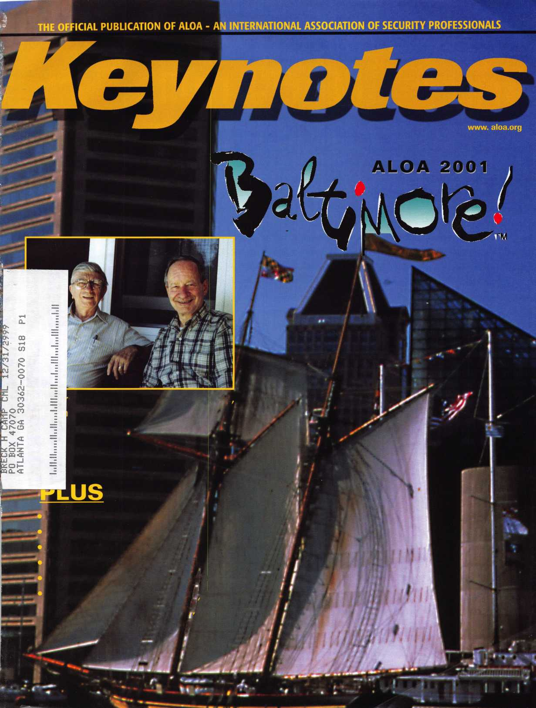

■■■■I

the^GS84°aateSO^c

.'SsSss^S’*

.e*^* $895^ 4*

Jump ahead of the competition at

warp speed and see your profits soar.

**Hickok’s New Generation STAR transports you with the factory tool for programming keys to  
Ford-Lincoln-Mercury and Mazda vehicles with passive anti theft systems (PATS).**

**^ Program vehicle keys through Model Year 2001 with Hickok’s NGS Model 800-8LA-$1995 ^ Update your existing software-the 2001 Complete New Model Ford Software Update Model 80LA-$895**

**800/342-5080**

**HICKOK**

INCORPORATED

**uHuui.hickok-inc.com**

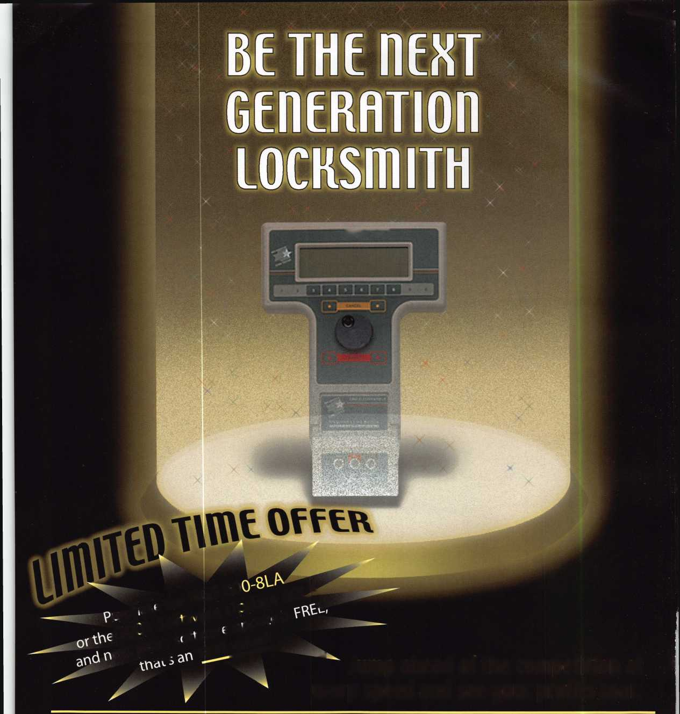

‘Your Key to Knowledge'

Volume 1, Number 1

New Disk Arrives!

Absorbs catalogues,  
application  
guides, manuals,  
and spec sheets!

Locksmiths celebrate!

A new CD-ROM from STRATTEC Security Corporation called PartSearch 2001 has arrived on Planet Earth, and lock­smiths everywhere are feeling jubilant. That’s because PartSearch 2001 puts a whole new world of information at their fingertips in just a small fraction of the space it used to take. This disk includes complete product information going back to the 1972 model year, ready for installation on any PC with a minimum of 16 meg of RAM. It’s a complete cross-referenced library in one compact package.

Knowledge is Power!

If knowledge is power, then PartSearch 2001 is destined to be one of the most powerful tools in any locksmith's arsenal. The information can be accessed in a number of ways: by model year, by vehicle make or manufacturer, or by part number. It even references non-STRATTEC part numbers for still more flexibility. And it contains graphics and application guides for thousands of parts, making installation and service a snap.

Time is Money!

The real power of PartSearch 2001 will make itself felt when locksmiths start using it. Instead of leafing through stacks of catalogs, searching for application guides, and checking parts lists; they’ll be finishing jobs quicker, getting more work done, and making more money. In a world where time is money, the value of this little disk is hard to estimate. But the price is easy to handle.



**Get Yours Today!!!**

ONLY $10!

Get your PartSearch 2001  
right away! Don’t delay! Simply  
call your STRATTEC distributor  
and tell them you’ve heard about

the new disk from STRATTEC

that’s going to make every lock-

smith’s life easier, simpler,

and more profitable. For  
just 10 bucks, this is one

CD you’ve just got to  
add to your collection.

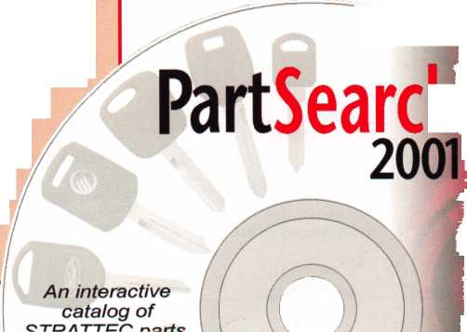

**July/ August 2001**

**Volume 49, Issue 5**

(0

Ul

DC

D

H

<

111

1L

Keynotes

14

**ALOA Anniversaries**

A look at some of our members celebrating membership milestones this year.

16

Cover Feature: A Thirst for the Game

Tom Schwarzkopf, CML, and Stan Piotrowski, CPL, are always pursu­ing new knowledge - never the limelight.

22

**Prince of the City**

Frank Markisello, CRL, of Aable Lock in Ozona Park, NY, has made his "mark" in the industry by staying involved and by cooking up sev­eral helpful locksmithing tools.

By Tom Lynch

26

**ALOA Convention Nostalgia**

What is it about the ALOA show that draws so many people from all over the world? Past players share memories of shows past.

By Claire Cohen, CML

30

**Federal Lock and Safe**

Checking into a big company lying just to the south of Baltimore. They've got big plans. Check them out.

32

**Access** Control:

**Understanding Access Control Jargon**

The only thing bad about walking around the show floor at ALOA is wondering if you can remember all of the new terminology that gets thrown at you. Here are some access control terms that will help you sift through the jargon you find at the show.

By Paul Chandler, CRL

36

**Desktop Dispatcher**

Dispatching software has always been either a pain in the neck or a pain in the wallet. Check out this new software and look for ALOA- related discounts!

By Sal Dulcamara, CML

40

Automotive:

**Passkey Ignition Locks**

In 1996, GM went to the Passkey system on many of its cars. Servic­ing on these models should be done step by step, and a professional job can be done the first time.

By Bob Arthur, RL

44

Traditional:

**Medeco Update**

When Medeco first introduced KeyMark in 1995, it was a consider­able departure from its previous tradition. For the first time, Medeco had put out a product that dealt strictly with key control and not high security. The rest is history.

By Sal Dulcamara, CML

*July/August 2001*

48

Safes:

**The Laurel and Hardy Show**

This beast was a Diebold Class 2 four-drawer file cabinet. All the things about the opening that went wrong were like a bad Vaudeville routine.

By Greg Perry, CML, CPS

52

Institutional:

**Experiences of an Institutional Locksmith**

Landing at Navarro College in Corsicana, TX, I wound up

By C.D. Lipscomb, CML, CPS

59

**ALOA Financial Report**

By John Greenan, CML, CPS

62

**In Their Own Words**

ALOA Scholarship recipients tell their stories

68

**ALOA Convention Exhibitor List (Updated)**

**DEPARTMENTS**

2

Contents

4

President's Journey

6

Upcoming Events

8

Core

12

Applicants

70

Legislative Update

72

Classifieds

74

Associate Member Listing

76

Back Page

VISIT OUR WEB SITE AT:

vwwv.aloa.org

Editor

Technical Editor

Editorial Advisor

Art Director

Advertising Sales

Contributors

Jim DeSimone [editor@aloa.org](mailto:editor@aloa.org)

David Lowell, CML, CMST [david@aloa.org](mailto:david@aloa.org)

John D. Cannon, CML [jdcannon@worldnet.att.net](mailto:jdcannon@worldnet.att.net)

Lindsay Magers [lindsay@aloa.org](mailto:lindsay@aloa.org)

Susan Haverkamp 121 Davis Street Nacogdoches, Texas 75961 Phone: (936)569-7172 VoiceMail: (208) 248-8893 e-mail: [adsales@aloa.org](mailto:adsales@aloa.org)

Jerome Andrews, CML Paul Chandler, CRL Claire Cohen, CML Brian Costley, CML, CMST Ray D'Adamo, CML Sal Dulcamaro, CML Billy Edwards, CML Dan Graffeo, CRL,CMST A.J. Hoffman, CML Jeff Nunberg, CML, CMST Mikey Oehlert, CPL, CPS Randy Simpson, CML Robert Stafford, CML Dave Thielen, CML Greg Perry, CML,CPS Tom Seroogy Charles Stephenson, CPS Dennis Watanabe, CML, CMST

|  |  |
| --- | --- |
| Executive Director | Charles W. Gibson, Jr., CAE [charlie@aloa.org](mailto:charlie@aloa.org) |
| Convention & Meetings Manager | Kelly Carr, CMP [kelly@aloa.org](mailto:kelly@aloa.org) |
| PRP/Education Manager | David Lowell, CML, CMST [david@aloa.org](mailto:david@aloa.org) |
| Operations/Membership Manager | Mary May [mary@aloa.org](mailto:mary@aloa.org) |
| Director of Information Technology | Randy McChristian [randy@aloa.org](mailto:randy@aloa.org) |
| Government Affairs Manager/ Chapters & Regional Associations Liaison | Tim McMullen [tim@aloa.org](mailto:tim@aloa.org) |
| Comptroller | Kathy J. Romo |
| Network Specialist | Greg Jackson |
| Membership Coordinator | Shelly Jett |
| Convention & Meetings Assistant | Karen Lyons, [Karen@aloa.org](mailto:Karen@aloa.org) |
| PRP/Education Coordinator | Ashley Manson |
| Accounting Coordinator | Kathy Stokes |
| Mail Room Coordinator | Humberto Cerda |
| Receptionist | Alin Valdez |

Additional contact information for the ALOA Board and most Keynotes authors is available through “Locksmith Search”’ on the ALOA Web site- [www.aloa.org](http://www.aloa.org) or by contacting the ALOA office at 3003 Live Oak Street; Dallas, TX 75204; [800)532-2562;

FAX [214)827-1810; e-mail [aloa@aloa.org](mailto:aloa@aloa.org).



President

John J. Greenan, CML, CPS (773) 486-2030 [fsl.john@mindspring.com](mailto:fsl.john@mindspring.com)

Secretary

John D. Cannon, CML (703) 960-6413 [jdcannon@worldnet.att.net](mailto:jdcannon@worldnet.att.net) Directors, Northeast John C. Magee, III (856) 845-3434 Peter Sarailian, CRL (201) 947-6291 [psarailian@yahoo.com](mailto:psarailian@yahoo.com) William L. Young, CML (610) 647-5042 Directors, Southeast Thomas W. Tate (850) 476-4211 Donald E. Rule, CML

1. 324-2658 [rulecml@ebicom.net](mailto:rulecml@ebicom.net) Directors, North Central Mark E. Blum, CML, CPS (517) 482-5809 [mblum@arq.net](mailto:mblum@arq.net)

Tom Ripp, CRL (608) 262-3831 Director, South Central Randy L. Simpson, CML (713) 780-7026 Directors, Southwest Gordon R. Racine, CML (719) 384-4707 [aloaswdir@excite.com](mailto:aloaswdir@excite.com) John A. Ilk CRL

1. 574-3277 [getreil@yahoo.com](mailto:getreil@yahoo.com) Director, Northwest Scott L. Henke, CRL, CPS (907) 248-3785 [action@alaska.net](mailto:action@alaska.net)

Director, Associate Members

David F. Matthies

(727) 541-5536

dmatthies@southemlockcom

Trustees

Dallas Brooks

(334) 826-8990

David M. Lowell, CML, CMST

(800) 532-2562

Breck H. Camp, CML

(770) 455-6244

Edwin Toepfer, RL

(416) 225-5589

Mission Statement: The Associated Locksmiths of America, Inc. is dedicated to enhancing the professionalism, education and ethics among locksmiths and those in related sectors of the physical security industry. With approximately 10,000 members in the United States, Canada and the freeworld, ALOA is poised to help members obtain the knowledge, the strength, and the confidence to perform their role in the physical security field with pride and dignity. But it is only through active involvement and participation that ALOA can fully achieve its potential-and can help members to achieve theirs.

Policies: Keynoted6 is the official publication of the Associated Locksmiths of America, Inc. (ALOA). Keynoted acts as a moderator without approving, disapproving, or guaranteeing the validity or accuracy of any data, claim, or opinion appearing under a byline or obtained or quoted from an acknowledged source. The opinions expressed by the authors do not necessarily reflect the official views of ALOA. Also, appearance of advertisements and new products or service information does not constitute an endorsement of products or services featured by the Association. The Association does not accept responsibility for the inaccuracy of any data, claim, or opinion appearing in this publication, due to typographical errors on the part of the authors, Association staff or its agents. Editor’s Note: This publication is designed to provide accurate and authoritative information in regard to the subject matter covered. It is provided and disseminated with the understanding that the publisher is not engaged in rendering legal or other professional services. If legal advice and other expert assistance is required, the services of a competent professional should be sought.

Authors’ Payment: Payment for eligible submissions to Keynotes will be based on the following criteria: topic, time spent and past contributions. Authors who regularly submit to Keynotes are generally paid a higher rate. The latter is especially true of authors who write to fit specific editorial needs and submit said copy by Keynotes deadlines. As a general guideline: Average payment for a 750 word, business or ‘light’ technical article would be $200. Payment for a 1500 word article involving significantly higher time and research efforts would be $400.

Payment will not be offered for articles submitted by ALOA employees or members of the. ALOA Board of Directors (unless material is of a technical nature), nor for articles submitted by a company that promote that company’s products or services. ALOA reserves the right not to pay for articles submitted by an individuals) that promote a particular company’s products or services.

Disclaimer: The Associated Locksmiths of America, Inc., (ALOA), reserves the right to refuse any article for any reason. Additionally, ALOA reserves the right to edit, amend or modify any article submitted for publication in order to preserve technical accuracy, clarity, fairness or grammatical correctness. ALOA will make the best efforts to notify the author of any changes. The extent of ALOA’s liability for any article or information contained therein will be a notice of correction or retraction in the next possible issue.

Keynoted (ISSN 0277 0792) is published monthly except for the combined June/July issue by The Associated Locksmiths of America, Inc., 3003 Live Oak St., Dallas, TX 75204-6186. Telephone: (214) 827-1701; FAX (214) 827-1810; e-mail [aloa@aloa.org](mailto:aloa@aloa.org). Subscription rates for members-$15.00 per year. Second class postage paid at Dallas, Texas. POSTMASTER: Send address changes to: Keynotes, 3003 Live Oak St., Dallas, TX 75204-6186. © Copyright 1999, All rights reserved. No part of the contents may be reproduced or reprinted in any form without prior written permission of the publisher.

Past Presidents

1997-1999 Dallas C. Brooks 1995-1997 David Lowell, CML, CMST 1993-1995 Breck Camp, CML 1991-1993 Henry Printz, CML 1989-1991 Evelyn Wersonick CML, CPS 1987-1989 Leonard Passarello, CPL 1985-1987 Joe Jackman, CML 1983-1985 Stanley Haney, CPL 1981-1983 Louis LaGreco, CPL 1979-1981 John Kerr, RL 1977-1979 Clifford Cox, CML 1974-1977 Charles Hetherington 1972-1974 Gene Laughridge 1970-1972 William Dutcher, RL 1968-1970 Constant Maffey, RL 1966-1968 Harold Edelstein, RL 1964-1966 William Meacham 1962-1964 Robert Rackliffe, CPL 1960-1962 Edwin Toepfer, RL 1956-1960 Ernest Johannesen

***July/August 2001***

***Keynotes***

Find Your Role in Our Profession

Goodbyes are never easy, and I'm sure my writing skills won't make this one any easier,  
but here goes:

This is my final column as your President; my able successor, Randy Simpson, CML, will  
be providing continuing leadership for ALOA, and I'm confident that the transition will

next two years in this profession will be just as critical to us as the past two have been.

There has been so much activity in our industry in the past two years, as new laws and  
management schemes change the shape of our working world on a regular basis. It's  
become commonplace to expect some sort of enormous merger or earth-shattering regu-

in and day out are increasingly challenged to develop good relationships both with their customers and with those who help them supply their customers. Meanwhile, the defi­nition, even the very nature of security and its importance in our society, is changing right before our eyes.

There's an overwhelming sense of camaraderie in this industry, and that's more than our saving grace - it's our competitive edge in today's ultra-competitive workplace. Through the unparalleled sharing of our knowledge and resources with one another, we have posi­tioned ourselves as competitors and contributors to the evolving market of today and

My hope for you is that you remain involved in your profession, and perhaps get more involved if you can; it will pay off for you exponentially in the long run. And more than

It is my firm belief that when you win for yourself, you win for the entire measure of our

be a smooth one. I wish Randy the best, and I ask you to give him your support, as the

lation, shaking us up from above and below. The people who practice this profession day

tomorrow.

that, I urge you to serve your profession by succeeding in your personal business goals.

proud profession. ALOA members have always fought the good fight - and it's been my great honor to be a part of that spirit.

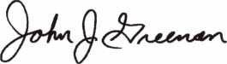

***Visit our Website on****[www.stamcctv.com](http://www.stamcctv.com)*

THE COMPLETE

CCTV PROGRAM ON CD-ROM  
FOR STAFF TRAINING AND

PRODUCTIVITY ENHANCEMENT

STAM Insight has been

developed to enhance CCTV

skills and productivity with

many different uses.

Productivity

**W** System Drawing  
€1 Estimation  
• CCTV Training  
**W** CCTV Reference  
It Sales/Demo  
H System Design  
I# Staff Evaluation

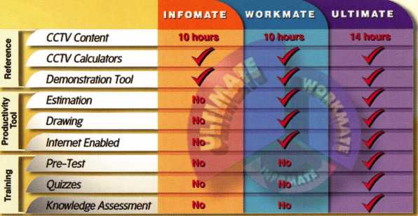

Sold in Over 50 Countries

Distributed by:



3003 Live Oak Street  
Dallas,Texas 75204

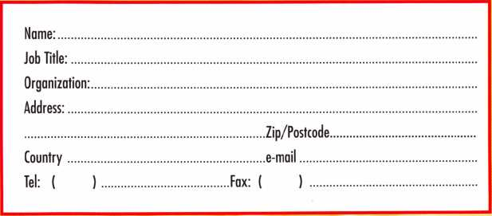

COPYRIGHT © 1996 Security Training and Marketing Pty Ltd.  
All rights reserved ACN 057 006 541

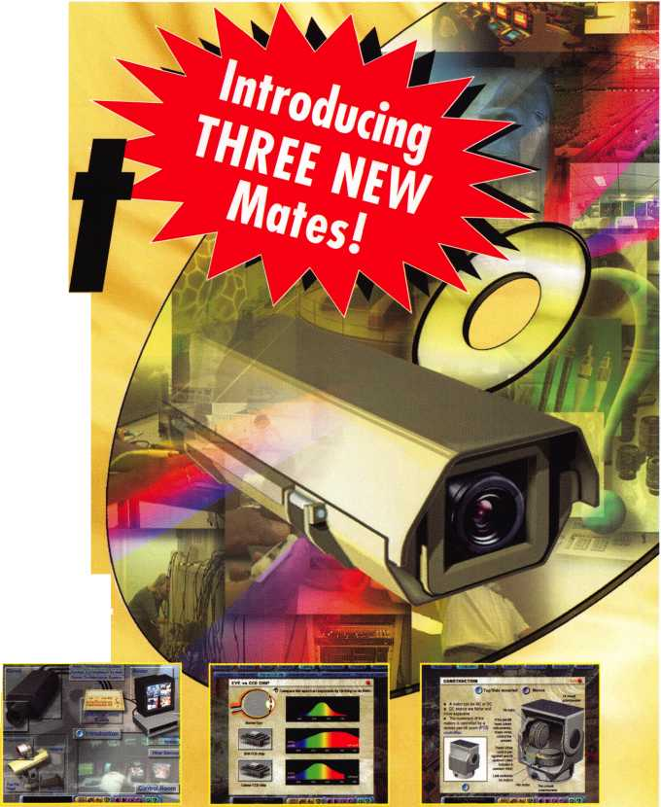

**JULY**

13

f/ ALOA PRP Sitting Dallas, TX

Contact: Ashley Manson (214) 827-1701 (214) 827-1810 fax

15-22

iX\ ALOA 2001 Security Expo Baltimore, MD (800)532-2562

**AUGUST**

10

^ ALOA PRP Sitting Dallas, TX

Contact: Ashley Manson (214) 827-1701 (214) 827-1810 fax

**SEPTEMBER**

7-9

The Association of Ontario Locksmiths (TAOL) 28th Anniversary Convention Sheraton Parkway Toronto North Call toll free: 888-272-8265

6-9

^ Greater Philadelphia Locksmith Association Convention & Trade Show Philadelphia, PA 8 ACE CLASSES

Contact: Nelson Dayton Reservation Chairman (610) 688-9188 FAX (610) 975-0172

14

f/ ALOA PRP Sitting Dallas, TX

Contact: Ashley Manson 800/532-ALOA (2562) (214) 827-1810 fax

15

Ozark Professional Locksmith Association Annual Distributor's Show Inn of the Ozarks Eureka Springs, AR Call: 501/524-3660

27-28

MINK Convention 4 ACE CLASSES Omaha, NE

Contact: Elmer Howard (402)330-8701

**OCTOBER**

3-7

SERLAC

Education, Trade Show and Banquet Jacksonville, FL Call: 800/845-5294

12-14

Jo-Van Distributors, Inc.

Annual Trade and Educational Show Call: 416/752-2238

12

rf ALOA PRP Sitting Dallas, TX

Contact: Ashley Manson (214) 827-1701 (214) 827-1810 fax

15-21

Tri Regional Locksmith Conference 13 ACE CLASSES Portland, OR

Pacific Locksmith Association Contact: Stan Hauer (503)325-7334 Email [hauer@pacifier.com](mailto:hauer@pacifier.com) Contact: Ken Mead (503)873-6932

10-20

^ Northern Praire Chapter of ALOA Fargo, ND

Contact: Todd Ludwig, CML 701-232-9440

**NOVEMBER**

9

f/ ALOA PRP Sitting Dallas, TX

Contact: Ashley Manson 800/532-ALOA (2562)

17

ALOA PRP Sitting Grand Canyon Chapter of ALOA Contact: John Ilk, CML 602/574-5277

7-11

ff~ Yankee Security Convention

12 ACE CLASSES

Sturbridge, MA

Contact: Stephen McKinney

617-789-3274

**DECEMBER**

14

ALOA PRP Sitting Dallas, TX

Contact: Ashley Manson 800/532-ALOA (2562)

Indicates ALOA ACE Class Indicates PRP Sitting



Keynotes

July/August 2001

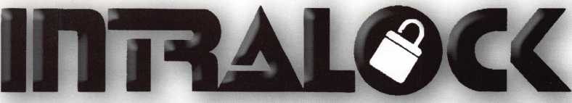

TOOLS LIMITED

**wuiui. intralocktools.com**

new

affordable

price!

Super strong rare earth magnets

ial gripper with reversible shaped

aws to grip most dials

Easy to assemble mounting jig  
Self contained - no computer required

Phone: (888) 264-6627 A I 2639-B Progressive Way

(604)852-8904 || | | Abbotsford, B.C.

USA: (562) 699-0060 **TOOLS LIMITED** U2T6H8

**Serving industry with superior products since 1985.**

July/August 2001

7

Keynoh

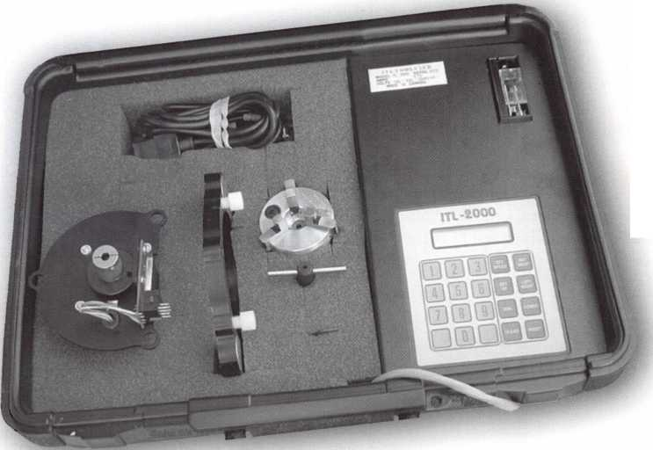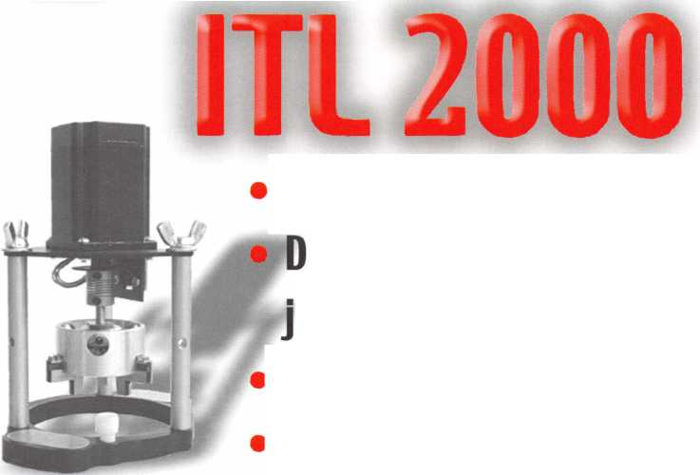

**CORE**

ALOA Members Elect New Officers

A new ALOA president will be sworn in at this year's convention following our June election. Randy Simpson, CML, succeeds John Greenan as ALOA's 22nd president. Randy owns Baker's Safe and Lock in Houston, and has been on the ALOA Board of Directors for many years. He brings a wealth of expe­rience and is a large shop owner in a major city who wants to focus on emerg­ing technology.

Other results of the election included the election of three new directors. There were open seats in the Southeast, Southwest and North Central regions this year. The complete list of the new ALOA Board (to be sworn in at the Annual Meeting in Baltimore) is as follows:

PRESIDENT Randy Simpson, CML

DIRECTOR, SOUTHEAST (TWO POSITIONS)

Don Rule, CML Vincent Formon, CML, CPS

DIRECTOR, SOUTHWEST (TWO POSITIONS) Gordon Racine, CML Julie McCluney, CRL

DIRECTOR. NORTH CENTRAL (TWO POSITIONS) Mark Blum, CML, CPS John Soderland, CML, CMST

PRP CERTIFICATIONS

The following locksmiths recently earned their ALOA Proficiency Registration Program certifications by passing their respective exams:

CRL

Joseph Farris Dan Flahiff Kevin Hudak Jason Koler Scott Lininger Thomas Thorpe James Trew Michael Wells

Eastpointe, MI Toledo, OH West Chester, PA Toledo, OH Woodburn, IN Warren, IN Toledo, OH Cincinnati, OH

CPS

Phil Crawford Montgomery, AL Michael Yarberry Sellersburg, IN

8

*July/August 2001*

**Letter To The Editor**

Last Friday I received the three issues of Keynotes that you sent me. Thank you. I have several older issues (1992 - 96) and can see the great improvement. The new issues look great! I like especially like the new format with separate departments for the different aspects of locksmithing. I'm going to make copies of the articles on institutional lock- smithing and keep them in a note book for easy reference. I'm also going to use them to educate some of the decision makers here and get the universitiy's job description upgrad­ed.

Thanks R. Wanser

New Mexico Locksmith Association Convention. 2001

I made my way to Ruidoso, seeing many wonderful places that I had never seen in the process. The scenery was so interesting that at one point about 10 miles from the end of the journey, I got so wrapped up in looking at the beautiful country, that I forgot my gas gauge and nearly had to walk the rest of the way. One of the friendly and neigh­borly people that lived there saved the day for me, and I made the rest of the trip just fine.

The Basic Locksmithing, Picking, and Impressioning classes that I taught over the next two days went off very well. The students were great, and seemed to draw more knowledge out of me than I knew I had. Regardless of how well I did as an instructor, I don't think any­one in class had more fun being there than I did teaching.

On Friday night, the entertainment was for the group to go to the "Flying J Ranch," a family orientated dinner playhouse. We were treat­ed to a western motif complete with a western town streets, horse rides, pistol shooting, a western town street that came with it's own "gunfight". The "gunfight" was quite comic and harmless, and even the "bad guys" went away laughing. Later, we were treated to a wonderful western "Chuck Wagon" barbeque meal and show. The performers were a group that were well rehearsed, and gave a top-notch entertain­ment experience. Even the members of the audience (not our group) who were heard to say, " I don't know if I am going to like this west­ern stuff' were smiling, laughing, clapping, hooting and cheering along with the rest of us before the night was over.

Saturday night was the trade show, with free food, and drinks for all. The show was enthusiastically attended and most there won at least one door prize. Sunday morning, I attended the NMLA membership breakfast and business meeting. The New Mexico Associations are characterized by the gracious, friendly, and harmonious way that they conduct their affairs. This meeting was no exception. The conduct of business, and the election of officers went so smoothly that great cred­it is to be given to its officers and members. Don Brazil, CML, was elected to be the new incoming President of NMLA. He replaces Steve Smith, who has done an excellent job leading this group for the last two years, and who presided over this excellent convention and meet­ing.

I, and my fellow instructors, David Thielen, and Red Howell were treated so well and so graciously that we all would be happy to be able to come back again.

*Keynotes*

GREATER PHILADELPHIA LOCKSMITH ASSOCIATION  
52nd ANNUAL CONVENTION & TRADE SHOW

September **6-9,** 2001

• 8 ACE CLASSES

CONTACT NELSON DAYTON RESERVATION CHAIRMAN

PHONE #: (610) - 688 - 9188  
FAX #: (610) - 975 - 0172

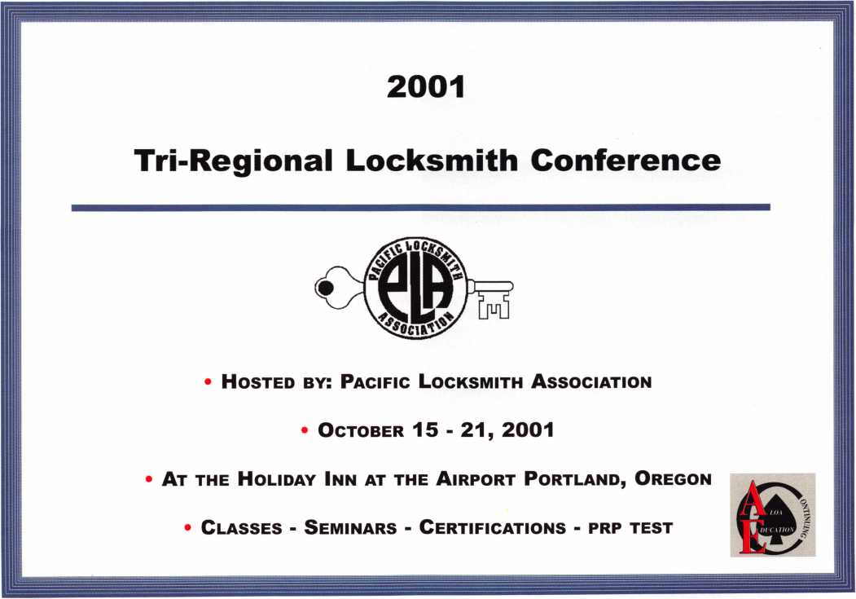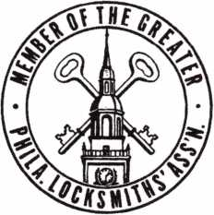

*July/August 2001*

*Keynotes*

To **Locksmiths, Security Professionals and Friends:**Kenneth J. Stemig  
ALOA #2758

F

or over 30 years, Kenneth J. Stemig ("KJ") was the key to quality and service at the  
E. L. Reinhardt Company and the locksmith industry. KJ turned a small whole-  
sale locksmith supply business into a well-respected and appreciated regional busi-

ness while keeping the "corner store" feel. He worked every day that he could because he  
loved the people he worked with, which included his family.

When you think about it, the reason KJ was such a great person was because he never let  
go of his family values. He treated everyone he knew as if they were a part of his family. It  
didn't matter if you were a new, young locksmith or a well-established business.  
Throughout his years, he helped support many locksmith organizations and had over 30

years membership with ALOA, Associated Locksmiths of America. KJ always said "They (locksmith organizations) are the backbone of  
our business and also the industry." KJ loved to play golf and watch football with his family. KJ couldn't get enough joy when it came  
to the holidays. He loved Christmas and the 4th of July. KJ will be greatly missed by everyone that knew him, especially his family.  
He was a wonderful man and a loving husband and father. We will miss him.

Born September 23rd 1935 - Passed away May 31st 2001

Meet the ALOA Staff

U

p in our Dallas headquarters the debate rages as to how  
many members actually care who works for ALOA.

Answers from members range all over the board. Either way,  
we usually put some information about the ALOA staff into the  
convention issue, in varying degrees of intensity (depending on  
the year). This year, we decided we'd give the members a break  
and just do a group shot and be done with it. So here we are in  
front of our lovely Dallas home away from home, smiling like  
we're in front of a camera or something.

Front row (left to right): Alin Valdez, Kathy Romo (Controller),  
Mary May (Membership Manager), Karen Lyons (Convention Assistant),

Tim McMullen (Government Affairs Manager), Lindsay Magers (Art Director), Kelly Carr (Convention Manager), Shelly Jett , CMP  
(Membership Coordinator). Back row (left to right): Greg Jackson (Network Specialist), Kathy Green (Accounting Coordinator), Jim  
DeSimone (Publications Manager), Ashley Manson (PRP Coordinator), Ret. Col. Bill Gibson, CAE (Executive Director), David Lowell, CML,  
CMST (PRP/Education Manager) and Humberto Cerda (Mailroom Coordinator). (Note: Our Director of Information Technology, Randy  
McChristian, is actually in this picture somewhere. Can you send in your best guess to the ALOA office for a nice prize?)

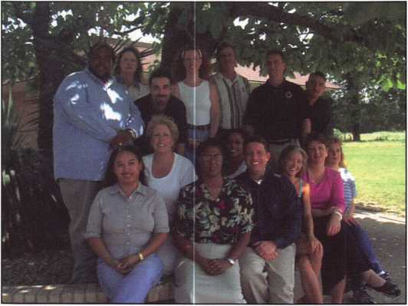

*Keynotes*

*July/August 2001*

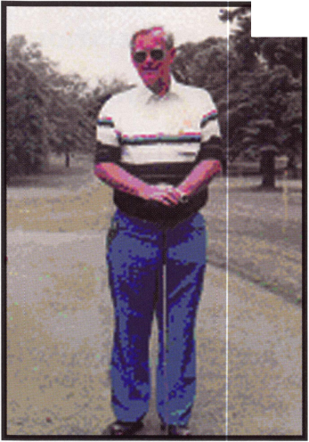

003 PINS

The Worlds Most Advanced  
Universal Pinning System

Qual View® Pin Tray printed Under Clear

... A Word About Quality

LAB Demands and purchases only the best raw  
materials. Brass material is 360 alloy, full hard  
temper. All LAB Pins are inspected with the  
latest inspection equipment and quality **systems**,  
documented by our Quality Control Team.

The LAB Royal Crown Pin ™ Design  
is a Registered Trademark of  
LAB Security Systems

lass Pins!

**|& Accurate Pinning**

ts About 4.

crown 0^0,

9 Most accurate universal pin made

Accurate within .001 of all major lock  
manufacturers specifications

*Developed by LAB, top on every  
.003® Pin features the iRoyal Crown Design"  
with radius edges bietided into a flat  
center to embre the smoothest operating  
cylinders. Master pins will not tip or roll*

LAB PRO-STAFF CHOICE AWARD.

An overwhelming majority of security  
professionals when using universal pins  
prefer The LAB . 003 System

9

Choose from 9 MS Universal. 003 kits

9

9

9

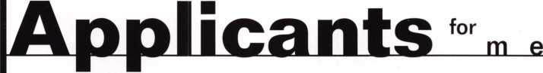

m b e r s h i p

AE

AZ

CA

FL

GA

HI

IA

IL

MA

MD

APO

Robert L Mitchell  
Glendale  
Guy C Grosser  
SPONSOR: William Lee  
Phoenix

Michael J Hartman  
SPONSOR: William Lee  
Scottsdale MO

Charles E Diffie  
SPONSOR : William Lee

Burbank

Khachig E Manoogian  
SPONSOR: James Kleman  
Oakland

Tracie Mennenga  
SPONSOR: Charles  
Cunningham  
Sacramento  
David J Beaudoin Sr

Chiefland Tames Benvenutti

SPONSOR: Charles Jones Nl

Gainesville

James Damien

SPONSOR: Leonard Solt

Miami

Carlos O Santacruz

NM

Warner Robins Ronald G Boulanger SPONSOR : Marion Edwards

Pearl City

Karl K Kagimoto

SPONSOR: Earl Tokuda

Davenport Robin Peppers

Chicago Jaime Mendez

SPONSOR: Otilio Arzola qj-|

Kelvin Wing

SPONSOR: Otilio Arzola

Rafael Venegas

SPONSOR: Otilio Arzola

Fall River

Michael O'Shaughnessey OK

Baltimore William E Brant

SPONSOR: Tom Demont PA

K M Goins

MT

NC

NH

College Park



Carroll T Allen, III

*Keynotes* *July/August 2001*

Fort Meade Robert M Booher Gaithersburg Eric F Arenz

SPONSOR: Greg Jacobson Glen Burnie Joseph M Mooney SPONSOR: Philip Rovenolt

Wentzville Joseph E Walsh SPONSOR: John Greenan

Bozeman Lester E Dennis SPONSOR: J Casey Camper

Havelock Jamie M Fuller SPONSOR: Ralph Fuller

Enfield

Claire F Walton SPONSOR: Henry Ilsley

East Orange Edwin E Rosario Long Branch Christopher Tanzi Matthew Marhen

Las Vegas

Ronald Barron CRL SPONSOR: Rick Milliorn

Bronx

David Allen Jr Conesus Glenn E Miller Cortland Gordon E Ivory Eastchester Matthew Parrillo SPONSOR: Paul Miller South Ozone Park James Schubert

Akron Jim Davis Cincinnati Kenneth J Puthoff Lancaster Hillard Kloda

Claremore James R Ripley SPONSOR: Dennis Spyres

Hanover

Jimmy L Schumacher SPONSOR: Robert Channell

Carvelle Warner York

Matthew T Keesey Daniel Kemelman Chad M Moser

SC

Greenville David E Feece SPONSOR: Mark Lumadue

TN

Maryville Linda J Hall

SPONSOR: Marian Swann

Memphis

Jean P Cook

TX

Corpus Christi Weston D Wade El Paso Jose Morales

VA

Crozet

Kenneth E Varner Sr SPONSOR: Linwood Crawford Mitchells Cathy L Day

SPONSOR: William Johnson Norfolk

Dwayne A Thierjung Roanoke

Charles D Stracke

Wl

Beaver Dam Jeremy D Frank SPONSOR: Jerome Frank Milwaukee Ward Koenig William R Eckert SPONSOR: Joy Skowron

Ontario

Marvin R Gruger

AL

Calgary

Douglas J Scratch SPONSOR: Craig Smith

ON

Gloucester Terry G Duncan

Kowloon

Kok Hon-Choy SPONSOR: Edmond C K Chow

North Point Wing Yee L Cheung SPONSOR: Edmond C K Chow

Phase III, Shatin Cheung Siu-Kong SPONSOR: Edmond C K

Chow

Tsuenwan

Chan K Ho Chuen

SPONSOR: Leung Kwok Kei

Man Ka-Fai Wanchai Lau J Ka-Po

SPONSOR: Edmond C K Chow Waterford TonyJ Fitzpatrick Egota Nakano-Ku Tokyo Yu taka Kobayashi SPONSOR: Toshihiro Asano Kumagaya-city Saitama Masashi Adachi SPONSOR: Toshihiro Asano Nagoya-City Aichi-ken Hirotake Kitou SPONSOR: Takashi Kuwana Nerima-Ku Tokyo Kazuo Suzuki

SPONSOR: Toshihiro Asano Omiya-City Saitama-ken Masayuki Ishii SPONSOR:Toshihiro Asano

Kyoung-Ju City Kyoung SoonJ Kwon

1

Member Name

Number of Sponships

Kwok-kei Leung

Toshihiro Asa no

Henry W Raymond

Yuriko Yanai

Stewart J Levine CML

Mary S Ohmit CPL

Charles C Robertson CML

Jack Hobin CPL

William B Neff CML

Salvatore J Dulcamaro CML

Myeong-Rae Cho

Dana L Barnum CML

Barry K Leas CRL

David M Lowell CML, CMST

Danny W Rudd CPL

Larry A Warnick CML

C Allan Halverson

Jeanne G Lodge CML

Breck H Camp CML

William Lee

Dallas C Brooks

Lawrence F Smith Jr, CML

Anthony J Ramunno CML, CPS

Marian M Swann CRL

James M Watt CML, CPS

Jeffrey S Nunberg CML, CMS

J Thomas Hood CML

Jim Williams CRL

Scott L Henke CRL, CPS

James H Glazier Sr, CML

Robert F Carroll CPL

Robert H Stafford CPL

John C Elliott Jr, CML

Jerome L Cohen CML

Peter K Gauthier CPL, CPS

Elvis D Hammerschmidt CPL

Robert D DeWeese CML

Man-Soo Seo

James J Cawby CML, CPS

Eugene R Altobella Sr

Michael B Groves

Philip A Rovenolt CPL

John L Shandy CML

John S Dorsey CML

D Michael Lee Sr, CPL

Robert W Duman Sr, CML

James E Fowler Sr, CML

David C Harris CML

William L Young CML

Peter R Hall

Thomas G Vandersteen CML, CPS

William P Grant CRL

Keizo Takahashi CRL

Walter W Lascar RL

Evelyn V Wersonick CML, CPS

Joseph P Ferrero CML

Gary F Teams CPL

Michael E Jordan Jr, CML

Brian J Reetz

Robert C Rodocker CRL

William J McElheney CML

Jon B Griswold CML

Michael D Robinson CRL

Russell P Fuller CRL

203

113

100

69

66

66

65

51

47

40

38

35

35

34

31

31

31

30

28

28

27

26

26

26

26

26

26

26

25

25

25

25

24

23

23

23

23

23

21

21

21

20

19

19

19

19

18

18

18

17

17

17

17

16

16

16

16

16

16

15

15

15

15

15

And The Best.

e

Brightest

How can I join the President's Club?

You can earn a membership in this prestigious club by recruiting just 10 new members for ALOA.

*Any ALOA member may participate.

What do I get?

When you recruit 10 members, you receive a handsome blue blazer with a President's Club crest. For each additional five members you recruit, you receive a lapel pin with gold-filled numbers, indicating, your recruit­ing successes.

You also get the satisifaction of knowing that you are helping your association, helping your industry grow, and you are helping fellow locksmiths achieve success.

How do I get started?

Contact the ALOA office for a supply of applications (8001 532-ALOA or FAX [214] 827-1810. One President's Club credit is awarded for each new applicant. Credit is awarded only after the membership application is approved. However, the credit will apply for the period in which the application is received. Failure to identify yourself as the sponsor on the application form at the time it is submitted to ALOA for processing will forfeit any credit.

*ALOA Board of Directors not eligible for membership in the President's Club

*July/August 2001*

*Keynotes*

Daniel L Landry Jr James L Hancock CRL James E Gruber CRL Joseph W Whitaker CPL James T Brickler CRL Joseph C Fuller CML, CMST Leonard J Passarello CPL Frank D Hartung CML Paul M Souber Donald H Shiles RL John A Ilk CRL Richard C Sievers Joe J Lee CRL Ernest W Wright Rolando Bouza John D Cannon CML John J Greenan CML, CPS Raymond C Lusk CML John F Engel CRL Eric F Veal

Thomas J Demont CML, AHC

Basil W Shannon CPL

Calvin G Harris CML

Herbert C Dusenberry CML, CPS

Timothy K Chow

Dale L Knowles CPL

Alvin N Minor

Gene Eldridge CPL

Ronald P Riggins CML

Lester S Brodsky

Larry L Votaw CML

Thomas R Smith CPL

William T Straub CML

Richard T Johnson CPL

Dale V Crosby CPL

James V Hawley CRL

Eugene R Altobella Jr

James Bright

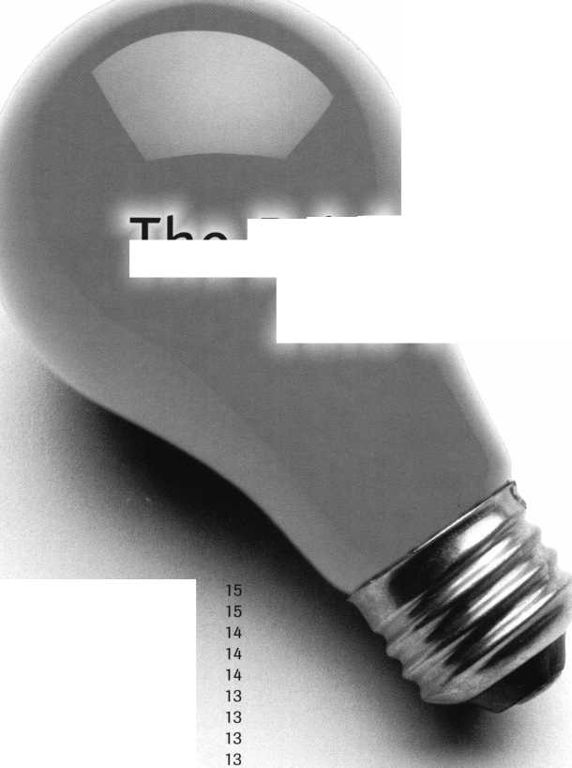

Anniversary

Membership Milestones

The following list represents those ALOA members who are celebrating  
membership anniversaries this year. Their years of service and participation  
set a great example for all in the profession to see.



|  |  |  |
| --- | --- | --- |
| 30 Years | Richard A Rosenberg RL | Jerry C Shaffer |
| Frank P Agius Rt | Danny W Rudd CPL | Robert E Son tag RL |
| Douglas t Anthony RL | Kenneth B Schueler | Charles W Thomas CML |
| Harry B Best RL | John P Segerdahl RL | Leonard E Whitford Sr |
| WE Blair | Daniel J Sibigtroth RL |  |
| William V Breazeale CML, CPS | Guy M Spinello RL | 45+ Years |
| George Brum ley RL | Ernest J Spory CRL | Ewell W Bradburn |
| John P Butkowski RL | James R Stephens | James L Britt RL |
| John J Carneval | James E Taylor | Herman B Brust Jr, RL |
| John C Costello RL | Thelma A Trouland | Edward J Delphia RL |
| Alva C Croghan | Davis O Turner RL | Edwin Dietzel |
| Robert E Dejonge RL | Robert W Wells CPL | John Dziuba RL |
| Downie W Dowless Jr; CML, CMST |  | Harold Gort |
| Larry R Dufrene RL | 35 Years | William C Kenton |
| Kenneth E Dunlap RL | Godfrey J Baumgartner RL | James F Love |
| James R Easter CML | Garvis E Crider | Philip A Macy |
| Richard C Gallusser | John DeCosta Jr, CML | Arthur E McGinnis |
| Leonard Geffner RL | Carl A Fowler RL | William D Mclnerney RL, AHC, CPP |
| Frank B Hicks RL | Patsy Gunkel RL | Roman G Moncur |
| Louis H James Jr | Stuart WJohnson | Carl W Moyer |
| Dana L Johnson CML | David E Leeper RL | Jay Nelson RL |
| Michael A Kirkpatrick CML | Stanley J Miskinis RL | Arthur R Paholke RL |
| Ronald G Krause RL | James Mozisek CML | Roger J Paradise RL |
| Francis J LeCuyer RL | Jim E Shelby RL | Ernest J Ricciuto |
| D J McCormick Jr | Charles E Skobrak Sr, RL | Don J Spenard Sr, RL |
| Stephen R Mead RL | John W Walter CPP | Carl A Stapel RL |
| Gordon S Morris RL | Marion J Walters CRL | Herbert Stein |
| Benjamin L Page |  | SJ Sussina RL |
| Leonard J Passarello CPL | 40 Years | James L Taylor RL |
| Burlie S Peeler Jr, RL | Raymond E Beggs CML | Edwin F Toepfer RL |
| William W Price | Robert W Freed RL | George E Walters |
| Henry H Printz CML | Warren G Heaton RL |
| James P Pritchett CPL | John McManus |  |
| Noel M Rappoport RL | William A Meacham |  |
| B Keith Rollins Jr, RL | Ramon F Merlin RL |  |

*Keynotes*

July/August 2001

Product

Showcase

MAG Security is well known as the inventor and manufacturer of the Install-A-Lock door security plates. Today we provide over 600 items of door and window security products including M.A.G. Install-A-Locks, latch Guards, Filler Plates, specialty Strikes and numerous auxiliary win­dow & patio door items.

M.A.G. Engineering

15261 Assembly Lane  
Hunting Beach, CA 92649

(P) 800-624-9942  
(F) 714-892-6845

**CCL** Security Products

CCL Security Products is proud to introduce the K440 Sesamee padlock. The K440 has a four- inch shackle, which gives you the largest clearance out of any Sesamee on the market today. Remember, when looking for the best quality in cam, desk, cabinet, or drawer locks look no further than CCL.

CCL Security Products

199 Whiting Street New Britain, CT 06051

860.339.6199 FAX 860.223.7601

[www.cclsecurity.com](http://www.cclsecurity.com)

Adesco Guest Safe Series 2

The Adesco Guest Safe is designed for hotels, college dorm rooms, or any application where temporary storage is a necessity. The GS-5E-LTB unit is equipped with an easy-to-use elec­tronic lock, while the GS-5EC operates with the swipe of a credit card.

GS Standard Features:

Solid steel construction  
Master override key Pre-drilled bolt  
holes for simple installation (bolt  
included) Hand-felted false bottom  
hides anchor holes, Multi-language  
guest instructions, Attractive two-tone  
epoxy-based paint finish.

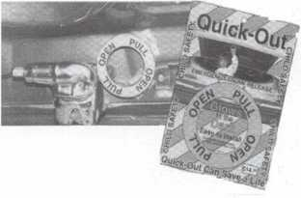

QUICK-OUT

Fits virtually all model autos. Easy to install. A child can release the trunk latch from inside the trunk to escape. Federal Law on new vehicles. A must for all others. This is probably the most important device in this catalog. Window posters and mounted locks avail­able.

QUICK-OUT

Aable Locksmith  
86-19 97th Avenue  
Ozone Park, NY 11417

718.847.1377  
FAX 718.847.0991

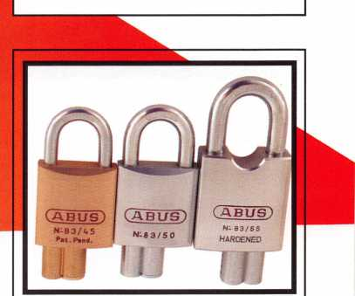

ABUS Lock Co.

ABUS is pleased to introduce it's new product specification and price book which features over 200 new products and accessories for the locksmith mar­ket. The ABUS motorcycle lock line is also featured which includes chains, locking cables, brake disk locks and cut resistant U-Locks.

Featured product:The Heavyweight Padlock series. Don't miss out on these heavy duty locks.

For more information on the ABUS  
Padlock Line please call:

1 -800-352-2287

|  |  |
| --- | --- |
| 1 | L_ |
| Julv/Auaust 2001 Keynotes |
| — | r |

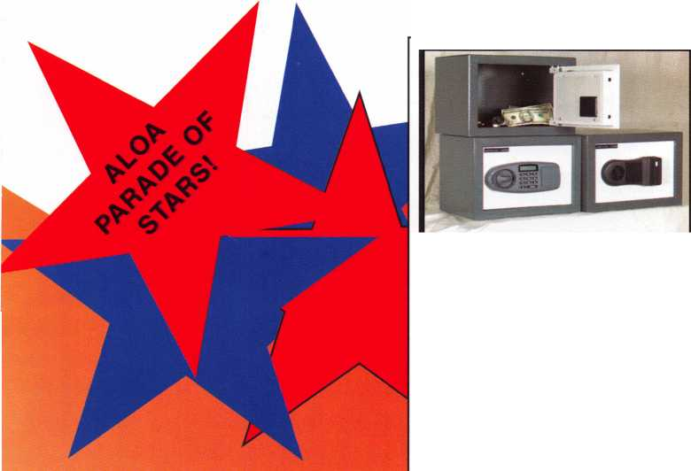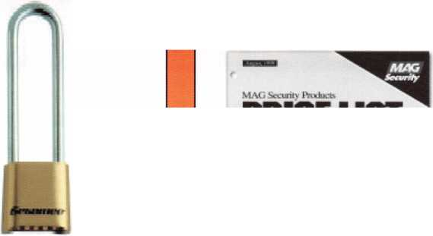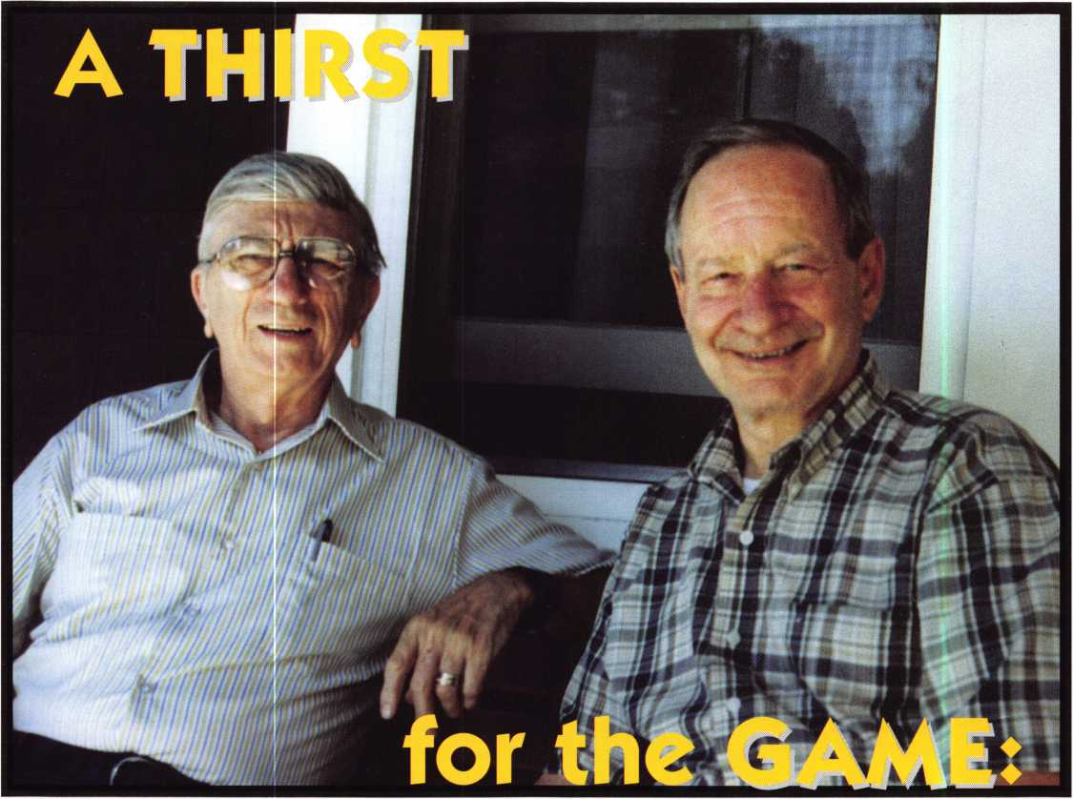

Tom Schwarzkopf, *CML,* and Stan Piotrkowski, CPL, are always pursuing new knowledge - never the limelight

A

good locksmith loves the chase.

It's the elusive lock that's the fox,  
4all locksmiths flying blind in

dogged pursuit. To do it right, you often have  
to do it all, which is the thrill of the game. The  
spirit of a true security pro leaps at the hon-  
est chance to do something new, uncover  
some new trick that brings light to a corner of  
the game that had been dark before. By that  
definition of the profession, Baltimore's Tom  
Scwarzkopf, CML, and Stan Piotrkowski, CPL,  
are two of the best in the game.

I *Keynotes*

W

e're in ageless Baltimore, a town  
brimming with history yet very

much a modern town with locksmith services  
as up to date as any city around. Baltimore  
cannot cloak its general easternness, but is  
perhaps understated compared to the Big  
Apples and the DCs surrounding her. There is  
the occasional antique lock headache to kick  
around at the local association meetings,  
along with just about every other question  
you might have. That's where we meet up  
with our Baltimore boys, Tom and Stan, and  
they couldn't be more helpful. Or busy. And  
for long-time volunteers like these two, it's not  
exactly an easy proposition to get a maga-  
zine interview. Locksmiths like to work, of

course, not talk. Their innate ambivalence to the limelight doesn't make it any easier. But soon enough, we track them down for an exclusive Q&A.

Tell us about your background and howl why you got into locksmithing.

Tom: Years ago, I started in the printing indus­try and when that industry closed up, I worked for Maryland Housing - the more I got into building houses, the more I got into doors and locks. In 1980, I did a mail-order locksmith course out of New York and that's how I got my start. Later I joined the Maryland Locksmith Association. Within six

16

*July/August 2001*

months of that, I joined LADC - and I've been members of both ever since. We had lots of classes and there were always people around to answer technical questions. It's been that way for 20 years. When [ALOA Treasurer] John Cannon, CML, was president of DC, I was secretary for four years. After that, I was treasurer of the Maryland associ­ation and I'm currently the secretary/treasur- er of the DC group. I'm a firm believer that if you're going to belong to an organization, you owe it to yourself to do more than just show up at the meetings - you have to do whatever you can to make sure the organi­zation flourishes. It always pays off for you, and I've always found the work interesting.

Stan: I began locksmithing at age 39, as a retirement plan. I worked as a computer operator at Western Electric in Baltimore back in the days when computers were as big as your living room. On the side, I was helping a friend who ran a lock and key shop in town. I took some classes and really took to it. I joined the local associations and I wound up getting a choice location for a lock shop; I had to outbid a barber, seam­stress and a few other retailers to get it. It was right on Route 1, Belair Rd - or "Blair" if you use the Baltimore accent. There's actual­ly a book on Baltimore lingo, and I think if you're going to go to Baltimore, you need to know the language. The rest is history.

Tell us about daily locksmithing in Baltimore. What are the unique lock­smithing challenges that can be found there?

Tom: My shop is in my home now, because 99 percent of what I do is done outside of a shop. We finished re-keying the Federal Social Security building downtown Baltimore. We put in a Medeco Keymark system and we had cylinders that had to be keyed there. We had to get special security clearance to service those locks. It was just unscrewing the cylinder and checking the cam on them. Some of them we had to drill extra holes for the lever handle. They were the base Arrow lock - the lever handles were the most time consuming. We went from the depths of that building up to the roof. The roof had locks that wouldn't let you onto the roof, but if you were outside on the roof, you could get in without the key! Other than that,

I do lots of real estate work, and for people who are moving into houses and I make keys every day for real estate offices that have people moving into homes. Yesterday I had a lady with an old wood locker that her great grandmother had. It's a drilled key, but it's going to need two flags on it. I had one a few years ago, John Phillip Sousa's orchestra and we got some music pieces and uniforms and stuff from him.

Stan: I had one old Italian lady who had been mugged and she was in this old house. Every door in the house had a double cylin­der deadlock on it - even the bathrooms. When I came to the house, she had a ring around her neck of keys and they were all color-coded. If you worked there, she would lock you in, and if you forgot a tool, she'd lock you out while you got the tool from the van, and then she locked you back in again.

There were iron rods over the windows and everything; it was a real fortress. I remember once she wanted me to bring her a loaf of bread and a bottle of milk on my way to change her locks again. I thought she was kidding, but I did it because I felt sorry for her; I knew she was afraid to leave the house ever since she'd been mugged. It was a crazy house. Inside, she had big church stat­ues of saints that must have been like eight- feet high. When she died, nobody in her family could figure out her locks. The lawyer gave me a ring of keys and took me three days to get that house whittled down to about five or six locks. Then they sold the house and it was the last I ever heard of it. I got mugged and shot once. The guy wanted my wallet and I reached back for it and he shot me right in the shoulder and ran off. I was closing the shop when it happened, and it was dark with nobody around. I managed to get in the car and get home. I got in the door and collapsed. My wife was a nurse and she helped me some and I was volun­teering with a food service for the fire and paramedic department at the time, and I knew some of the guys who helped me. I wound up with the bullet lodged in my lung and it was very painful. You lay there with these tubes in you and it hurts so bad; I was in intensive care for two weeks. I didn't think I was going to make it. The doctor was for­eign and he called this bullet a "missile" and he told me to leave it in there and it would grow over and be fine. Except he told me I might not make it through the metal detector at the airport. He was kidding, and I need­ed to laugh. I lost six months of work, but thank God I was starting to draw on my pen-

17

*July/August 2001*

*Keynotes*

sion from my first job.

Tell us about some similarities!differ­ences between lock shops in Baltimore, and perhaps how you work together to help each other out at times.

Tom: I think mine is the same as it always has been. I don't turn someone down if they have a problem. I'm not one of these guys who looks at other locksmiths as competitors. I've still got keys from old Studebakers and stuff. I'll always help out if I can. Life's too short to be fighting with people all the time. When I was starting out, there were people who were willing to show me what they knew and to help me learn, and I appreciated that. Now, I think there are some guys who shrug that off instead of being more tuned in to giv­ing your buddy a hand. Some guys special­ize in different areas and if one guy gets in a fix, the rest of the guys are there to support him. That's how it should be, I think.

Stan: Tom and I have known each other from when our daughters were in school together, and we always helped each other out. We had a big job in Western Maryland in Deep Creek Lake, which is ski country, and we stayed up there for a month. And they had ordered a complete system from Yale and one of the workmen stole a masterkey ... about 220 hotel rooms. So they needed a whole new system set up. And they needed 1500 keys with a dozen master keys. And we took everything in one van and stayed in a hotel up there for a month. This was a brand new van packed to the gills and it died about 25 miles from the town. And this was before cell phones and everything. So 1^1 KeynotesJuly/August 2001

we got a tow truck and we unloaded all our stuff at the motel, and we had to rent anoth­er vehicle while they fixed the van. We would come home on weekends. And we did it floor by floor.

Tell us about your volunteer efforts over the years. Everyone we've asked about you says that neither of you is power hungry, but that you have volunteered with local and national associations for years and always do what is asked of you. Explain your philosophy of getting involved in the industry.

Tom: If I'm ready to open my mouth, I'm going to go on and do what I said I would. The fact that I'm treasurer is not because I had my eyes on a prize or anything, it was that we needed somebody and I knew I could help, so I figured "let's go." I feel like I'm able to give something back. You feel good when you volunteer and I'm always hearing about learning from being involved and I consider myself an example of that.

Stan: I belong to the Maryland, the LADC and the Virginia associations. We were gone every weekend for something. It was always another meeting or another class or something. We did our best to try and get Virginia and Maryland together on educa­tion as much as we could. I didn't mind vol­unteering, but I just didn't feel like a great leader. I always thought if we had good leaders, Tom and I would work behind them fine. I was treasurer of the Maryland group for about 8 years. When John Cannon took over, they really were dynamic about getting

things done. They really turned it around, and I didn't mind giving my time if I was see­ing progress like that. By volunteering so much, we didn't get to attend as many class­es as we should have. By the time you finish putting the show on, you miss the class.

Tell us how you think the industry will evolve over the next 5 or 10 years.

Tom: There will be more and more electrical involvement. Some of it I think is good, and some of it I wonder about the usefulness. I think there will always be a very strong niche for the mechanical locks. You probably have to know enough to know that you need to keep learning. To be competitive, you have to keep up with classes and be able to excel at the cutting edge stuff. I'm going to a class tomorrow. Sometimes you wonder if it's worth it, but it almost always pays off for you. It's free to local members - as long as you're a locksmith. We helped with the Virginia group when they were working on their licensing law. A bunch of us from Maryland would drive down there for about two years.

I think getting a law put together is a question of whether you want to do it or not. The things that we wanted were nixed by the politicians because they didn't want to restrict any of the work to just locksmiths. So many of these laws were not written to support lock­smiths. If you open up that can of worms, wound up getting hurt with the regulations instead of helped. The police don't even like a lot of these laws because they hate enforc­ing them.

**Expect Quality...Demand HPC!**

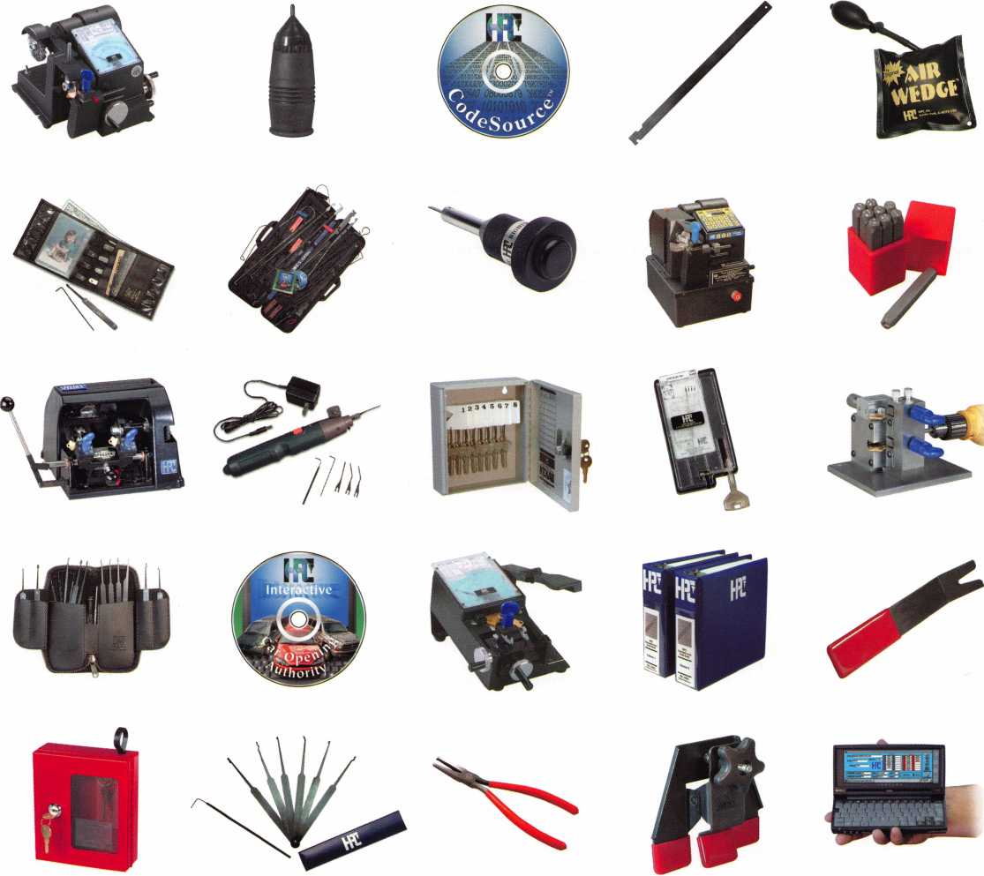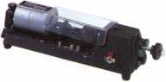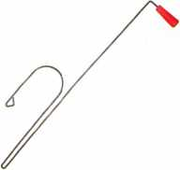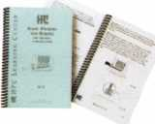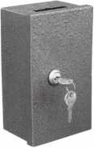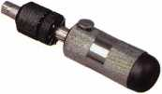

Pictured from left to right starting at the top:

1200CMB, HGG,CS-CD,C0-11, AW-99, BFW-8, AKK-99, FIT-2, 1200MAXAA, HCF-1/8, 9180MC, EPG-1, KEKAB-8, HKD-75, DM-500, NDPK, COA-CD, 1200PCH, HAC, AST-4, 511, EMER-6, ALCP-10, PW-100, CS-CEHPC, 747XU, LC-1, TLP-7SB, 00-80, KEP-M2, & 9120RM.

Learn all about these products and many more at www. hpcworld. com

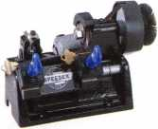

*July/August 2001*

*Keynotes*

I 19

Stan: You know, you have to work smarter as you get older, and I don't get into things that I'm not sure about. I'm too old to hang doors now, and cars are so sophisticated, that you might knock out a side airbag trying to open a car. I think the mechanical side will always be here because there are just so many locks out there. You have to be knowledgeable about electronics right now because they are playing such a major, major role in the indus­try now. Tom and .1 just take all the classes we can. We're going to Fairfax, VA, this weekend to look at a high security class.

What's your favorite aspect of your job — and why?

Tom: I get involved with a lot of things, but my favorite is meeting different people and getting involved with whatever problem they have. It's not the same thing every day, and it keeps you interested. 90 percent of the time - if you do well with somebody - they'll be happy they have someone who knows their stuff. The vari­ety is what has kept me interested. I got into alarm lock classes and Mas Hamilton had a lot of interesting new aspects.

Stan: It's an ever-changing and there's always a need for additional education. The guys who think they know enough about something and miss the classes are the ones who are always in trouble. Every little piece can help you and make things easier for you. If you get into a class and the instructor is good and keeps the discussion moving forward. Learning new things is the best part of this pro­fession, and nobody knows everything. By communicating with other locksmiths and learning their experiences. Someone always

has a question and an answer, so it's always good to get together. I think I've missed about two GPLA shows since 1976. It's an amazing show. At one time, LADC had the most CMLs in the country. The reason was that they all got together and formed study groups. And they got together and knew so much about every aspect of locksmithing.

Name one thing in your van!shop that best describes you — and why.

Tom: I've been an amateur photographer for years and I've always liked cars. My dream car is a Rolls Royce and I think our system is backward. You should make all your money when you're young so you can experience something like a Rolls Royce your whole life. My first car was a 1931 Packard. I had to stop every 30 miles to put oil in it. But the guy who sold it to me 1937 Packard, and had fenders you measured in inches. I had that until I got married. It was a tank. I rebuilt the engine. It was very nice, plush. You could drop it into third and drive straight up a steep hill.

Stan: Sometimes my shop would look like the wreck of the Hesparus. It was the shop of a working man and I would clean whenever I had a minute. When I did a job, I never left the old parts there. I always wanted to leave a job better than how I found it. You try to be as neat as you can. It looked like a tornado went through a lot of times, but then you clean it up and start all over. That's what a working man does.

What has ALOA done for you, and what can it do in the future to help out all lock­smiths?

Tom: Well, the magazine is nice. We're get­ting more articles again and it's more techni­cal now. That helps a lot. ALOA has had a great influence on getting information on what's going on around the country, especial­ly in the legislative area. I just signed up for some classes at ALOA this year. I just think it's a good opportunity to have a melting pot for locksmiths to exchange information and to bring it out as it affects them on a national level as well as just the local level. Lots of things ALOA has been involved with and that ALOA can do. I feel like they would like to do more, but they still do a good job of letting people know the potential of what is going on.

Stan: Anybody that does not belong is kidding themselves. You can't operate without sharing this knowledge. I think if you don't volunteer to hold an office in your local association or for ALOA, you're foolish. It teaches you so much more about business. You have to balance everything out and make sure everything is heading forward. It helps you do more with your own business. If all you want to do is take, take take - you won't ever get anything back. When I closed my shop after 30 years, it was like a bloodbath. It was nice to know so many local locksmiths who might be inter­ested in some of the things I needed to get rid of. I still go to the meetings and I still put my two cents in, and I don't want a specific job.

*Keynotes*

*July/August 2001*

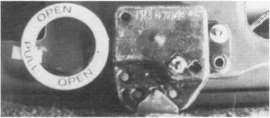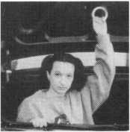

4*

**&** “Quick-Out” Emergency Trunk Release

Prevent Tragedy - Install a “Quick-Out” Device Today

Fits Virtually All Model Autos

Easy to Install

A Child Can Easily Release the Trunk Latch from  
Inside of the Trunk to Escape

Federal Law in new vehicles. A must for all others.

In packs of 10 FREE Window Poster

QUICK-OUT INSTALLED $11.00 G3. + $3 S&H EASY ESCAPE

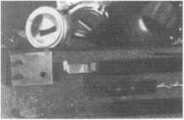

The Innovator

1998 and up GM in-dash ignition removal kit.

Patent 5,454,245

Removes plastic ring and chrome cap in seconds; makes access hole to pick side bar; turns cylinder to ACC position.  
Removes lock in less than five minutes with no damage to lock. Your first job will more than pay for the kit.

Introductory price: $70.00 + $4 S&H



1996 and up 8-Waffer Ford Ignition  
Removal Kit and Side Bar Breaker Tool

Patent 5,701,773

Turn ignition to “ON” position in less than 60 seconds for fast removal or use kit to

push side bar in, then turn cylinder to “ON” position without any damage. Fit key, replace same lock. Or use the force tool to  
turn to “ON” position for fast removal in 60 seconds; no damage to waffers. $90.00 + $4 S&H

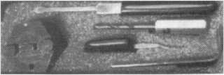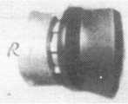

FINISHED CYLINDER

1994 and up 9-Waffer GM Ignition Removal

Patent 5,454,245

A new system for the future. These locks have side bars longer than the old type and must be in  
the “ON” position to remove the cylinder. My tool will do this. Best of all, you will not damage

the cylinder. You can repair, fit key and replace the same cylinder. Do only one job and you will have the price of the kit paid for. A  
replacement cylinder costs about $22.00, VATS $45 our cost. Order one today at my special introductory price, and be prepared for  
these new locks. $60.00 + $4 S&H. ***Upgrade it for ’95 Blazers, Suburbans, S-10 Pickups, etc. $20.00 + $4 S&H***

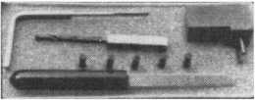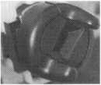

Tool Kit

FINISHED CYLINDER

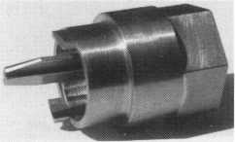

Ford “Quick On”

Patent 5,454,245

Now turn all 10 cut ignition cylinders to the “ON” position for fast removal - in less than 60 seconds. Sable, Taurus, all styles, even with airbags. No damage to housing.

$65.00 + $4 S&H

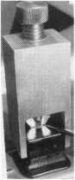

No-Nonsense Squeeze Lock  
Plug Remover

Patent 5,165,158

Now you can remove all squeeze lock plugs in 15 seconds  
or less, from all GM, Ford, Chrysler, AMC, Jeep, no more  
fumbling, gadgets, cut fingers, broken tabs, need for 3  
hands for removal of lock. It’s so easy you can do it in the  
dark, while it’s still in the glove box. $50.00 + 4 S&H

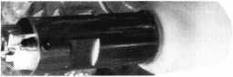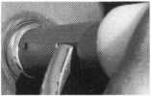

The GM Persuader

This unique tool will open virtually all GM trunks and doors, through the current year, where tool fits into the cylinder core cavity,  
in less than 50 seconds. No drilling, pulling, picking, special tools, or electric needed. When customer’s key does not open trunk

because: Problem 1: spring retainer popped up into outer shell; Problem 2: one side of side bar sprung off side bar  
does not retract; Problem 3: key or cylinder worn side bar does not retract; Problem 4: key jammed in lock in  
“turned” position, etc. With The Persuader you will open these locks in less than 50 seconds. No damage to lock, just  
repair and replace, nothing to wear out. Yes, if needed, it will open with no key.

Note: because of The Persuader’s capabilities, it will be sold to locksmiths only. $45.00 + $4 S&H

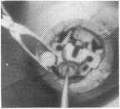

Ford Disc-Out Kit

Patent #4,682,398

A tool kit to remove those stubborn Ford pin ignition locks from 1976 through the current year. These locks incorporate 2 locking  
devices and a hard steel disc across the shear line. They must be in the “ON” position, to release both locking devices, so as not to  
damage the housing. I guarantee the job to take 5 minutes with my kit. Complete Kit$60.00 + $4 S&H

Aable Locksmiths • 86-19 97th Avenue • Ozone Park, NY 11417 • 718.847.1377 • Fax 718.847.0991 Frank Markisello guarantees all of his products to do as stated or your money back! .

L

*July/August 2001*

*Keynotes*



rince of the



Tom Lynch

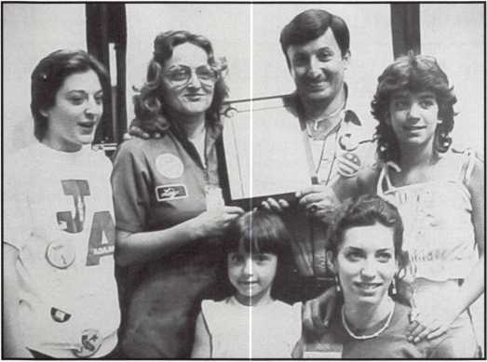

Photo #1

Honor, integrity and humor are often a hard achieve­ment for many in life. In a world that often seems upside-down, we rarely experience a human spirit that captures these qualities with humility. In the United States Marine Corps., the making of men from boys is more than a job, it's a tradition seeped with the American spirit and from its ranks have come many heroes. In July of 1999 at the ALOA convention in Cincinnati, I had the pleasure of spending time with one of our industry heroes. His name is Frank Markisello, of Aable Locksmith of Ozone Park, NY. Frank made the origina­

tor of many of the very first automotive ignition bypass tools. From the fence lines of the Cuban Missile crisis to the mean streets of New York, Frank has achieved his success utilizing a working man's ethics and morality. At the trade shows you can find him along with his devoted wife, Liz, and any one of his four daughters, sharing his ideas and tools with locksmiths. His youngest daughter, Maria, runs the Marketing and Exhibit division of the company and is always at the shows to contribute. Like kids in a candy store, the crowds swarm around him and you can hear them say aloud, "Hey there's Frank!, what ya got this time?"

In 1961 Frank dropped out of school and joined the United States Marine Corps. Like all good men, he sweat­ed out the grueling training that the infamous Camp Lejune could offer. He later was assigned to the 1st Infantry as a Radioman, and found himself on the front line in Guantanamo Cuba during the Missile Crisis. His duties were to walk the fence line and observe the move­ments of the Cuban defenses. As he would perform his duties, Frank would pass candy bars through the fence to the soldiers on the other side, and contemplate which opponent he may have to engage if an order came to

*Keynotes*

*July/August 2001*

attack.

open, using only the key machine given to them by the  
school. They worked seven days a week, earning only  
$10-20. While Frank ran out on calls, Liz tended to the  
walk-in customers and her children playing in the play-  
pens at the rear of the shop.

As the girls grew older, they found themselves partici-

pating with the daily chores of the  
shop and often under the watchful  
and protective eye of dad. In the  
predominant Italian neighbor-  
hood where Frank raised his chil-  
dren, the reality of the streets were  
not uncommon. The family grew

photo #2 along with the business and they

family was a struggle and the need for benefits was were becoming increasingly popular in the neighbor-

important, so he left the duties of the machine shop and hood. With all the girls being courted by the boys, and

had taken a job at the U.S. Post Office. There he was the necessities of the business; Frank was on his toes!

given a stack of books from his supervi-

Upon his honorable discharge, Frank began work in a  
machine shop, running press machines. Although he  
hated the job, he needed the money and knew he had  
responsibilities for his wife and children. To try to bet-  
ter himself he enrolled in the "Heath Kit" TV repair

course. The course required him to  
build a television from scratch utiliz-  
ing the instructions and parts in the  
kit. After completing the course,

Frank provided his family with their  
first 25" color console unit! At the  
time it was like having a Cadillac in  
your living room. Supporting his

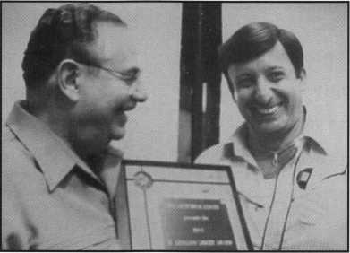

— l

**HINES**

sor and was told to "learn." At night  
Frank would wax floors for extra cash

with the machine he had purchased. |F^

Raising four girls kept both Frank and  
his wife Liz hustling.

A year later, Frank discovered lock- Photo #3smithing and enrolled in the NJ Locksmithing Institute  
in Little Falls, NJ. The instructor at the time was  
Leonard Singer. The course content posed no barriers for  
Frank and he quickly graduated with recognition. In the  
school newsletter, Leonard Singer wrote a story about  
him and alerted all his classmates that, we can expect  
more from this young man." After all this work and  
training, he and his family were prepared to purchase a  
building in New York. The intent was to use it for  
rentals to tenants, but they quickly found that the ten-  
ants could not, or would not maintain the rents. So,  
Frank and Liz decided to open a lock shop and take a  
chance at making money. Within two months they were

As with any growing venture and  
large family (see Photo #1), Frank  
found himself once again needing  
more money. So when the compe-  
tition down the block went out of  
business he decided to make his  
move and he bought the shop con-

tents for $700. His acquisition yielded him a coveted  
"Turrent" key machine. Soon, he had gained a reputation  
for for bit and barrel keys, and mortise lock parts. His  
business flourished and he made alot of money off that  
one machine. Enough money, that he was able to sub-  
scribe to the trade magazine "Locksmith Ledger." It was  
here that Frank began to submit "Ttricks & Tips" to help  
out other fellow locksmiths that had been so generous to  
help him by contributing their tips. His tips were so  
widely admired that it won him the Leonard Singer  
Award in 1983. (see Photo #2). His award was $1000  
and a new Framon Code machine and a ceremonial  
plaque, (see Photo #3). He later met Leonard Singer at

July/August 2001

Keynotes

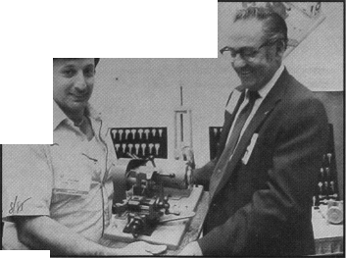

the ALOA con-  
vention to receive  
his award, and  
while attending  
the show, Frank  
found himself the  
proud winner of a  
van that was

being raffled off, (see Photo #4). This prize was the icing  
on the cake for both he and his family. Their meager  
beginnings out of the back of an old station wagon to a  
new, fully-equipped van filled them with excitement.

Franks biggest prize was the opportunity to meet  
Leonard Singer, who he now regards as his mentor and  
dear friend. In Franks words, "Leonard inspired me to  
make things for the guys in this trade, rather than  
telling them how to do things." And so it was. In 1984  
the GM Sidekick was born, creating a frenzy among the

locksmiths.

This tool was  
the result of  
Franks desire to  
find a better way  
to around the  
GM ignitions  
hardplate. So,

he gathered up a variety of common items like, a lead  
sinker, cardboard, grease and some key blanks. He went  
on to melt down the lead anchor and use it to form  
around a key blank. The cardboard was cut to the shape  
of the hardplate and was used as a drill template. He  
used the grease to prevent the lead from sticking to the  
cylinder plug as he made his casting, (see Photo #5). He  
then took this prototype to a machinist friend and the  
rest is history.

In his Side Kick Kit was the GM Side Bar Drill Out  
Block. It was designed to drill out the side bar on 1979  
and up vehicles. His new tool was made to make service  
on these sidebar locks easy for his daughters, who were  
now running calls for him. His daughter Rosie was the  
first to utilize it at age 16. Her success with the tool  
impressed not only Frank, but the customer who tipped  
her $10. The time needed for just about any job using  
the Side Kick is 3 to 5 minutes. This guide worked bet-  
ter than he had hoped and the demand for this tool was  
overwhelming. At the ALOA show where he had  
demonstrated its use, sales of 100 units went fast, which  
helped finance his future designs. Frank now has 12  
tools on the market for the benefit of the locksmith.  
The Disc Out tool simplifies ignition removal. You can  
cleanly remove the hard disc in the Ford ignitions in less  
than one minute. Included with the tool are special  
shims to shim-pick the ignition from the front, to rotate  
to the on position. The complete job should be less than  
five minutes.

Photo #6 is a homemade Styrofoam and cardboard tem-

plate of his  
Universal  
Interlocking  
Cylinder  
Protector. When  
I say "home-  
made," I mean it!

Even Frank

chuckles when he looks at it, but the end result is  
impressive. This interlocking cylinder protector is so  
universal that it will fit on virtually all rim and mortise  
cylinders. It is made of hardened tool steel and is 1/2"  
thick, 1 5/8" wide, 4" long. All you need to do is drill  
one 1/4" hole to secure it to the door! It is probably one

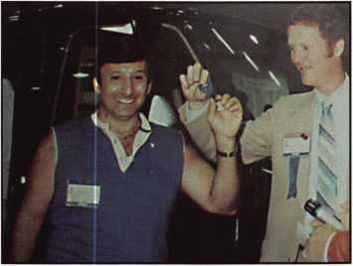

Photo #4

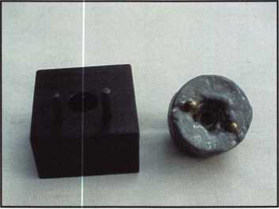

Photo #5

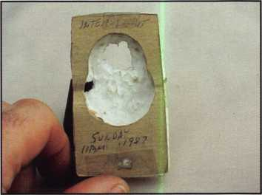

Photo #6

Keynotes

July/August 2001

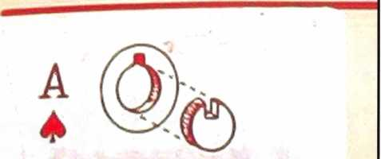

**> BREAKER')  
KIT**

PAT. PEND.

of the fastest units to install, with such a broad applica­tion. In Photo #7 is his world famous Ace Breaker Kit. This tool shook up the entire industry when it was found that it opened Ace, Ace II, American, Unican hard head and Parker, Gem, Fort, Guard, Greenwald, and other soft head tubular type locks.

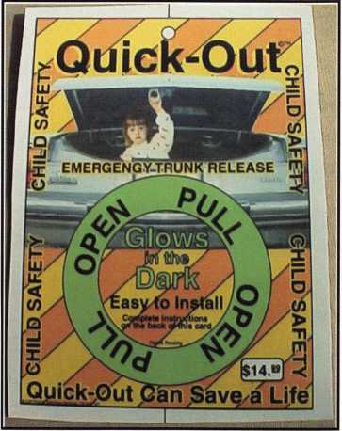

These are just a handful of the innovative tools that  
Frank has designed, his newer devices continue to pro-  
vide the industry with a standard by which all others

have tried to  
achieve. All of  
Frank's devices  
are patented, and  
often imitated,  
but he continues  
to present inno-  
vative, profit-  
driven devices  
for the benefit of  
his fellow lock-  
smiths. In

Photo #8, there ™ ,0

Photo #8

is yet another creative and insightful device that will  
benefit everyone. It is the "Quick Out" Emergency  
Trunk Release. In recent news stories, there were con-  
cerns raised about the increased infant death rates sur-  
rounding the trapping of children within the trunk com-

partments of vehicles. It's coverage fueled a response by automakers and Frank, to devise methods to prevent such tragedies. The Quick Out, is a glow-in-the-dark heavy plastic ring that is made in the shape of a circle. This was designed this way, to entice the inquisitive nature of children to see, touch and play. By doing so, Frank has increased the effectiveness of the devices appeal to a childs thought process. Like all of Franks tools and devices, it is easy to install, about 15 minutes, and it fits virtually all models. A new Federal Law is requiring these devices on new vehicles, but it is a must for all others. Frank has pledged to contribute .50 cents for each device sold, to a national organization called TRUNC.You can visit their website NetKitchen.com/TRUNC, and you can also check out another good site KidsnCars.org. In the past this indus­try overlooked potential product and services that sold like hot cakes, don't let another slip by!

"Necessity is the mother of invention," and Frank Markisello an inner city locksmith has truly proven that point. His continued contributions to this trade are ear­marked with a "better way" philosophy. He is a straight up type of guy and stands behind his beliefs that lock­smiths will not stand for gimmicks or fancy tricks. He also sells his tools to the trade only. You won't find them in specialty magazines or spy shops. If a single phrase could be used to describe this industry icon, it would have to be, "Diamond in the Rough." Under his tough New York skin, lies an approachable, jovial and gentle man, who truly cares about others. In fact, while spending time with him for this article, I witnessed his generosity when he delivered a care package for another locksmith who was experiencing some difficulties. Honor, pride and commitment have been his hallmark and one can only say, Semper Fidelis!

July/August 2001

Keynotes

ALOA



CONVENTION

NOSTALGIA

By: Claire L. Cohen, CML

I remember going to my first ALOA Convention in the late 1 970's. My husband and I were new in the industry. A friend, and ALOA member, suggested that we attend the trade show. With a sense of curiosity, we decided to see what this conven­tion was all about.

While at the trade show, I was impressed at the friendliness of the members. "Welcome....I'm glad you could attend", could be heard as we walked the convention floor. Young and old, novice and expert, locksmiths and family members were present to support their industry trade show. People walked up to us, noticing "Maryland" on our printed badges. "We know some locksmiths in Maryland...Do you know them?". "What type of business do you have?"

"Oh...you are both in business together...We know some other couples who work together. We'd like to introduce you". That day we met many security professionals. We were not viewed as competitors, but rather as individuals who shared work in the same industry-the locksmith industry. We openly discussed our businesses-similarities and differences, and talked about a vari­ety of everyday problems and solutions. We shared conversa­tion many hours after the trade show concluded. We realized

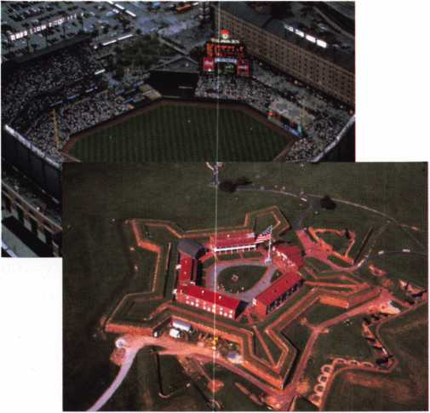

*Keynotes July/August 2 fit)1*

that our problems were not unique. We valued the time that others took to share their experience and professional expertise with us.

The trade show was an eye opener. Products that we had only seen in catalogs or heard about were on display. Knowledgeable factory representatives were eager to help us learn about their product lines. We did not attend classes that year, but quickly realized that that the classes sponsored by ALOA would be a most valuable resource for everyone in our company.

New friendships were made and continued as the years passed. We looked forward to each and every ALOA con­vention year that we could attend.

As I thought about the upcoming convention in Baltimore, MD this year, I wondered how others in the industry viewed their first ALOA convention. Here are some of their most positive responses.

□

It was 1 967 and my husband, Buddy convinced me that being new to the locksmith industry it was imperative we attend the ALOA convention. Being the pessimist I am, I really could not see that mingling with a few other locksmiths would truly enrich our business senses. Our first day there was fairly uneventful, classes for Buddy and shopping for me. It didn't take me long to figure out that the more classes I let him attend, the more money he gave me for shopping to occupy my time.

The first day of Exhibits arrived and I was still pretty apprehen­sive about the entire ordeal until I walked onto the show floor, the products and hundreds of people walking around took me by total surprise. I wanted to buy one of each product and meet everyone there. The highlight of that convention was meeting a wonderful lady that made me realize how important it is to not only love the career you have chosen for yourself, but to give back both physically and mentally what you can to improve that industry for others. Lee Rognon truly showed me

the importance of being involved and sharing your ideals and knowledge with your fellow locksmith. Since that first ALOA convention I never hesitate to stress the importance of attending the classes, seminars and exhibits to others in the industry. The benefits you reap will surely make a difference in your future!

*Judy Clifford*

*Anchor Safe & Lock Company Lake Jackson, Tx.*

Past Board Member and current member of the Board of Trustees for The Texas Locksmiths Association

Although I had attended some conventions for the exhibits only prior to that, I attended my first full convention in Kansas City in 1981. Laurie and I closed the shop so that we both could take a full convention package.

We were overwhelmed by the amount of knowledge gained in the classes and the openness of the conversations about "trade secrets" with fellow locksmiths. The individual who had the greatest impact on me was John Kerr. He was the first lock­smith that I had met who treated it like a business not just an ancient craft. This encouraged me to seek out classes taught by other locksmith business owners like Stan Haney and Bob Holcomb so that I could improve my business management skills..

If someone is debating whether or not they should attend a convention, I would give them this bit of advice. You can't afford not to. After we attended our first convention we were hooked and except for an emergency situation in 1986, I have not missed an ALOA convention since my first one.

I owe all of my success as a locksmith to ALOA and have tried since 1988, when I first became an ALOA board member, to give back the knowledge and expertise gained to the industry.

*David M. Lowell*, *CML,CMST*

*July/August 2007*

*Keynotes*

ALOA Educotion/Proficiency Registration Program Manager I think it was 1978 when I went to my first ALOA convention-1 know for sure it was in New Orleans. I met a lot of people I had only talked to on the phone and met a lot of people I never knew before. That part has happened a lot through the years because I have only missed one since that first one, the year my son was born while the show was going on.

I've met a lot of really famous people from our industry at the convention, I won't drop a list of names since I might have to fill the whole magazine and still miss some, but I will say that a highlight was getting to meet Ernest Johannesen, member num­ber 1. I'll also never forget the membership meeting when he took the microphone and got a standing ovation-quite a guy. Friendship is one thing you can get at the annual convention that you would miss anywhere else. Friendship with locksmiths from all over the world. There are a lot of locksmiths. I am proud to call friends that I met only because of the ALOA show. Some of them I only see at the show.

I've had a lot of fun, learned a lot and met many wonderful people by going to ALOA. The classes are great although I must admit that I've usually been so busy giving them I never did get to take one. Of course the product exhibition tops off the convention. There isn't any other place in the country where you can see and touch all the new products side by side. I wouldn't miss it, it's definitely the place to be.

*Billy B. Edwards Jr., CML*

My first ALOA convention was back in the late seventies, I think in Baltimore, but I'm not positive. I do remember being totally in awe at discovering a whole new world of locksmithing. Being new in the industry, I was in my own little world until then.

I took great classes every day and attended the product exhib­it -1 actually spent all day in there, talking to manufacturers and learning about products I didn't even know existed! I would definitely recommend attending at least one, after which you'll probably go back for more!

*Nelson Dayton, CML*

I think the first convention I attended was 1 960 in Washington D. C. As you know back then there was hardly any sharing of information and this was the first time I had an opportunity to go to any kind of class or meet other Locksmiths who would share information.

One of the classes I took was an impressioning class and it was very enlightening. The instructor was a good teacher and skilled at impressioning, but I was just as good. At that time we had a lot of car dealers around us and I was impressioning on a daily basis, but had no idea that I had become good at it.

I had only been in the business about 3 years and thought everyone else knew everything and I was the dumbest klutz around. The impressioning a was great boost to my self confi­dence.

I also learned that there was a tremendous amount of knowl­edge that I didn't possess. The networking and sharing that started at that convention and continues today was and is invaluable. I know that if it wasn't for all the people in the indus­try who so generously shared their knowledge and experi­ences, I wouldn't have been nearly as successful as I have been.

We have always come away from the conventions richer than before we arrived.

We have met so many great people who have influenced us and the business I wouldn't want to try to name them because I know I would forget someone.

I have also taken many classes at the conventions, and again they are invaluable.

For over 25 years the only thing we had resembling a vacation was the convention. We felt that we couldn't afford not to go.

I would recommend anyone that can possibly get there to do so. If I had only one thing I could attend it would be the con­vention. In one week you get to take several classes, and meet vendors and security professionals that it would take years to meet without a common meeting ground.

*William J. McElheney*, *Sr., CML*

*Keynotes July/August 2001*

■*fwin*_

Door Tube Lock

Tube Lock

Removajme Core Cylinder

rim /grd Mortise Cylii

In the tough, exacting world of high security, there's only one company that offers what ASSA does. New patents to protect cylinders and

keys longer, proving an additional layer of defense against unauthorized key duplication. A diverse product line engineered to safeguard

every environment imaginable, from the most demanding to the everyday. Support for our

wholesalers combined with factory knowledge and service that eclipses our competition.

We Secure The World

And a tradition of unparalleled innovation. All this in one family, the “ASSA Family of Locks”.

an ASSA ABLOY group company

ASSA, Inc., 110 Sargent Drive, New Haven, CT 06511, (800) 235-7482, Fax (800) 892-3256 [www.assalock.com](http://www.assalock.com)  
ASSA Canada, 3475 14th Avenue, Markham, Ontario L3R 0H4 Canada

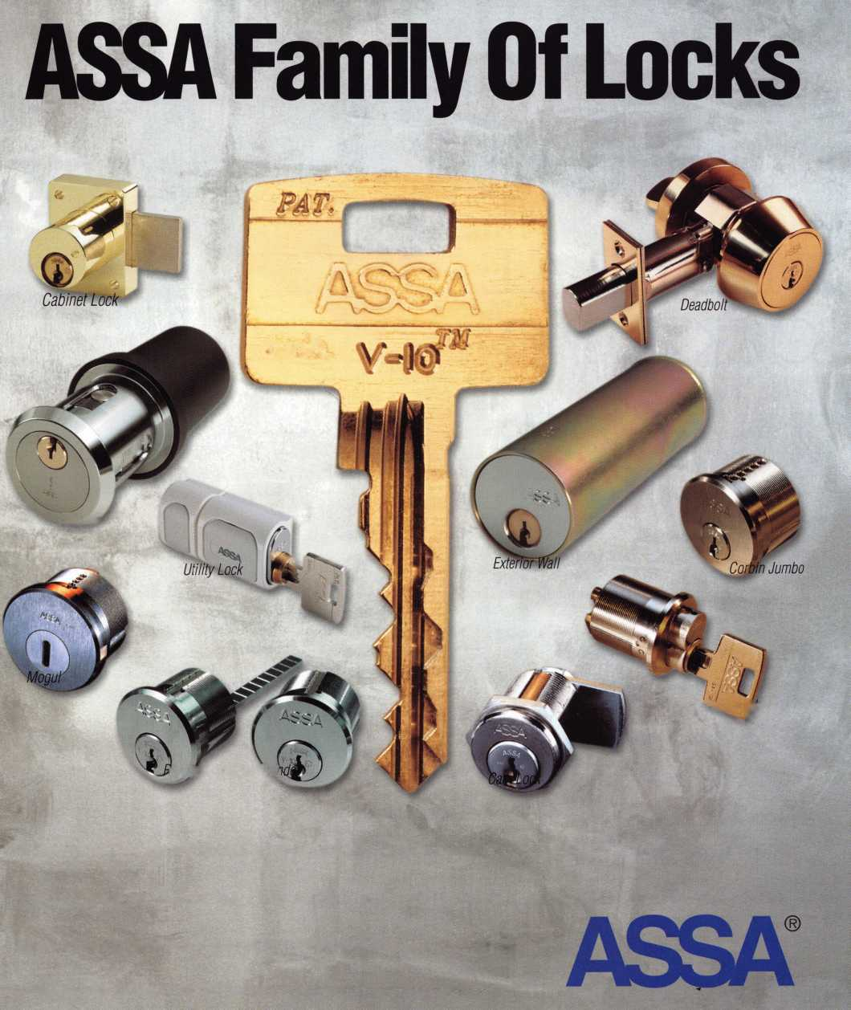

**Federal**

LOCK & SAFE

As part of "Keynotes" magazine's 2001 convention coverage for ALOA in Baltimore, we have profiled a regional company of note in the Baltimore - Washington corridor. Federal Lock & Safe, Inc. ("FedLock") is a locksmith company located in Arlington, Virginia. Their loca­tion puts them just several minutes outside of the nation's capital and 40 minutes from Baltimore.

In an interview with FedLock's President Peter Groves and Vice President Michael Groves, we had a lively & informative chat:

Q. What's the general descriptive info on FedLock?

Michael Groves (MG) We are a privately held locksmith services & security consult­ing company. Having said that, our motto is "We Secure Your World." Our people have worked on everything from residen­tial, commercial, government, & military, airplanes, boats, Presidential & Congressional security issues; it's an end­less list. Being in the Washington, DC metro area is a great place for our busi­ness. We have a range of entities here that are very concerned with every type of security imaginable, and they have the wherewithal to purchase that security. We currently run 14 service vehicles on the road, as well as our retail operation where we sell safes, GSA Containers, & counter locksmith sales. Our headquarters facility

in Arlington, which we purchased in 1999, is 19,000 square feet, and is a mix of office, warehouse, and retail. We are 15 minutes from Capitol Hill, 10 minutes from Georgetown, and 15 minutes from Tysons Corner. Suits us perfectly.

Q. How did you guys get started?

Peter Groves (PG) We started from scratch in 1988. I was working part-time as a locksmith while I earned my Masters in Arabic & Middle Eastern Studies from GW University. Some of our embassy clients are pleasantly surprised when I show up & uncork my rusty Arabic. Mike left his career as a commodities trader on Wall Street & was looking for something else to do. So, we took an ad out in the Yellow Pages, and ran calls, day & night, 24/7 for the next 6 years. Our first office, which we show a photo of to every new employ­ee, was an 8 x 10 bedroom in my Arlington rental house.

Q. Why are you guys different?

(PG) We never bamboozle a client. We feel a responsibility to do great work, and to be ethical & straightforward with our clients. Our techs are great; they work hard. Our guarantee? No waiting. In par­ticular, the property managers, the building engineers, and the agency service repre­sentatives do appreciate us keeping the pressure off of them.

Q.How does ALOA figure in your compa­ny's growth?

(PG) It's mandatory for all new teammates to join ALOA. The first year, Fed Lock pays half of the individual dues, then it's up to them to stay with it. 1 3 of our people will be taking the PRP in Baltimore, and every­one will be attending a variety of classes that the company pays for. We constantly utilize the ALOA study materials, and Keynotes, to stay current. It's important that our people realize that what they do is part of a professional occupation. ALOA rep­resents that image very well.

Q. What do you think have been reasons for your growth?

(MG) Hard work. Plowing everything back into the business. Working alongside good people. Our senior people are great: they care about the success of the business, they understand that sterling serv­ice & top-quality work are our raison d'etre and they are the reason we have really taken off in the past several years. They are unrelenting in their training of new peo­ple to do the work the right way, always, with quality in mind! Plus, we don't think we've accomplished what we really can, so we all stay humble - things can go south on you in a hurry.

Q.Care to tell us what your annual rev­enues are?

(PG) Well...no. With all due respect!

Keynotes

July/August 2001.

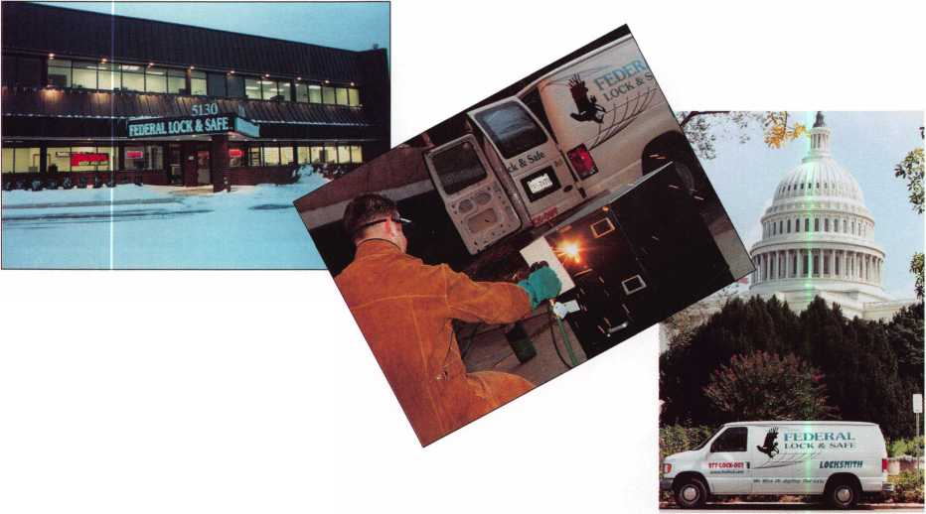

Q.How do you find technicians?

(MG) We look for tech applicants with electronics skills and common sense. We usually do not hire experienced locksmiths, which may sound negative. We just prefer to train 'em our way, and that way we know what we have out in the field when they're ready to roll. We usually know if they can absorb the material within 30 to 90 days. We've been burned a few times, no matter how careful we are. Seems to go with the territory. Our train­ing program is comprehensive: 4 to 6 weeks in-shop, then riding along with senior technicians, then slowly getting their feet wet on their own. We purchase doors & frames & set them up in our training area of the facility. That's where they drill, chisel, chop, and do installations of everything from deadbolts to door closers BEFORE they work with our clients. It's worth it to spend $ 200.00 on a door & frame and let the trainee chew that up, than to let them loose on a client's $ 2,000.00 custom oak door!

Q. Greatest difficulty as a business?

(MG) Well, I would say that finding a truly effective method of marketing what we do to new & even existing clientele is a formidable challenge. We do so many things, from high-tech electronics to cutting keys, that our clients sometimes lose track of all that we can do for them. And what really does get new business? We're way past the stage where we just stuck an ad in the Yellow Pages. We do a lot of direct sales. Upselling to our premium lines, such as Medeco, is a big part of our approach. Finding top-quality technicians is a never-ending task, of course, just as it is for everyone in this business. We know that we will lose 50% of all new technicians for a variety of reasons. The really sound ones stick, and we try to make this a good place to come to work.

Q. How does the Internet figure in Fed Lock's growth? (PG) We've taken a slow-track approach on that. We have a website ([www.fedlock.com](http://www.fedlock.com)), and soon it will be able to handle e-commerce & b-to-b transactions. Our facility is computer networked, and we believe strongly in the technology of the Internet, but we've been watching ventures like Marshall Merrifield's huge investment in Clark's website & well see how things like that go.

Q. So, where is FedLock headed?

(PG) Near-term, we will get 30 service vehicles on the road. Long-term we will expand & open other locations in the region. Maintaining quality & service standards are the challenges that come with growth. Safe sales are decent, but we want to ramp that up. We have just re­designed our entire safe showroom. We have safes in different settings, such as in a living room, and a rec room, actual "sets" that we've designed within the show­room to demonstrate to people that safes don't always need to be stuffed in the basement. Overall, we've seen an annual growth rate in gross revenues of approximate­ly 25 to 40% in each of the past 8 years. We'd like to maintain that.

EUROVAULT

EUROVAULT

EUROVAULT

There's a New and Better Way to Build a Safe **-**

The EUROVAULT EFP can be your top-selling, high security safe for home and business.

Capture the large, lucrative market for small capacity, high security safes with a level of protection that is in great demand by homeowners and business. EuroVault features a ground­breaking structural innovation called "steel matrix composite construction" which rivals the construction of larger, rated high security safes. See why EuroVault EFP will soon become the best-selling smaller safe for burglary and fire protection.

Steel, reinforced composite construction European craftsmanship ISO 9002 certified manufacturer Three sizes available One hour fire rating Expandable fire gasket on door jam

High security key lock Auto firing passive relocker Drill resistant hardplate Adjustable shelves Electronic lock options Lists under $1400.

DEFIANT SAFE COMPANY

3130 Towerwood Dr. Dallas, TX 75234

*1-800-225-2984*

*Julv/Auaust 2001*

*Keynotes*

1

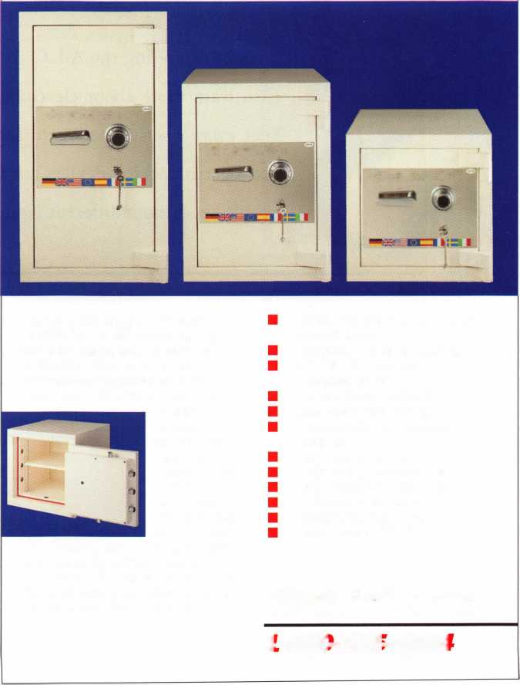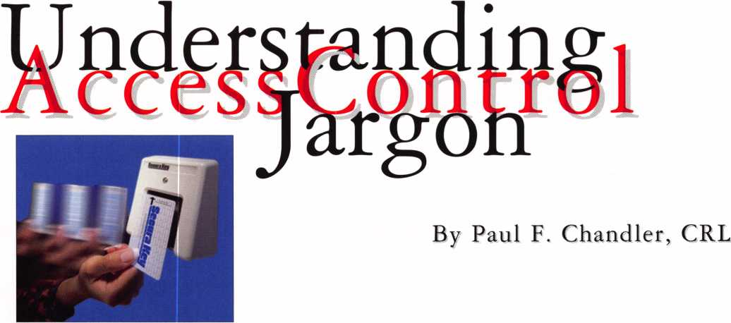

S

o you're attending the A.L.O.A. Show in Baltimore and one of your goals  
is to learn more about electronic access control. You make it a point to  
visit every booth where card access, digital keypads, biometric scanners  
and electric locking devices are displayed. Is it just you, or are all of these  
|| people speaking a different language?

In any specialized field there will always be a certain amount of jargon. Jargon is like shorthand. In a word or two we can communicate an idea that might take several sentences to fully explain. Jargon helps us to identify and categorize infor­mation. The problem is, not everyone knows the jargon that is unique to our field of expertise.

Let's review a few terms that you will hear bandied about when you "talk shop" with access control experts.

Wiegand

Originally Wiegand referred to a type of access control card. Wiegand cards have two parallel rows of tiny wires embedded in plastic. When a Wiegand card is swiped through a reader

Keynotes*July/August 2nm*

the wires convey a string of "bits," ones and zeros, that con­stitute a binary message. In this way, the card sends its unique ID to a controller.

This pattern of ones and zeros proved to be a very effective way of communicating from a card reader to a controller. Even when Wiegand cards faded in popularity, the Wiegand communication protocol grew. Nowadays we have all sorts of card readers that send card data to a controller in "Wiegand Format". There are also digital keypads and biometric scan­ners that speak "Wiegand". And while there is no universal access control language, Wiegand is the most common com­munications method we have.

So if a manufacturer tells you that his proximity card reader has a "Wiegand output," or if the maker of an access control panel says his system can accept "26 bit Wiegand" from any type of reader, they are referring to the industry-wide Wiegand communications protocol.

Biometric

Did you notice that I threw the jargon term "biometric" into a preceding paragraph? Biometric comes from root words that refer to measuring something that is alive. There are several parts of the living human body that are nearly unique. Today you can buy devices for access control that measure your fin­gerprint, the geometry of your hand, the vascular pattern of your retina, the pattern of your iris, your voice, the shape of your face and more. All of these use biometrics.

information gathering device so that it can be viewed or printed. In most cases, once the buffer is full it will replace the oldest record with the newest.

Different access control system will offer different ways of using the audit trail data. Many will allow you to filter the data so that you can look at (or print) just events that hap­pened at a particular door, or during just a specific time peri­od. Another filter may isolate just the activities of a single cardholder.

Time Zones

Many access control systems allow you to issue cards to users that are limited as to the days and times when they can gain access. The schedule that determines when a card will and will not work is called a Time Zone.

Biometrics are a very reliable, high security means of verify­ing that you are who you claim to be. In most systems the user first enters a PIN code or presents a card. This tells the system whose file should be compared to the present reading. Then the user presents the required body part and a comparison is made to the archive measurements. If the match is close enough, access is granted.

Audit Trail

When an access control system records which user attempted to gain access, along with the date and time of the attempt, this is referred to as an audit trail. Many access control sys­tems have memory dedicated to storing these transaction records, often called a transaction buffer. Information stored

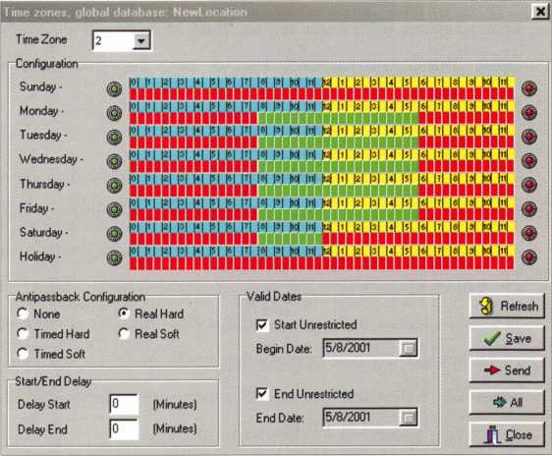

In most businesses, there are logical groupings of people who

in the buffer can usually be "downloaded" to a PC or other

|  |  |  |  |  |  |
| --- | --- | --- | --- | --- | --- |
|  | 13:38 | 5/29/2001 | 623 Sandy Casden | Valid Access | public entrance/ NewLocation |
|  | 13:36 | 5/29/2001 |  | Door Unlocked via Dock Zone | public entrance/ NewLocation |
|  | 13:36 | 5/29/2001 | 20 Jeff Hamilton | Valid Entry | parking entrance/ NewLocation |
|  | 13:36 | 5/29/2001 | 20 Jeff Hamilton | Valid Exit | parking exit/ NewLocation |
|  | 13:36 | 5/29/2001 | 20 Jeff Hamilton | Valid Entry | parking entrance/ NewLocation |
|  | 13:36 | 5/29/2001 | 20 Jeff Hamilton | Valid Exit | parking exit/ NewLocation |
|  | 14:00 | 5/29/2001 |  | Reader Active • Door Zone Off | Parking OUT/ NewLocation |
|  | 15:50 | 5/29/2001 | 623 Sandy Casden | Vafid Access | Parking IN/ NewLocation |
|  | 15:50 | 5/29/2001 |  | Door Unlocked via Door Zone | Parking IN/ NewLocation |
|  | 15:51 | 5/29/2001 |  | Reader Active • Door Zone Off | Parking IN/ NewLocation |
|  | 15:51 | 5/29/2001 | 623 Sandy Casden | Valid Access | Parking IN/ NewLocation |
|  | 00:00 | 5/30/2001 |  | RAPB forgive all via Reader | parking entrance/ NewLocation |
|  | 00:00 | 5/30/2001 |  | RAPB forgive aH via Reader | parking exit/ NewLocation |
|  | 00:00 | 5/30/2001 |  | RAPB forgive aH via Reader | Parking IN/ NewLocation |
|  | 10:24 | 5/30/2001 | 2 Bill Newill | Void Card | parking entrance/ NewLocation |
|  | 10:24 | 5/30/2001 | 2 Bill Newill | Valid Exit | parking exit/ NewLocation |
|  | 10:24 | 5/30/2001 | 3 | Valid Exit | parking exit/ NewLocation |
|  | 10:24 | 5/30/2001 | 2 Bill Newill | Antipassback Violation | parking exit/ NewLocation |
|  | 10:24 | 5/30/2001 | 3 | Antipassback Violation | parking exit/ NewLocation |

need access to the same doors at the same times. In some sys­tems these groups of people are collected into "Access Groups." Each access group is assigned to a Time Zone. In this way every cardholder receives just the access he or she needs in order to perform their jobs.

Anti-Passback

Anti-passback refers to a system of preventing one cardholder from sharing his card with someone else. This is usually used

*July/August 2001*

*Keynotes*

in parking applications, but may also be used in buildings where turnstiles limit one entry per card use.

In real anti-passback systems there are "IN" readers and "OUT" readers. The system keeps track of whether each card­holder is "in" or "out." If the system knows that you are "in," it won't let you "in" again.

In a parking lot this prevents one fellow from paying for a month's parking privileges and then sharing his card so that two, three or more cars all enter the garage with the same card.

Systems that support anti-passback usually have a provision for "anti-passback forgive." Forgiveness is more than just a commendable personal trait. It is also necessary when the access system thinks you're "in" but for some reason you're really "out." Anti-passback Forgive puts you back in sync with the system.

Alarm Shunt

This feature is used to bypass the burglar alarm system sensor associated with a door that has card access. Whenever a valid card is presented to the reader, in addition to activating the electric locking device, the access control system "shunts" or bypasses the alarm contact on the door. This allows the door to be opened without being seen as a break-in by the alarm panel. Once the door is re-closed, the bypass is eliminated and the door is protected by the alarm once again.

Request-To-Exit. AKA REX

Also known as "Remote Open," this refers to an input that is connected to some kind of switch that can be activated by someone wanting to leave through the access controlled door. The switch might be a simple wall-mounted button, a push- to-exit bar or a passive-infrared motion sensor. Upon receiv­ing the REX signal from the switch, the access control system unlocks the door for the same amount of time that it would unlock if a valid card was presented to the reader. In addition, the system records that the door was opened for a valid exit

and the door opening is not treated as an alarm condition.

Doors equipped with magnetic locks always need some means of unlocking them so that people can exit. Doors equipped with electric strikes can usually be opened mechanically and REX may not be so important.

Delayed Egress

Access control systems deal with limiting entry to a secured area. Delayed egress systems are used to discourage persons from exiting through certain doors. Delayed egress systems are installed on exit doors, which are required for life safety but are not intended for normal traffic use. Persons attempt­ing to exit are delayed for 15 seconds (occasionally as much as 30 seconds) before the door will open. During this time an alarm will sound and responsible staff can respond to see who is trying to use the exit.

Delayed egress systems are available from most major electric lock manufacturers. Their use is strictly governed by the Life Safety Code and the interpretations of the local "Authority Having Jurisdiction." (By the way, "AHJ" or "Authority Having Jurisdiction" is jargon for the local official - Fire Marshall, Building Inspector, etc. - who decides what is and is not allowed in your town. Make friends with this person.)

Delayed egress is a great security improvement for hospitals and nursing homes that have to cope with wandering patients. It is also a good solution for large retail stores that have fire exits in remote corners of the building far from the check-out lines.

This sample of industry jargon may prove helpful when you need to interpret the rantings of an access control specialist. And, if your expert uses any other terms that are unfamiliar to you, don't just stand there nodding your head knowingly. Stop him and ask for the plain English version. Then you'll be able to add that bit of jargon to your conversation.

K*eynotes*

*July/August 2001*

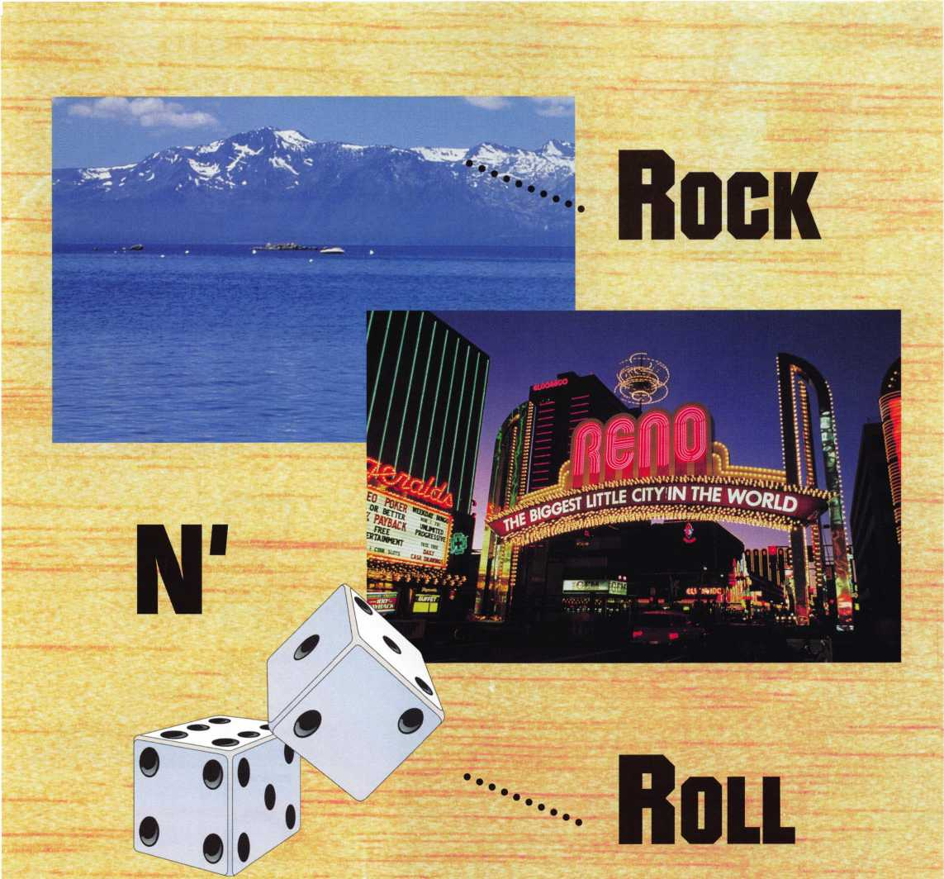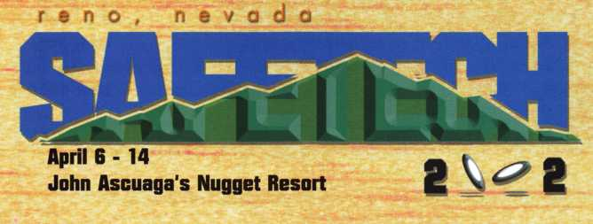

*July/August 2001*

*Keynotes*

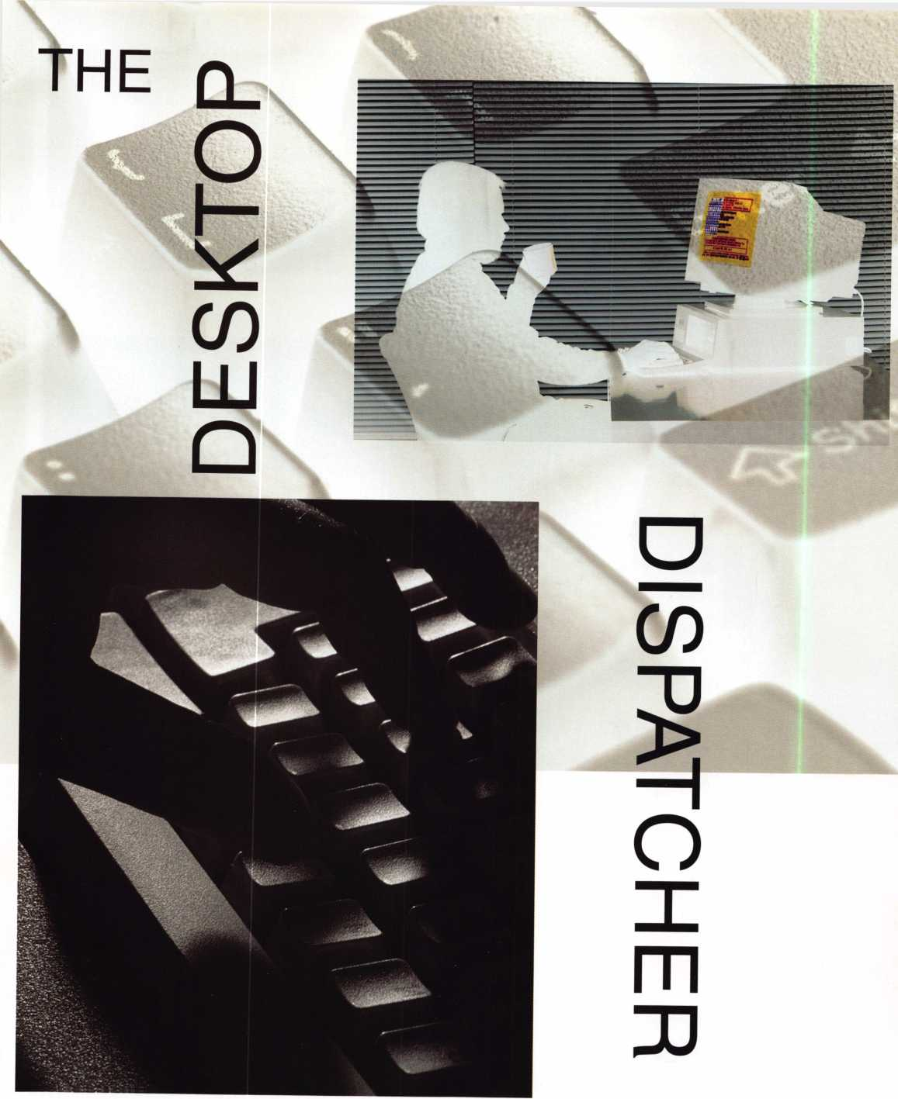

*Keynotes*

July/August 2001

**What is the Desktop Dispatcher?**

■

The Desktop Dispatcher is a Windows based program that is used to create, sort, track and print service work orders and customer lists.

HOW DOES IT WORK?

■

The basic program is made up of four databases or files that work together to make the program work. The Dispatch Screen is where the work orders are entered and stored until completed. The Customer List is where all the information (contact and equipment) on each customer is stored. The "Calendar" is used to show all the appointments that have been scheduled for the next 14 days. You can schedule appointments for any time you need; however, they just won't show in the calendar until they get within the 14 day win­dow. The calendar will also allow you to create and schedule a call without having to switch screens. Just click in the appropriate cell, enter a time, the customer's name and assign the call to a technician. Each cell has a link button that takes you right to the Dispatch Screen to allow you to enter the rest of the information for the call. And finally, the "Cleared Call File" is where each call or work order is stored when the job is completed. It also builds reports and statistics automatically. For example from the Cleared Call file, you can find out just how many calls a particular technician closed during a partic­ular time. Or, you can pull up just about any combination of statistics you desire.

To enter a new call, all the user has to do is click on the "New Call" button to create a new work order. At this point, the program prompts you to enter the phone number of the caller. If the phone number belongs to a customer already enrolled in your customer list, the program will enter the cus­tomer's name in the billing address area for you. If not, the

customer will automatically be enrolled when you enter the information in the billing address area of the work order. This is a great way to add new customers to your customer list. Next the user enters the address where the service is being requested. Again, there are two convent buttons that allow you to eater use the same address, or look up the address from the customer list. This is a great feature when it comes to clients with a corporate address and several chain locations. It allows you to select the corporate office as the billing address and look up the job address from your customer list. All the information gets entered for you. If you have done any work at that address before, a brief, one line, description of the last 2 calls you cleared, for that address, will be displayed on the screen as you enter a new work order. On each line of the brief description, there is a button that links you to the full record in the "Cleared Call" file.

Next the user just tabs through each field entering the appropriate information. There are lots of neat, editable, pop­up menus that allow you to do things like assign the call to an employee, pick a payment method, pick an appointment time, enter the name of the person who took the call and more. If you schedule an appointment, you will get a reminder in big red letters on the day of that appointment, reminding you that "THIS APPOINTMENT IS FOR TODAY" You can also enter text and audio notes right on the work order. The audio note is a great way to record something that you may not want the customer to see in print when the work order gets printed out. There seams to be a field for just about everything and when the job is done, it all gets stored in the Cleared Call file.

When it comes time to clear the call, you have the chance to enter the parts used on the job which will be tracked and used to build reports in the Cleared Call file. If your shop uses flat rates or service charges instead of hourly labor, it is not a problem. This program works either way. If you want to track the amount of time spent on site, simply click on the arrival time button to have the current time stamped on the call.

h.ly/Augnst 2001

Jfej/nntes

When the technician calls to clear the call or when you return to the computer, you can stamp the Departure Time button the same way. The program does the math for you to figure out how much time was spent on site. You can then enter how much time you want to bill for the job. This allows you to round up or round down the amount of time spent on the call. Finally, you choose the labor rate, tax rate and trip charge from more pop up menus and then clear the call by clicking on the Cleared Call button.

When you clear a call, you are given the chance to build an invoice for that call. If you purchased the invoicing mod­ule, an invoice will be created automatically without having to retype all the information. The invoicing module also includes lots of handy things like thank you letters, late notices, income and tax reports and more. The invoicing mod­ule comes with each program and because it is password pro­tected, you can purchase it at any time.

There is another version of this program that has all the features mentioned above plus an Automatic Inventory Module. Called A.I.M for short, this module keeps a perpetu­al inventory for all the parts you use. The AIM module comes with over 8000 locksmith related parts already entered. It allows you to assign your own part numbers, enter up to 3 suppliers for each part with their respective reference num­bers, select automatic reorder levels and even select how much you want to mark up each item.

If you purchase this version, the price and description of each part is entered automatically for you when you enter a part number on the work order. Not sure of a part number? OK, you can look them up, too. When you clear the call, the on hand quantities for each item will be adjusted automati­cally. When you reach the automatic reorder level for each item, you are reminded that it is time to reorder that item. You can even build a shopping list. With a click of a button, the program searches for all the items that have reached your reorder level and allows you to view a list of all those items that you can then print but and/ or fax to your suppliers.

When the parts you ordered show up, all you have to do is adjust the quantities in the AIM.

**Who can use it?**

■

Everyone. Many of the built- in features would benefit the smaller shop as well as the larger shops that have full-time dispatchers. For example, I don't care what size company you have, you can't remember everything you do for every cus­tomer, all of the time. With The Desktop Dispatcher, each time a call is cleared, it gets stored in the "Cleared Call" file for later reference. The next time a customer calls and says that the thing-a-ma-bob that was installed 3 months ago, is not working right, you can find out just who installed it and when.

The "Customer List" does more that just store contact information on your customers. With fields that allow you to store combinations, key codes, photographs, schematics, exploded view diagrams and audio notes, your notes for your customers and their equipment are never far away. Imagine this: You or an employee, in the field, is having a problem servicing a safe. With one or two mouse clicks, you could be looking at photographs or even listen to audio notes that have been recorded the last time you had a problem with that safe.

What if I already have some of this information on com­puter? Not a problem. The desktop Dispatcher allows you to import your customer list or inventory files in the following formats Tab-Separated Text ( .TAB.TXT), Comma-Separated Text (.CSV, .TXT), SYLK (.SLK), DIF (.DIF), WKS (.WK1, .WKS), BASIC (.BAS), MERGE (.MER), EXCEL (.XLS, .XLW) and DBF (.DBF)

HOW MUCH DOES IT COST?

■

With similar programs costing upwards of $1500, perhaps the best feature of this program is its low price. It starts at just

Jteynotes

JuN/August Pnm

$250 for the basic program. An additional $125 gets you

the Automatic Inventory Module and another $125 gets you the accounting module. You can buy the basic program or the AIM version and add the invoicing module later.

Who makes this program?

Look for us at the ALOA Show in Baltimore and tell them you're an ALOA member for discounts!

The Desktop Dispatcher is made by Mark Fleming Enterprises of Florida. 561-714-5240, [www.DesktopDispatcher.com](http://www.DesktopDispatcher.com) Mark, a veteran locksmith with 10 years of experience as a lock­smith and 5 years experience programming. His first version of this program is still in use by his employers who service bank equipment all over the state of Florida

What else can it do?

■

Heard of hand-held computers? The Desktop Dispatcher allows you to export your calls and customer lists to any hand held computer using the Palm OS operating system. That's right, you can put your calls right into the "ToDo List." If you purchase some third party software, you can even synchronize the calls on the hand-held with the calls on the desktop or laptop computer in the shop. This will allow you to make changes to the calls on the hand-held while in the field and then come back to the shop to up - date the shops computer with a click of a button.

Conclusion

■

This program is crammed packed with features at a very affordable price. One missed call could pay for the $250.00 basic program. No mater what size shop you have, this program will save you time and help organize your service depart-



44

Weighs” in BI6!



Enjoy the new technology from ABUS!  
Using the 83 Series Pinning Window™ Cylinder!

**NEW**

OLDER

Order the **NEW** “83/55” in any keyway from

your distributor! Receive a **FREE** ABUS ($7.99)

Trigger Lock for each # 83/55 ordered! **That’S a 55% Savings!**

Unique  
“Tear Drop”

Design

* Yale 8®
* Kwikset®
* Schlage C®
* Schlage C-L®
* Corbin®
* Sargent®
* Arrow®
* Russwin®
* Weiser - Falcon®

with

#83/55  
order

• Z-Bar®

OLD

HURRY while supplies last! Promotion ends - June 30, 2001

For ordering information:

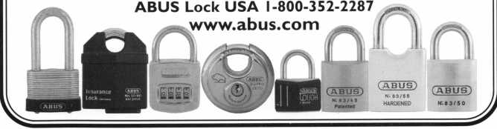

ment.

July/August 2001

***Kp.ynntRft***

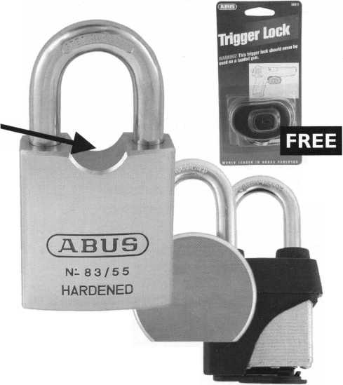

By

Robert Arthur, RL

Not too long ago, I happened upon an article in a major locksmith publi­cation explaining the procedure for replacing the lock in the 1996 Cavalier and J-Body cars. It was obvi­ous that the author had not done his homework, for the explanation given for this procedure simply would not be possible. He concluded his report by advising his readers to simply cut and splice the wires for this lock, and that this was an acceptable practice.

We are supposed to be pro­fessionals, and it is my opinion that splicing wires is not only unaccept­able, but also unprofessional. If I were the customer, and were paying roughly $1 20 for a new part, I cer­tainly would not find the cutting and splicing of wires acceptable. I doubt that you would either! Had I as a cus­tomer witnessed a so-called profes­

sional damaging the part I was to pay for, I would fire him on the spot!

The previous author also quoted a source that told him the flat rate for this operation was 1.7 hours. This does not take into account the removal of the upper dash pad, as well as loosening the instrument clus­ter for access. Per my crash manual, total time allowed for this operation would be 2.2 hours. This time is based on crash manuals used in the insurance industry, and they are nor­mally more conservative on times than the dealers flat rate guides. In any case, I will attempt to explain the proper procedure for replacing this lock to the best of my ability.

At first glance, this operation appears very scary. The 1 995 J Body car, utilized the modular column with the ten cut ignition lock. It was not,

however, utilizing the passkey system. In 1996, GM went to the passkey system on these vehicles. The wire for the passkey system runs down through the column shrouds, upwards behind the instrument cluster, and plugs into a socket built into the top of the instrument cluster. This connector can only be accessed by removing the entire upper dash pad. Don't panic; it's really not that bad. We will take it step by step, and if you follow these steps, you can do a profession­al job the first time.

Although this vehicle is equipped with both a driver and pas­senger airbag, replacing the lock does not require a disarming of the airbag system. Neither airbag has to be removed to facilitate these repairs.

July/August 2001

*Keynotes*

1 .The upper and lower column shrouds are held on by three screws utilizing a com­bination torx center, with a 9/32 bolt head outer. Either tool will work to remove these screws. Remove these screws from the bottom of the lower shroud. Once removed, gen­tly separate the two halves. Once separated, pull the upper shroud upward and toward the steering wheel. It will slide free of the two pins on the rear edge connecting it to the lower shroud. The lower shroud must be gently worked out over the lock cylinder cap, and the tilt lever removed on tilt column models. The tilt lever pulls straight out! Once this

»i—^ has ^een done, l°wer shroud can then be

removed. Once the shrouds have been removed,

■ m the lock, housing, and wire are clearly visible. See

lm Photo 1 and 2.

1. At each end of the instrument panel, a trim panel has been installed for cosmetic purposes. These are easily pryed gently off The vehicle fuse block is locat­ed behind the driver side panel. Do not confuse the fuse panel door with the trim panel. The fuse panel door comes off with the trim panel. See Photo3.

A screw is installed at the point indicated in photo 4, remove this screw. Remove the sin­gle screw at the passenger side as indicated in photo 5.

1. Next, open the glove box door. There are three screws located along the top edge as indicated in photo 6. Remove these three screws.
2. Next look through the opening on the far left side of the glove box. You will see two brass headed 9/32 bolts. In photo 7, the holes are visible where I have already removed these two bolts. These two bolts must be removed.
3. A defroster register is located on the dash pad. This is top center, near the wind­shield. It is held in place by a phillips head screw located near the bottom center of the grill. Remove this screw, and gently pry the grill out.
4. Once the grill has been removed, a 9/32 screw is visible near the upper right hand corner of the grill opening. Remove this screw.

I 7. Gently pry the instrument pad up from the front \ ^ edge of the instrument cluster. It is only being held

in place by bullet type clips at this point. Once you have pryed it loose at this location, the instru- ^ ’> wk ment P°d can lifted °ff and placed aside.

8. The passkey lock wire connector is now visi- I j - J| ble plugged into the top right side of the instru- ment cluster. See Photo 8.

Iflpr ^ 9. Gently disconnect the plug from its socket.

*July/August 2001*

Keynotes M1

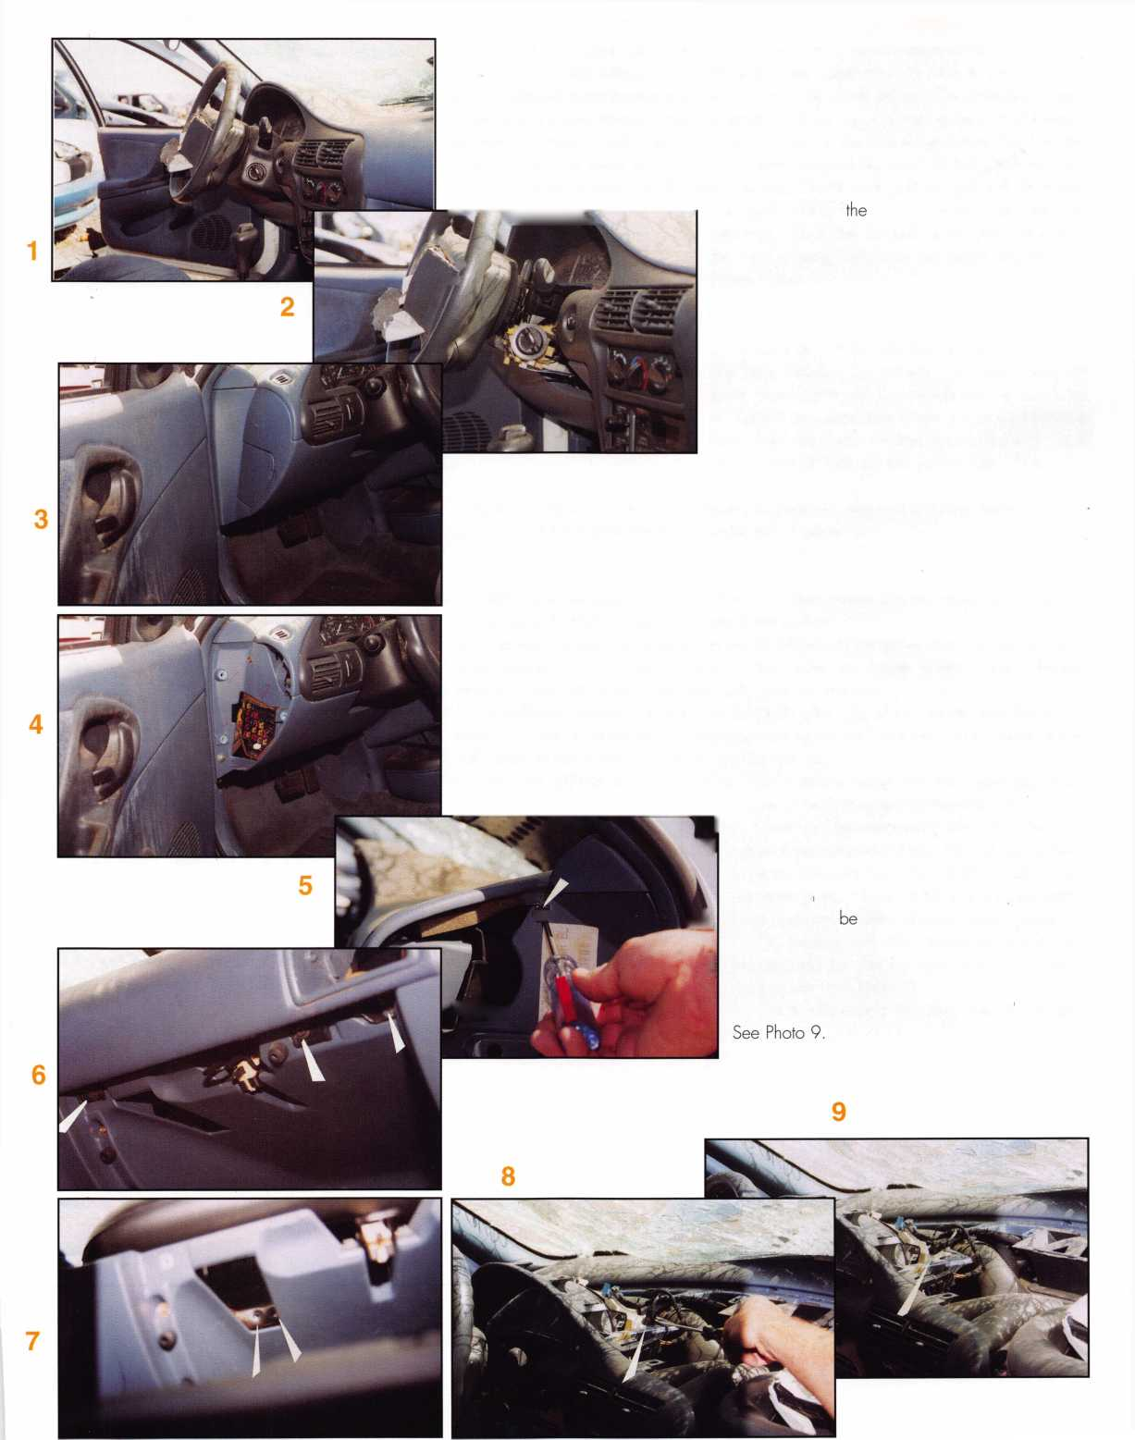

10. If you look, you will notice a 9/32 screw located at the two rear corners of the instru­ment cluster. You will also notice three screws attaching the front instrument bezel assembly on the top front edge. These are located to the left and right of the bow, and one at the far right end. Photo 10 shows the left rear cluster screw, and the left front bezel screw. Photo 1 1 indicates the positions of the right rear cluster screw, and right front bezel screws. Remove these five screws.

1 1. You may now gently pull the instrument cluster up and forward, Gently do this, and ONLY enough to pass the wire connector through the opening gained at the bottom edge of the instrument cluster. See Photo 1 2.

1 2. Once the wire has been passed through this opening, it can be pulled up the steering column as shown in photo 1 3.

1 3. We are now ready to remove the lock. Directly below the lock, the wire is held in place by a plastic clip. Remove the wire from the clip. If you have a working key, turn the lock to the on position, and depress the retainer located on the front edge of the lock hous­ing. The lock will slip out of the housing. If you do not have a working key, it may be nec­essary to drill out the retainer, in order to remove the old lock. See photo 14.

14. Installing the new lock, is simply a matter of reversing the order of these procedures.

1. Install the new lock into the housing.
2. Place the wire into its clip below the lock cylinder
3. Guide the wire down alongside the column, under the dash, and up through the opening gained behind the instrument cluster. Again, you may have to pull the clus ter gently forward in order to get the connector through the opening.
4. Once the wire is through the opening, slide the cluster and bezel back into position, and reinstall the five screws.
5. You may now plug the wire back into its socket. At this time, it would be a good idea to check out the lock and make sure everything is working as it is supposed to. If so, then you're good to proceed. If not, you will have to check for problems. Maybe a loose connection or a blown fuse. (Please see the end of this article for programming procedure.)
6. Place the dash pad back into position, and snap the front clips back into place.
7. Install the screw into the top right corner of the defroster grill opening.
8. Snap the defroster grill back into place and install the phillips head screw.
9. Install the two brass headed 9/32 screws into the bracket located on the left side opening of the glove box.
10. Install the three screws along the top edge of the glove box opening.

1 1. Install the screw at the passenger side of the instrument panel, and snap the trim panel back in place.

1 2. Install the screw at the drivers end of the instrument panel and snap the trim panel back into place.

1 3. Work the lower column shroud into place.

1. Install the upper shroud into the lower shroud and snap the to halves together.
2. Install the three screws into the bottom of the lower shroud, and your job is com pleted.

Keynotes

***July/Angust 2001***

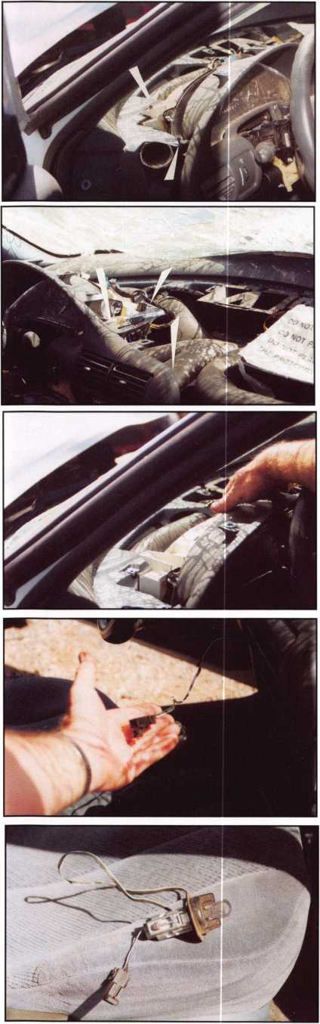

The 1997 model was changed to make the wire connector accessible under the dash. Apparently the man­ufacturer looked at this as a design flaw and changed it with the next production. Unfortunately, the 1996 models are out there and we as professionals are going to have to deal with them. Since we are going to be working on these vehicles, let's do it right. Any hack can cut the wires and splice them, but we as professionals should not con­sider doing that kind of work. Let's do the job, do it right, and charge the price for doing professional work. We didn't design the system, we didn't build the system, but we can repair the system right, and charge accordingly. If they don't want to pay us for professional work, the cus­tomer always has the option of going back to the dealer. It will cost him more to have it done there by us. As with every job I do, if the customer doesn't want to pay to have it done right, I don't want the job.

Programming the Passkey System

The GM Passkey System uses a lock cylinder plug with a

magnet built into the side of the plug. The lock case has

a Hall Effect Sensor built into it. As the key is inserted, and the plug rotated, the sensor reads the magnet and allows the vehicle to start.

The lock was designed by Strattec in such a manner, that if forced, the magnet will break, thus disabling the sys­tem. When replacing this lock, there is a one out of ten chance that the new lock will work with no programming. If, however, the vehicle starts and immediately dies, the system must be programmed to accept the new lock.

In order to program this system, the following steps must be taken.

1. After making the first attempt to start the vehicle, turn the lock off, and back to the on position. The Security light will begin blinking on and off. After about 10 minutes, the security light will stop blinking and stay on.
2. Attempt to start the vehicle by rotating the key on to the start position. If the vehicle does not start and continue running, repeat the above procedure. In some cases, as many as three programming sequences must be done, before the vehicle starts on the fourth attempt.

continuous gear hinges,

very, very good at it!

Here's why.. . Our founding strategy was simple. Provide  
the highest quality product and service at a reasonable price. Striving to achieve  
this goal has made us industry leaders and innovators. SELECT was FIRST to:

* Anodize clear hinges after machining = last longer
* Offer templated, logical hole pattern hinges
* Offer Quick Shipments - 48 hours or less on most orders
* Provide single hinge packaging with fasteners included
* Create an 85" standard length continuous gear hinge
* Provide 410 SS plated and hardened fasteners
* Offer full-surface swing clear hinge with replaceable covers

Designed for today, Geared for tomorrow...

select-hinges.com

m :

**SELECT PRODUCTS LIMITED**

9770 SHAVER RD • PORTAGE, MI 49024  
800-423-1174 . FAX 800-423-7107

TRUST AN INDUSTRY LEADER.

*July/August 2001*

*Keynotes*



MEDEC

KEYM

By Sal Dulcamarq^iCMLg

When Med^M® fatst introduced  
and lauj^^^^^^Hkrk® in the  
fourt|^^^^^^^1995, it was a

fsideraffe departure from its

tradition. Where

Mede^^meant high security or  
^^^^mbination of high security

id key control, KeyMark strict-

unrepresented key control. The

^^ftinal product line was a Best  
^^^^htible or now additionally  
as a "small format"  
^^^^^^Mreable core (SFIC).  
The small format and deeply  
d^^^^noles (to transfer plug  
moti<7Ti to the drive pins) made a  
Best-style I-Core awkward to  
introduce features or compo-  
nents that would allow it to be  
considered truly high security.  
KeyMark, therefore, became  
Medeco's first key control only  
product line.

Keynotes

*July/August 2001*

Photograph 1 shows examples of the products first introduced as the KeyMark line. In the foreground are two small format I-Cores. A 6-pin core and keys is at the left, while a 7- pin equivalent can be seen to the

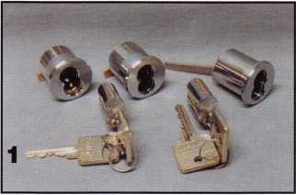

right. In the background are three small format housings. The two to the left are mortise style housings of two different lengths. The one furthest to the left would allow no more than a 6 pin core to be contained with­in it, while the housing in the middle could hold either a 6 or 7 pin length I-Core. The housing all the way to the right, is a rim type I-Core housing. That one will also hold 6 or 7 pin cores. The primary basis of the key patent was the dramatic offset angle at the bottom of the KeyMark key way, referred to as the security leg. U.S. patent number 5,176,015 defined the angle range for the security leg to range from 5 to 85 degrees, although current angles tend to be in the middle of the specified range. The KeyMark patent is limited to only the United States. KeyMark products are not intended to be sold in

Canada or other parts of North or South America. The restric­tion includes the rest of the world outside U.S. borders. Screw Attachable Cams

One innovative feature that marked Medeco's entrance into the small format IC market was its use of screw attachable cams for its mortise cylinder type housings.

Photograph 2 shows a detached cam after the two cam screws were removed. While most small format IC housings use riveted cams and require quite a bit of work to switch to a differ­ent style cam, the KeyMark

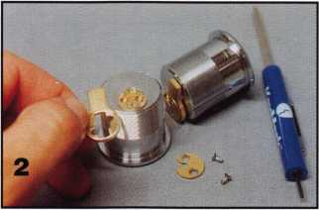

mortise housing only requires a screw driver. It shares cams with the Medeco high security mor­tise cylinders, and as such there will be very few brands of mor­tise locksets that won't accept a KeyMark mortise housing.

X KeyMark Phase II In January 1996, phase II introduced a full line of retrofit conventional cylinders. This product line allowed for the abil­ity to take a KeyMark key and make it work in full size or larg­

er format non-IC cylinders. Photograph 3 shows the modi­fied KeyMark key way used in larger diameter plugs. As you will see, that broached keyway pattern is not fully filled by the key. Look at the slight gap at the bottom of the keyway in

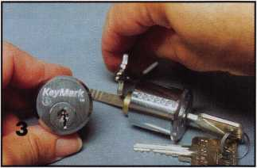

photograph 4. The broaching pattern below the bottom of the key is very narrow in order to prevent pins from the upper chamber from dropping into that gap.

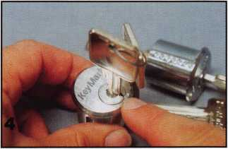

X Gaging a KeyMark Key Because of the peculiar offset key way, a KeyMark key is not gaged in the traditional manner. Photograph 5 shows

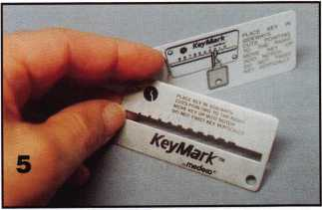

***July 2001*** ***Keynotes*** 1*45*

the gage with a separate instruc­tion card, indicating how the key would be held to accurately decode key cuts. Photograph 6 shows the gage being used.

KeyMark uses Best A-2 pin lengths. To account for the offset security leg, the A-2 key cut depths are referenced by the ledge rather than the bottom of

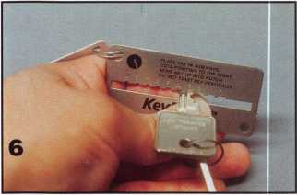

the key, even though it still uses .0125 inch increments. Specially designed key cutting equipment (or key holder adap­tors) is needed to account for the keyway profile and hold the key properly.

Knob Style Cylinders There are a number of KeyMark knob "style" cylinders that are not necessarily just for use in knob or lever handle locks. With various adaptor tail pieces, the same cylinder might end up in a deadbolt lock or a rekeyable padlock. Photograph 7 shows one version that is

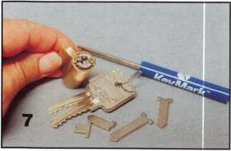

*Keynotes* *Julv/Aupust 2nnt*

designed for use with a variety of tail pieces designed to be rigid in operation. The back of the lock cylinder has a cross shaped opening which allows for verti­cal or horizontal positioning of the chosen tail piece. To install or switch tail pieces, the two diagonally positioned screws must be removed. With the tail piece retaining plate off, a tail piece can be attached and then secured by fastening both screws, as in photograph 8.

Another cylinder design is used for lazy action tail pieces. It and the tail pieces can be seen in photograph 9. The tail piece can be hooked in place without removing the threaded cap

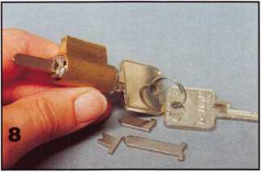

retainer, as in photograph 10. Both knob style cylinders will have to be similarly configured (in shape) to replace any particu­

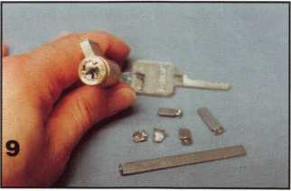

lar cylinder.

A Other IC Physical Formats KeyMark IC lock cylin­

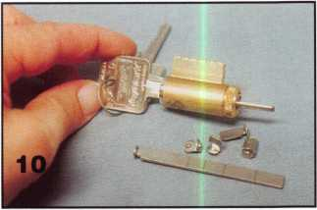

ders have been recently intro­duced that will fit into housings other than Best style or small format. Others are about to be introduced.

Introduced in December 2000, photograph 11 shows a KeyMark IC lock cylinder that will fit into the large format Corbin/Russwin IC housings. The left side view, in photo­graph 12, shows the outward physical profile to be the same. The internal construction is dif­

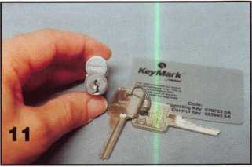

ferent. It has a full control shear line, with all 6 pins compared to 4 with standard

Corbin/Russwin. Keying is in Best A-2 format, so you can key

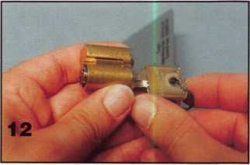

them the way you would with standard KeyMark IC. The same control key could be used for

both types in a single system.

Medeco introduced a unique patent pending design IC cylinder to fit into a Schlage large format IC housing, in July 2000. Photograph 13 shows the extended tip control key, that operates similarly to Schlage's control key. The core retainer pin is extended in photograph 14. Turning the control key clockwise retracts the pin for installing or removing a core. I- Cores in this format can be

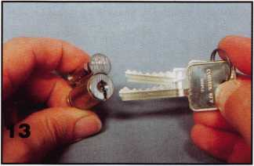

keyed into the same system as other KeyMark cylinders, but the control key will be different.

Two new format I-Cores will be introduced into the

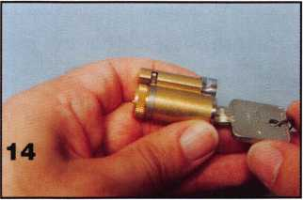

KeyMark product line, in fall of 2001. Shown as prototypes in photograph 16, a Sargent com­patible core is shown at the left and one for Yale housings is at the right. Like the

Corbin/Russwin design, the Sargent I-Core will be physically configured for a Sargent housing,

but it will be keyed in Best A-2 pinning format. The right side

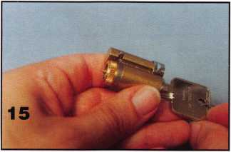

view is shown in photograph 17.

Medeco's high security 31 series I-Core will already fit into a Yale housing. KeyMark will now have an I-Core that will also fit. Photograph 18 shows the extended length control key required to install or remove a core from a Yale housing. The

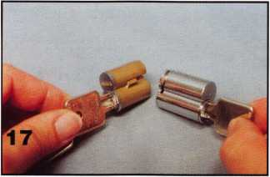

control key draws back the core retainer in photograph 19- Only the Schlage and Yale large for­mat I-Cores will currently require extended length

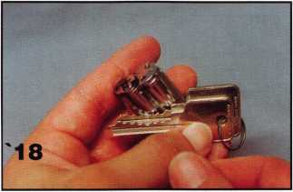

KeyMark key blanks to make control keys.

Medeco Maxum® for KeyMark Although Medeco previ­ously introduced a grade 2 dead­

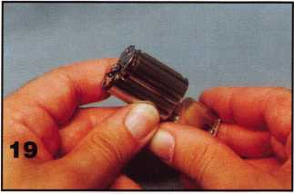

bolt that would accept the  
KeyMark (small format) I-Cores,  
there is now a version of the  
grade 1 Maxum deadbolt that  
can be used with small format I-  
Cores. Photograph 20 shows the  
lock with a KeyMark I-Core part  
way into the housing opening.  
It is now possible to integrate a  
heavy duty deadbolt with the  
KeyMark key system.

The KeyMark family of  
products is by no means yet  
completed. As time passes and

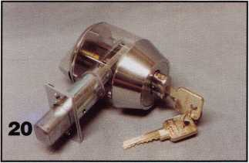

demand requires it, cylinders of other formats will ultimately be available with the KeyMark key- ways. For more information about KeyMark or other Medeco products, call: 800/839-3157. Find Medeco on the web at: [www.medeco.com](http://www.medeco.com)

***July 2001***

Keynotes

47

By

Greg Perry, CML, CPS

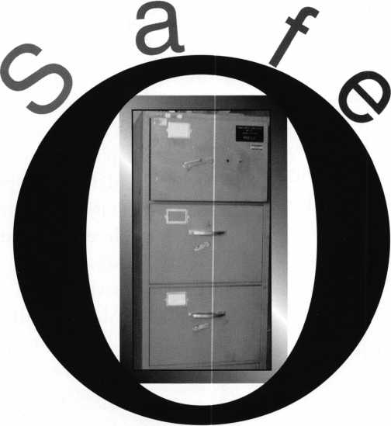

This article is self-titled by a couple of friends, two government locksmiths who started opening this Diebold Class 2 four-drawer file cabinet. It chroni­cles their attempt at opening, what went wrong and as a bonus we disassembled the door for show and tell. Two days after starting to open this beast they called me for advise. Instead I set up a time to meet my friends to help finish the opening. The call came in to them regarding a file cabinet safe that needed to be opened so the department responsible for it could send it off to salvage. It seems the user assigned this safe retired five years ago and the department found his safe in the basement locked up and no record of the combination. But before any safe can be sent to salvage it must be open in case some classified materials are still inside. The goal is to open the safe with no regard to repair, simply get

*KeynotesJuly/August 2001*

PENING

it open as quickly and cheaply as possible. Most of  
the time they achieve this goal. This time Murphy  
reared his ugly head, a few mistakes or wrong choic-  
es and neither goal was met. I don't want to down-  
grade these guys. They open a lot of government  
containers mostly with Mas-Hamilton locks, either

X-07's or X-08's. But both locksmiths started in the  
business after the change from mechanical safe locks  
so they have little prior experience to draw from.  
First "mistake" was their choice of drill point. They  
chose to drill for the lever screw in case something  
was wrong with the lock. Although this is a valid  
drill point and quite useful at times, it's not my first  
choice. Drilling the lever screw is more destructive  
to the lock and requires more accuracy. If you drift  
a little or you don't maintain a perfect straight in  
hole to the lock it can frustrate your opening. The  
hole was good but not a trophy shot. Second "mis-  
take" was using 3/8" bits. Drilling with a 3/8" bit  
instead of a i" bit means you are removing 2.25 times  
as much material. That extra material translates into  
additional time and effort to put a hole into the con-  
tainer. Drilling they ran into some HARD! hard-  
plate. Although I wasn't there for the drilling they  
claimed it ate Strong-Arm carbide bits. Eventually  
they drilled it with Strong-Arm diamond core drills.

I think if they had dropped down to **1**" bits the drilling would have been a lot easier. If they truly needed a 3/8" hole a better plan is to drill using **1**" or even 3/16" bits to start the hole and then enlarge it to 3/8". The only reason I saw on this job to use 3/8" was to remove the ball bearings they encountered in the second layer of hardplate. Once they removed the bearings they went back to diamond core drilling the next 2 layers of hardplate. In total they drilled through the outer 1/8" skin then 1" of easy insulation before they hit **i"** of hardplate, more insulation then the layer of ball bearings.

The bearings were removed one at a time with a magnet until the hole no longer had any bearings in the way. Next they found two more **i"** layers of hardplate before finally entering the lock mount­ing plate and into the lock. It took them 6 diamond core drills and a bunch of carbide bits to get the hole into the safe.

They switched to a **i"** high speed steel bit and drilled the lever screw, but they couldn't retract the bolt. This is when they called me and asked if I had

any ideas. I suggested they try

drilling the hole to 3/8" in case they left some of the screw then try again to retract the bolt. Still no luck, my turn, I arrived late

on a Friday afternoon to take a quick look at the damage. Looking in the hole with a bore scope I could see the back cover pushed out about 3/16" and the head of the lever screw stuck between the body and the cover. Oh no, is the relock fired? This lock appears to be one of the orig­inal MP locks from S&G with gear teeth all around the outside of the wheels and a different relock then is currently pro­duced. Instead of a single lever that blocks the bolt path they used a spring loaded pin and the lever holds the pin out of the way. I found out later that I was right on the type of relock, but wrong on the type of lock. Because of the design I could not see if the relock had fired, at this point it was only a guess. I posted a request on Clearstar (the Internet site) over the weekend regarding the best method to overcome the relock still thinking this was the problem. Most suggested drilling for it, one suggested drilling and punching the handle cam. In all cases though everyone said drill. Monday morning I took another look through the hole. Something was bugging me about the relock. This time I had a sample lock with me. Finally it hit me, the screws hold­ing the back to lock body were still there, since the relock lever

is on the other side of the screws the relock had not fired. The question still remained as to why the bolt would not retract. The reason had to do with the back being pushed away. As they drilled the lever screw they put a lot pressure on the bolt and bent or jammed it into the bolt track. I pulled the bolt back into posi­tion with a hook and started pry­ing the bolt to the unlocked posi­tion. It took quite a bit of force but I finally started moving the bolt. Once I could no longer pry it over I used an awl or ice pick tool to tap into the brass bolt and continue to pry it over to the open position. Once the safe was open the real fun began. Since this safe was destined for salvage we decided to disassemble it to see what makes it tick. First we removed the lock to find a couple of brass stars used to confuse a x- ray picture for the actual gates of the wheel pack. Next we removed the bolts and cam assembly. After using a grinder to remove the welds we pried the inner layer of sheet metal out exposing a layer of insulation. Next we dug out the insulation exposing two of the three-i" lay­ers of hardplate. Removing these exposed the ball bearings, the tray they sit in and more insula­tion. A little more grinding and we removed this tray exposing

***Julv/Auaust 2001***

***Keynotes***

more insulation to be dug out and finally the outer layer of hardplate. This plate is the size of the draw­er front and is attached to the outer door skin with some tabs, there is also another layer of insulation between them. At last we are done with the disas­sembly.

This opening was fun for me. I didn't have to do any of the hard work drilling or sweating instead I just got to do the thinking, a little prying, and some writing. Even though I disagreed with the hole placement, it was a one hole opening, and you can't disagree with that. Laurel and Hardy won this opening with a little help from a friend. Next time they'll stick with a scope hole and 1" bits.

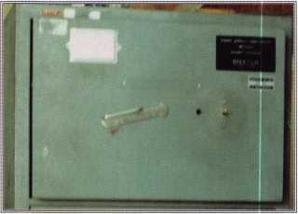

Our victim A-4 drawer diebold class 2 file cabinet MFG. about 1962

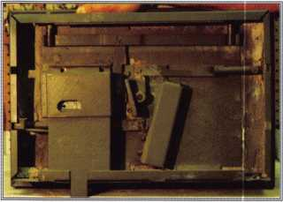

Inside view fully assembled.

-***Keynotes*** *July/August* ***pnm***

Inside view lock exposed

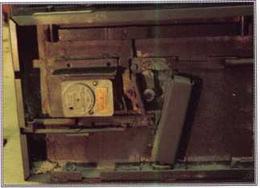

This shows how bent the back cover is

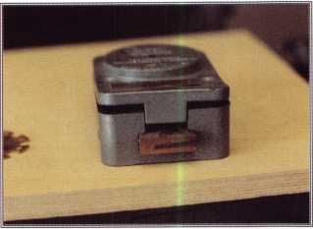

If you look in the hole, you can see the dim­ples from the awl used to pry the bolt over.

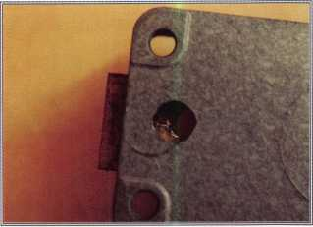

Four different vintages of the S&G 8400 style lock. MFG dates from the left are: 7-56, 9-63, 8-67 and 6-81. The left two have the old style pin relock. The right two have the new style lever relock. The right three have small gear teeth around the wheels to help prevent manipula­tion. The right one has smooth wheels.

Two views of the old style pin relock.

1

2

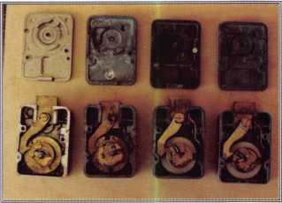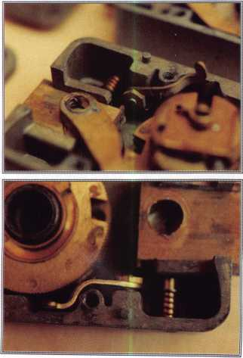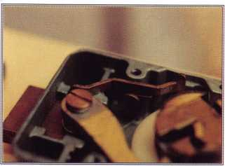

A closeup of the new style lever relock.

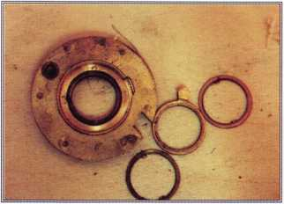

Old style wheel.

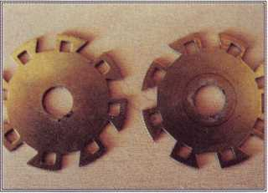

Photo's of the Star wheels to confuse an X-ray picture of the actual wheel gates

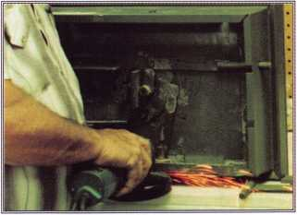

We're grinding the welds to disassemble the drawer front.

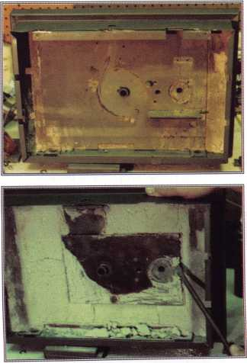

Welds are cut and all the bolt work is removed.

The inner pan is removed and we are prying out two layers of 1/4" hard plate.

With the two inner lay­ers of hard plate removed, we expose the tray containing the ball bearings.

Two layers of poured insulation each about 1ml. thick on either side of the outer hard plate.

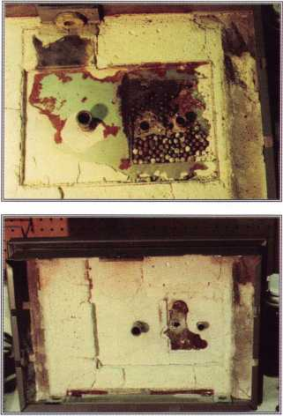

The large plate on the  
right is the outer most  
hard plate. Total hard  
plate count is three  
plus one layer of ball  
bearings.

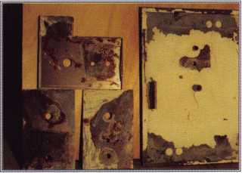

To be fair to  
Strongarm, I decided  
to test drill some of  
the removed hard  
plate. I drilled at 2200  
RPMs with 3/16", 1/4"  
and 3/8" bits. The  
3/16" made it almost  
all the way. The 1/4"  
drilled 2 holes, and  
the 3/8" drilled 1 hole.  
All four holes were  
drilled in under 5 min-  
utes total including bit  
changes and photos.

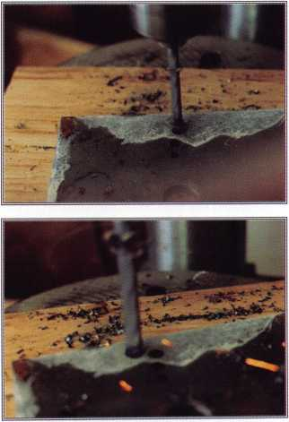

Close up of the used Strongarm bits. Only the 3/16" lost its tip.

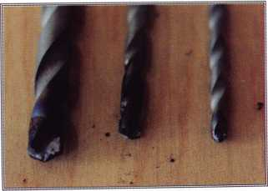

*July/August 2001*

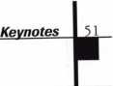

By C.D. Lipscomb, CML, CPS

I

n the early seventies, I worked  
as a self-employed carpenter-

contractor. After suffering a crip-  
pling injury in a fall, I took a  
teaching job at Navarro College,  
in Corsicana, Texas. Eventually,  
because of my construction skills,  
I found myself as assistant to the  
Director of Maintenance. One of  
our biggest problems then was  
doors and locks. No one can tear  
up a door or lock like a college  
kid. Prior to that time, this  
small Junior College had relied  
on one of the Sargent lock distrib-  
utors in Waco for masterkeying  
service and highly technical lock  
service. Then, everything else  
related to locks, was done by col-

PERIENCE

OF AN

**Institutional Locksmith**

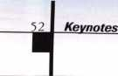

*July/August 2001*

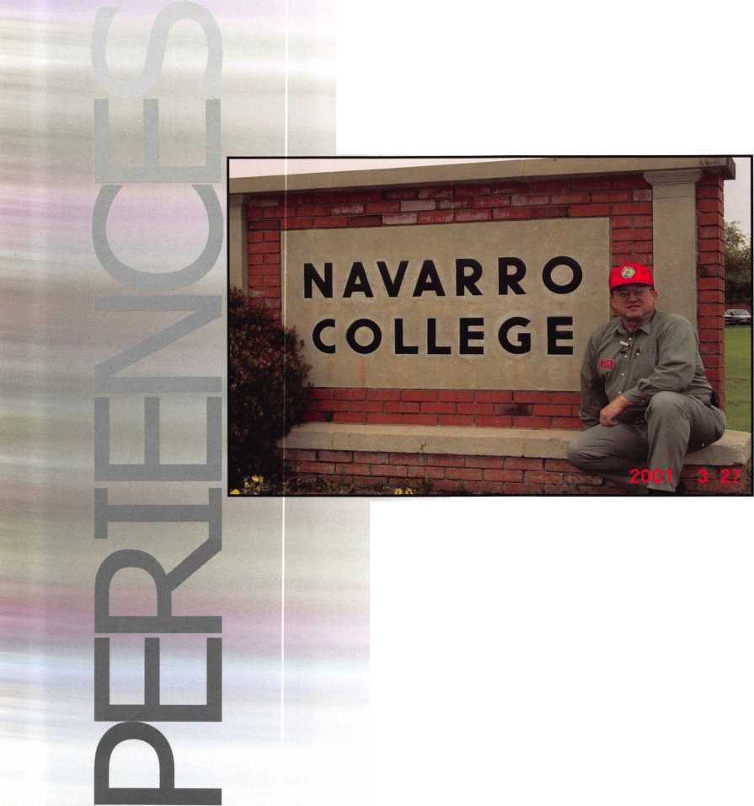

lege maintenance personnel who were definitely not locksmiths. Repairs to grade one Sargent locks were often done by replac­ing them with Weisers or Kwicksets bought and keyed up at the local lumberyard. I was told by my superiors that the old locksmith in town, a crusty natured, seventy something year old gentleman of 40 years experi­ence, was "too blind" to pin up the "sophisticated and delicate" masterkey system that the col­lege had. Then, I took my boss's word for that. Today, I suspect that the real problem was that he was too high priced, or too crusty, too independent, or too something else. I have come to find out since then, that he was a true master of the locksmith trade. Anyway, due to my car­pentry background I was assigned as the resident door and lock person. This suited me fine. I had learned door service and repair as a carpenter, from an expert. With all the confidence of youth, I figured that if anyone else could build a lock, I could learn to work on it. Looking back on it now, if I had known then, just how much there was to learn, I don't know if I would have done it. But, I did.

I

wasn't content to simply take  
old locks off and buy new ones.

It seemed too wasteful to me. I  
coerced the guy at the lumber-  
yard to get the Weiser Rep to

come by and teach me how to pick and pin Weisers, and Kwicksets. I got the college to spring for a Zipf pinning kit and a few tools that I bought through the lumberyard. By taking them apart enough times, I learned to repair the Sargent mortise and knob locks. Then, I learned that I needed to learn to more about masterkeying Sargent locks. I called up the distributor that we regularly bought locks from, and told him that to continue selling us locks, he was going to teach me about masterkeying them. Reluctantly, he did. I have long since forgotten his name, but to this day, he is the only person I have ever met that described himself as a "Lock Engineer". From what I learned from him, I was able to make fundamental key changes and repairs to the system.

T

he college owned several  
buildings that were off cam-

pus. Two of them were old  
motels that the college bought to  
use for student housing. My first  
test of my new found masterkey-  
ing skills came when I re-keyed  
one of the complexes. The first  
time around, I did it as what I  
now know to be the "Shoe box "  
method of masterkeying. I just  
took a bunch of keys and picked  
one out to be the master and  
keyed up those 40 apartments.  
Needless to say, soon after, the  
fecal matter hit the wind driven

appliance. "Interchange" was the operative word here. I had people going where they should not and other people awfully mad about it. So, I re-did the entire job. I figured out the system perfectly, I thought. This time, it was bet­ter, but I still had a few inter­changes, and predictably, a few irate students. The bad part was that I had built the system so that I could not fix it. The third time, I enlisted the help of my sister, an IBM programmer to help build a program that would avoid the interchanges. Neither of us had a clue, but I told her what I wanted the program to do, and she built one that did it. This time, everything worked as it should. The system that I put in then lasted until I installed a new one many years later while working as an independent lock­smith shop owner. The point is that I learned an important les­son early on about the impor­tance of what a locksmith does, and the responsibilities of an institutional locksmith, and I was fortunate enough to have nothing tragic happen because of my ignorance. Later, I took classes at the associations and learned the correct and easy way to do what was so painfully hard to do then.

T

here were many rewarding  
and interesting experiences

that happened to me while work-  
ing as an institutional locksmith.

***Jutv/August 2001***

***Keynotes***

One of which was my first foray into forensic locksmithing, so to speak. I once had a work order to go and fix a certain teacher's lock. I found the mortise cylinder retaining screw to be loose. I tightened it back up and while I was in that department, went around and checked all of the other locks there to see if they were loose, also. I found an unusual number of teacher's offices, plus the outer door, all had the cylinder screws loose. In nearly every case, the cylinder was screwed in tight, so that there was no problem when nor­mally using one's key. However but the cylinder could be unscrewed, and the lock opened with one's finger, or a screwdriv­er. Still not really suspecting anything, I tightened up all the locks in the department. As I left there, I walked past the entry door to another department. As I passed the door lock, I noticed that the mortise cylinder was just a tiny bit turned. Trying my master key, I found that it worked the lock fine, but if I tried, I could remove the cylin­der. This was just too much of a coincidence to be just poor main­tenance. When I checked the locks in this department, again, the outer and teacher's doors were all tampered with to allow easy entry by anyone who knew to unscrew the cylinder. This started me off on a campus wide search where I found like prob­lems in nearly every important

department office in the whole school. This lead, ultimately, to the exposure and dismissal of a gang of foreign students who were stealing test answers and selling them to other students. They had the most sophisticated criminal ring going that I had ever seen. Unfortunately, they had taught others how to do the same thing and I fought this problem off and on the rest of the time I worked at the college. Even putting tamper-resistant screws, or insisting on locked file cabinets did not seem to com­pletely stop them from gaining entry. It seems that some really smart people go to college. Imagine that.

F

rom the burglary ring inci-

dent, and other things that  
happened, I learned the value of  
preventative maintenance. I  
started on a program of examin-  
ing, cleaning, and tightening up  
the screws in the door hinges and  
locks, area by area, throughout  
the college. I found that doing  
so cut down on the number of  
service requests dramatically  
from those areas. It took a long  
time to go through all the locks  
in the college buildings, while  
handling all the normal day to  
day lock requests, but I found  
that it was well worth it. While  
I did this, I made it a practice to  
check the keys of the office hold-  
er that I was working for, and  
hand them a new accurately  
duplicated key made on an origi-

nal Sargent nickel-silver blank when I found a hardware store duplicate. Again, this was a lot of trouble, but paid off in reduced complaints and service requests. Locks do not seem nearly as "worn out" when they are operated with a good key and have new pins in them.

T

he most interesting events  
involved lockouts. While

there were auto lockouts there to  
be sure, in the early and mid sev-  
enties, the cars all had lazy pawls  
and were a snap to open with a  
Slim Jim. The interesting lock-  
outs that I refer to involved peo-  
ple locked out of, or into a room.  
Super glue was a relatively new  
thing then and certain male stu-  
dents thought that catching  
someone out of their room and  
superglueing the lock was great  
fun. Usually, I drilled the lock  
out as being the most time and  
cost effective way to remedy the  
problem. Then, I would have  
given anything for a "Mule Tool"  
to open the doors from the  
inside. I have crawled through a  
many a window to try to save a  
lock. If I could get the lock off, I  
could clean it up with acetone, or  
MEK solvents. We actually  
caught one guy who was gluing  
up locks. Seems that he felt the  
call of nature immediately after  
doing the deed, and wound up  
with his hand glued to an impor-  
tant part of his male anatomy.  
Today, I don't remember exactly  
how the college punished him,

>4 I ***Keynotes***

***July/August 2001***

but I feel that he had already suf­fered quite a bit by the time that they got around to him.

O

ther lockouts, involved the cylinder retaining screw

falling down into the lock and blocking the mechanism so that the closed door would not open. In this condition, it could not even be pried open without major damage to the door and jamb. This happened several times. Once, a classroom full of students was trapped inside at the changing of classes, with the next class waiting outside. The pressure and distraction was ter­rible. As I remember, I had to twist the mortise cylinder out and feed a wire inside to dislodge the screw to free the door. It was a turbulent effort.

T

hese are just a few of the  
experiences that marked

that period in my life. It was a  
wonderful time of learning that  
has brought me to where I am  
today. It was where I first fell in  
love with locksmithing.  
Although I later went back to  
contracting, I never quit or gave  
up locksmithing. I incorporated  
it into my construction business.  
It has remained as rewarding and  
interesting today as it was then.  
My time spent as an Institutional

locksmith included some of the best times of my life. I will always treasure it.

MasterLink Security Products

ROGER ALEXANDER-TUTTLE  
“...understanding the needs of locksmiths...”

Mortise/Rim/Knob Cylinders • Storefront Door Hardware  
Cabinet Locks • Chain • Key Blanks • Padlocks • Pins ...and more

Local: (954) 730.9669 • Toll Free: (877) 347.9669

Fax: (954) 486.0575

e-mail: [masterlink@mindspring.com](mailto:masterlink@mindspring.com)

3863 NW 19th Street, Lauderdale Lakes, FL 33311

It's True

Marray has developed the first  
screwless door loop.

Aluminum ma­terial means true anodizing.

No off color powder coat­ing or painting

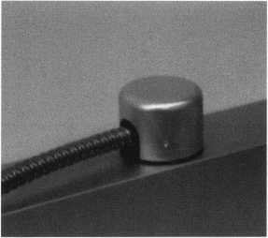

Standard 18” length. Can be ordered in cus­tom lengths

Plastic base stops shorts and pro­tects wires

Screwless base and cap means you drill two 1/2 inch diameter holes, pop the base into the hole, wire your system and snap on your covers. Simple as 1,2, 3.

**Here’s the best part We are giving away a**

FREE SAMPLE TO THE FIRST lOO CALLERS WHO MEN-  
TION THIS ADD. A $14.40 WHOLESALE PRICE VALUE.

CALL TODAY, IT’S FREE!!

1-800-500-1449

Marray *enterprises, inc.*

At Marray, we’re not just modifiers, we’re Master Hardware Modifiers™  
1128 Walsh Ave., Santa Clara, CA 95050. [www.marray.com](http://www.marray.com)

I wish you well.

Inl*y/Auaust 2001*

*Keynotes*

*The B is for Better*

|  |  |
| --- | --- |
| Cut | Root Depth |
| 0 | .2845" |
| 1 | .269" |
| 2 | .253.5" |
| 3 | .238" |
| 4 | .2225" |
| 5 | .207" |
| 6 | .1915" |
| 7 | .176" |

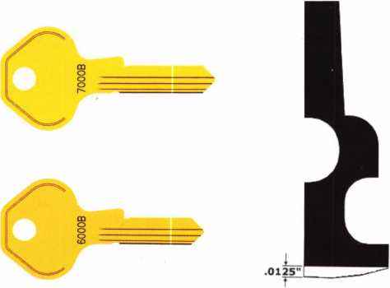

Master Lock Co. is making some changes to its ProSeries(r) line.

For as long as there has been a ProSeries(r) there has been a problem with the depth of cut for the locksmith. Locksmith key machines use the back of the blade as the reference point for cut­ting the key. It doesn't matter if the key being cut is a duplicate or being cut by code, the back of the blade is the locksmith ref­erence.

*A NEW key!*

Master Lock, on the other hand, has always used a register groove as the reference when bitting keys in the factory. The use of a register groove for measuring depths of cut means that unless you have an optical comparitor you can't really tell if you are cor­rect or not. We have solved that problem for you with a new key for a new design cylinder. Via some precision engineering we have designed the new key with a rounded back that will be a direct replacement for the current ProSeries(r) keys.

The current ProSerieslr) keys are positioned in the lock via the reg­ister groove. The new key will be positioned in the lock by the back of the blade making contact with the shell. The new key is also designed to ensure that it will never be positioned in the lock by the register groove. To be implemented as a running change in the product line, you should start to see the new keys in prod­ucts around August/September, 2001.

*What is the effect?*

Besides the better accuracy in cutting code keys, there is one *J*

effect to watch out for when duplicating keys. By rounding the J back of the blade we are effectively adding material to the key.

July/Aug*ust 200* /

***Keynntfen***



This added material means that you should use a rounded back key when duplicating one with a round back. If you don't, the depths on the duplicate will be around .012" shallower than they should be. If your original key doesn't have a rounded back and you duplicate it onto a round back key; the duplicate will be about the same .012" too deep and won't operate the lock.

Older non-round backed keys will operate a new cylinder design and the new round back keys will operate in the older cylinder design, the only incompatibility will be at the duplicator. Existing key codes will not be affected by this change. Existing pinning kits may be used to combinate cylinders with the new keys. Older keys will operate new cylinders, new keys will operate old cylinders. Naturally cut spacing does not change. Master Lock will be elimi­nating the non-round back key as supplies are used up, however llco and others do have a non-round back blank available.

Yes, there are new depth specifications for the new key. The toler­ance allowed with the new depths is *±.001That* tolerance range has become critical because of other changes in the cylinder con­struction that result in an overall increase in pick resistance and resist­ance to key manipulation.

*What to look for!*

Spotting the new keys has been made an easy process. There are three positive indicators. First, the blank number stamped on the head will have a suffix of 'B'. Second, there is a notch in the back of the blade that hasn't been there before, the notch is a stopping point for the rounding process. Third, the round back of the blade itself.

On the cylinder there is a noticeable difference as well. The cylinder will have an 'E' clip on the back to retain the plug in the shell versus the crimping of the shell that has been used in the past.

*Things that you can't see.*

At least not until you take a new cylinder apart. The fit of the shell to the plug has been tightened as well as the tolerance range for the shell is more demanding now. Once inside the cylinder you will find that spool pins are standard now in all pin chambers except 1. The shape of the pin has changed as well, the domelike chamfer on older pins has been traded in for a flat ended pin with a small chamfer only on the edge. There is also a new traditional driver with the same new end.

The number 291 pin kit is being upgraded to include the three new parts used in this new cylinder design. Individual packages of parts are also available using the following part numbers;

0296-0324 E-clip (package of 12 ea.)

0296-0323 New Regular Top Pin (package of 200 ea.) 0296-0322 New Spool Top Pin (package of 200 ea.)

INTERCHANGEABLE CORE PRODUCTS

Interchangeable

with:

•BEST • ARROW •FALCON /

Quality • Price  
Delivery

CONTROL

Q.2

•cn

*p

**SECURITY**

KILLEEN SECURITY  
PRODUCTS

That's what KSP is all about!

***33 Hermon St.***

Ask your wholesaler about  
our drop shipping•



**Worcester, *MA 01610  
Phone (508) 798-3200  
Fax (508) 753-2183***

**Safes In Stock...  
Ready to Ship**

**amsec FireKing  
Gardall HAYMAN**

**MEILINK** y/CTOR

MOR^PROFIT^RE^FREIGHT

pURmol

WHOLESALE SERVICE I

**800-848-9790**

***Our business is helping you sell more safes!***

July 2001

Keynotes

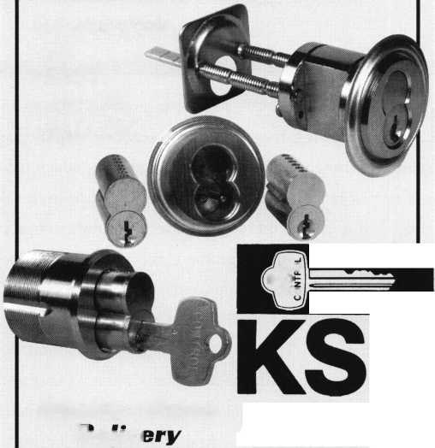

STATE OF THE ASSOCIATION

by John J. Greenan, CML, CPS

T

his last year for ALOA was one of growth. The associa-  
tion is growing its membership, services, visibility and

strength. Our membership grew 12% last year, which led to  
one of our largest Conventions ever last year with over 4500  
attendees. But growth means more than the number of people  
you have. In an effort to promote the profession of lock-  
smithing, the ALOA Board approved a program for open affil-  
iation between itself and existing state, regional and local lock-  
smith associations. To date, 20 locksmith associations have  
joined the Association Affiliate Program: California Locksmith  
Assn; Central & Southern Colorado Locksmith Assn.; Central  
Florida Locksmith Assn.; Central Pennsylvania Locksmith  
Assn.; East Tennessee Locksmiths' Assn.; Gateway  
Locksmithing Assn.; Great Plains Locksmith Assn.; Greater  
Dallas Locksmith Assn.; Greater Houston Locksmiths' Assn.;  
Greater Philadelphia Locksmith Assn.; Institutional  
Locksmith's Association; Middle Tennessee Locksmith Assn.;  
Missouri-Kansas Locksmith Assn.; National Locksmith Assn,  
of Canada; Nevada Professional Locksmith Assn; Pacific  
Locksmith Assn; Rocky Mountain Locksmith Association;  
Tennessee Organization Of Locksmiths; and the Texas  
Locksmiths' Assn.

The association's services grew as well. ALOA's Education Department offered more classes at conventions, more ALOA Continuing Education (ACE) classes and more PRP sittings than ever before. There will be 15% more classes at the Baltimore Convention than last year with 75 full-day classes, 38 half-day classes and 6 evening seminars. Since last years convention, ACE class programs were conducted at the Greater Philadelphia Locksmiths Association Convention, Southeast Regional Locksmiths Association Convention, Yankee Security Convention, Texas Locksmiths Association Convention, Master Locksmiths Association of New Jersey Convention, Safetech, New Mexico Locksmiths Association Convention as well as weekend classes in Wyoming, North Dakota, Alabama, Arizona, Missouri, Georgia, and Seoul, South Korea. We have - 35 scheduled PRP sittings this year - practically one a week!

Keynotes***July/August 2001***

The PRP is currently being updated to reflect new technology and procedures. The PRP is also being evaluated by an inde­pendent testing facility. ALOA's Award-winning Keynotes magazine grew its scope of informative news by offering more articles in selected categories including access control, auto­motive, traditional locksmithing, institutional locksmithing and safes.

ALOA's visibility grew with Board members visiting more locksmith association meetings and conventions than ever before. Our strength grew especially in ALOA's legislative efforts this year. We influenced 15 bills in 12 states that had a direct impact on our members and all locksmiths. Over 12,000 letter, faxes and e-mails went out to locksmiths alert­ing them of legislation impacting their businesses. ALOA was responsible for keeping legislation in Connecticut, Illinois, Mississippi and Oregon from harming our industry, and worked closely with South Carolina, North Carolina and Texas for positive locksmith legislation. We also introduced a web- based government affairs service that provides up-to-date information about key issues, gives quick and easy access to state and local officials, and enables locksmiths to contact leg­islators by customized or personalized e-mails, faxes or stan­dard letters. The Legislative Action Network, the local grass­roots lobbying arm of ALOA, grew to an impressive 415 mem­bers in 44 states and eight countries. Our strength in the buy­ing power of our members is also impressive. The total annu­al estimated gross sales of ALOA's membership is $1,024,943,000. The total annual estimated retail hardware sales of ALOA's membership is $681,359,000 More impor­tantly, this translates to $408,815,400 in wholesale buying power of ALOA's combined membership, based on an indus­try average of 40% off the retail-selling price.

The association is in one of the most expanding periods in our history. The momentum generated this past year puts us in an excellent position to address and influence the issues and demands that will take place in the security industry in the 21st century. ALOA's success is proof positive why associa­tions are necessary.

ASSOCIATED LOCKSMITHS OF AMERICA, INC.

(A NONPROFIT ORGANIZATION)

port

The Associated Locksmiths of America, Inc. engaged the firm of Sutton Frost Cary LLP to conduct the annual audit of the association's financial records for 2000. The audit was completed and a report made to the Board of Directors on March 6, 2001. Part of this report, The Statements of Financial Position (Balance Sheet) and Activities (Profit and Loss) are included with this report to the membership. The auditing firm was of the opinion that the financial records fairly and accurately portrayed the association's financial activities.

The purpose of the Associated Locksmiths of America is not to make a profit; rather the purpose is to provide education and other services to the locksmithing industry. However, these services cannot be properly providing without a sound financial base. In the mid-nineties the association experienced several bad financial years. In 1999 ALOA made a profit (before depreciation). In 2000 ALOA again made a profit. This makes the first time in many years that there have been two profitable years in a row.

It is too early to tell how 2001 will end. The two major components of income, dues and convention are at, or near, budget so far. With attention to con­trolling expenses, ALOA should have another good year.

ALOA remains financially capable of providing the services expected by the membership.

STATEMENTS OF CASH FLOWS

Years Ended December 31, 2000 and 1999

**Financial**

r e

|  |  |  |
| --- | --- | --- |
|  | 2000 | 1222 |
| Cash flows from operating activities: | | |
| Change in net assets | $121,203 | $(29,172) |
| Adjustments to reconcile change in net assets to net cash provided (used) by operating activities: | | |
| Depreciation | 40,956 | 42,108 |
| Changes in assets and liabilities: | | |
| Certificates of deposit | (3,101) | (2,721) |
| Accounts receivable | (257,730) | (34,464) |
| Inventory | 2,480 | 1,947 |
| Prepaid expenses | 14,147 | 8, 084 |
| Accounts payable | (29,468) | (30,368) |
| Accrued expenses | 7,434 | 5,212 |
| Prepaid dues and exhibit fees | 254,559 | 11.014 |
| Net cash provided (used) by operating activites | 145.520 | (28.360) |
| Cash flows from investing activities: | | |
| Repayment of loans made to affiliate | 49,652 | 38,356 |
| Capital expenditures | (33.197) | (25.434) |
| Net cash provided by investing activities | 16.455 | 12.922 |
| Cash flows from financing activities: | | |
| Payments on long-term debt | (9.798) | (9..373) |
| Payments on capital lease obligation | ( 3,418) |  |
| Net cash used by financing activities | (13,216) | (9.373) |
| Net increase (decrease) in cash | 148,759 | (24,811) |
| Cash at beginning of year | 226.267 | 251.078 |
| Cash at end of year | $375,026 | $226,267 |
| Supplemental disclosures of cash flow information - | | |
| Cash paid during the year for interest | $4,399 | $2,972 |

Noncash financing activities -

during the year ended December 31, 2000, the Organization purchased equipment amounting to $10,181 by entering into a capital lease agreement.

***Keynotes***

***Julv/Auaust 2001***

ASSETS

Current assets:

Cash

Certificate of deposit Accounts receivable Inventory Prepaid expenses

Current portion of note receivable from affiliate Total current assets

Property and equipment  
Land

Building and improvements Furniture and equipment

Less accumulated deprecition Property and equipment, net

Note receivable from affiliate, less current portion

Current liabilities:

Accounts payable Accrued expenses

Current maturities of long-term debt Current maturities of capital lease obligation Prepaid dues Prepaid exhibit fees Total current liabilities

LIABILITIES AND NET ASSETS

Long-term debt, less current maturities Capital lease obligation, less current maturities Total long-term liabilities

Total liabilites

Net assets - unrestricted

Revenues:

Membership dues and services

Convention

Management fee

Advertising

Promotional programs

Intrest

Educational programs Miscellaneous Total revenues

Expenses:

Administrative Convention Keynotes magazine Building operations Member services Depreciation Promotional programs Educational programs Committee Total expenses

Increase (decrease) in net assets Net assets at beginning of year Net assets at end of year

2000

$375,026

59,375

302,095

30,118

76,004

25.040

867,658

79,836

302,516

445.810

828,162

(599.202)

228.960

145.080

$1.241.698

$39,264

31,770

10,711

3,455

442,402

459.260

986.862

11,318

3308

14.626

1,001,488

240.210

$1.241.698

$970,158

872,973

110,400

100,141

37,158

41,850

82,817

14.632

2.230.129

1,123,495

467,296

241,883

53,104

32,953

40,956

26,623

120,871

1.745

2.108.926

121,203

119.007

$240.210

im.

$226,267

56,274

44,365

27,638

90,151

444,695

79,836

302,516

402.432

784,784

(558.246)

226.538

219.772

$891.005

$68,732

24,336

10,237

375,005

272.098

750.408

21,590

21.590

771,998

119.007

$891.005

$965,768

678,046

107,400

88,784

35,173

23,145

82,573

5.944

1.986.833

1,024,067

406,011

274,248

48,216

80,112

42,108

21,473

109,776

9.994

2.016.005

(29,172)

148.179

$119.007

*Keynotes*

*July/August 2001*

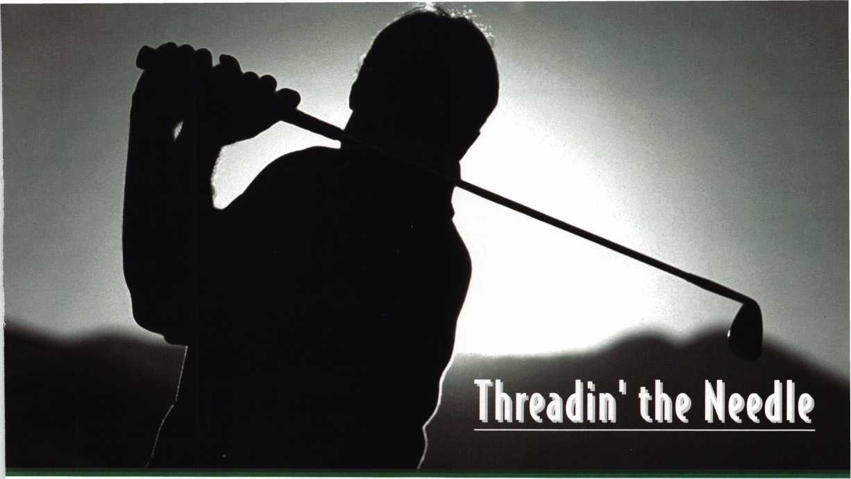

T

he Woodlands Golf  
**Course of Baltimore**

Your $150 registration fee -■ a tax deductible donation to the ALOA Scholarship Foundation -- includes

Support the ALOA Scholarship Foundation while joining in on one of the most thrilling outings of ALOA 2001. The 16th Annual ALOA Open Golf Tournament will be held Wednesday July 18, 2001, during the 2001 ALOA Convention and Security Expo in beautiful Baltimore.

transportation, breakfast, green fees, golf carts, an event golf shirt and hat, and assorted beverages throughout the course for everyone. Each participant is eligible to win one of many incredible prizes, including: golf clubs, equipment and apparel.

BEST OF ALL, you will play the official course of the NFL reigning champions the Baltimore Ravens. (It's amaz­ing how the grounds crew mends all those divots.) Famed Hog Neck designer Lindsay Ervin used the lay of the land to create in The Woodlands a course that is beatiful, challenging and fair at the same time. The whole course is carpeted in bent grass - tees, fairways and greens, and is kept in "tournament" condition year round.

space is limited for this exciting and great cause. Call us today toll free at 800/532-ALOA (2562) to reserve your spot on the first tee.

*Note: The ALOA Open **is made possible through the generous support of our sponsors: Yale Security Group, Inc., Amsec, Lucky Line products, Security Solutions and Stattec Incorporated.**

The ALOA Scholarship Foundation offers several scholarships each year to those wishing either to enter the  
profession, or to advance their skills through education. The scholarship board works year-round to gather  
money to fund the program. ALOA is awarding more and more scholarships each year.

Meet

the ALOA 2001

Scholarships

Winners!

Clifford Hosea

I have had a longstanding desire to enter

* JBm the field of locksmithing. After much  
I thought, I have made the decision to  
J9 enter the locksmithing business. I have  
made a strong decision to obtain the best  
V 4§|^| possible training. I know that training

■PE should come through ALOA. I have a

strong aspiration to one day have my own  
locksmithing business, thereby providing  
my family with the financial stability they deserve. I have no  
doubt whatsoever that the information, education and practi-  
cal experience gained at the ALOA convention will be invalu-  
able to me and my career.

Jacob Kuehn

I have been pursuing locksmithing for the last couple of years, talking to locksmiths in the area, learning some his­tory and a few locks to assemble. I tried to get into an apprenticeship program in school, but locksmithing was not offered. I have learned some fascinating locksmithing tricks from my uncle, who first got me interested in the profession. What I have learned so far is fascinating and I want to learn more. I want to take full advantage of what­ever training I receive. I want to use my training to improve, develop and advance the locksmithing profession. This is an extraordinary field of work.

Steve Goodwin

I received an Associates Degree in  
Business Administration, and started  
my locksmith business in 1995 in south- j  
western Virginia. I worked there until  
November 2000, when fire destroyed  
my home and business. My business  
reopened in December 2000, in a new  
location in Winterville, NC.

I

Casey Amos

I have been working in the locksmith industry for nearly two years, and have taken all the classes and seminars that have been made available to me. I would like to eventual­ly earn my CML and make a career out of locksmithing. I am engaged and planning a future with my fiancee, who is currently in college. I graduated in 1997 and worked else­where prior to coming working as a locksmith. I am just starting and have limited finances; I would appreciate your consideration for any classes I could take.

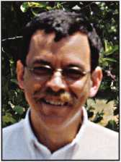

July 2001

*6* 2 j *Keynotes*



Patrick Noling

I chose this trade at this time of my life  
(age 36) because I wanted for my life  
and my old job was not enough. I  
learned in the Army (1981-87) that half  
is not enough. I learned my field from  
top to bottom. If you want to succeed  
and strive to be the best, schooling of all  
different types in your chosen field are  
crucial. Learning is knowledge, and I do

not take this lightly.

I plan to use this knowledge and everything from classes, reading, videos or others to be the best I can be. Someday I want to pass this knowledge onto somebody else who wants to learn this trade.

Nick Wilson

I have been a locksmith for almost two years. What I've learned has been enjoyable and I am always looking forward to learning more. I know that if I am to make a career out of locksmithing I need more knowledge. I have become more proficient, but I still have much more to learn. The major improvement areas I need are in picking, impressioning and servicing automobiles. Another aspect of my job is public speaking, and I speak to different groups (such as AARP and various neighborhood watch programs) about security and the services a locksmith can provide. I hope to get a firm grip on the skills I have already begun to establish. Taking ALOA classes in Baltimore will help be better prepared to take on some of the obstacles that can be encountered in this field.

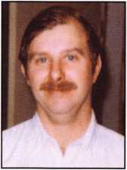

Smith

I'm a husband and father of three girls.  
I take great pride in being a party of  
my family. I volunteer many hours per  
week in a local youth group. This  
enables me to be with my children and  
to help other children in our commu-  
nity. I have my own business, but with  
the onset of financial and health prob-  
lems of one of my children, I have been

forced to change things in my life. For a year now, I have  
helped Bob's Lock Shop on numerous occasions and am  
currently a full-time employee. I find locksmithing very  
interesting and rewarding. I hope by expanding my knowl-  
edge of the trade and by attending classes with hands-on  
experience, I will someday become a master locksmith.

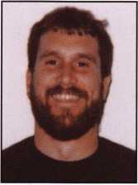

I have been employed as a locksmith for  
the past five years and I feel fortunate to  
have found a career that I enjoy. I'm a  
single mother and I would like to  
expand my knowledge in this field. I  
would like to attend the ALOA conven-  
tion in Baltimore this year.  
Unfortunately, I am unable to afford  
additional classes at this time. That is

why I would like you to consider me for a scholarship. My  
goal is to become a master locksmith. This would make me  
a great asset to my employer, the locksmithing field and it  
would enable me to support my family.

I started my locksmithing career last year  
with my husband in their family-owned  
locksmith business. I want to expand my  
knowledge in the industry by attending  
ALOA classes at the national convention,  
so I can assist my husband in the day-to-  
day operation of the family business. I  
am a member of my local locksmith asso-  
ciation, Florida West Coast Locksmith

Association, a proud affiliate of ALOA. I am also a mother of  
two boys and two stepsons.

Denice Barnhardt

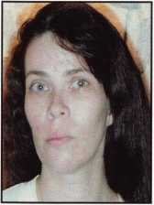

Susan Zipp

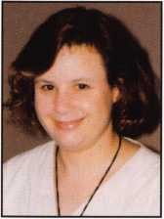

Shimshon Alpert

I enjoy locksmithing very much. I was a locksmith in America and learned a great deal there. I studied hard and earned my CPL. When I moved to Israel, my learning was, unfortunately, greatly slowed. I wish to continue my gen­eral education in locksmithing - both in theory and in practice through the ALOA classes at the upcoming ALOA 2001 Security Expo in Baltimore.

***July 2001***

***Keynotes***



s

c h o I o

r

ship

s

I am an apprentice locksmith in  
Kennett Square, PA. I enjoy working  
with my hands, and have been learn-  
ing the art of locksmithing now for  
about four months and have thorough-  
ly enjoyed it up to this point. I have  
caught on to the basics of lock-  
smithing rather quickly and am eager  
to learn more in its vast fields of study.

The different areas and degrees of difficulty are what inter-  
est me the most, and I wish to enhance my knowledge in  
these fields. By furthering my abilities in the areas of lock-  
smithing, I would be more valuable to the company as an  
employee and to my co-workers as a helpful hand. In the  
future, I wish to help run or possibly even own a lock-  
smithing company; being certified would take me that  
much close to those possibilities.

Brent Becker

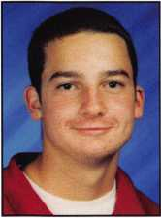

Travis Blanton

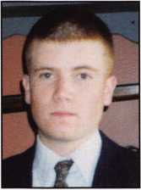

Since I started in locksmithing, every  
day has varied in so many ways. This  
business is very exciting for me, and I  
feel education is a very important part  
of any field and as an apprentice lock-  
smith, I appreciate the opportunity to  
learn from trained professionals. In  
my short time in the industry, I have  
learned to identify obstacles and dig

for the correct solution to finish the job. With your help,  
I would have a defined edge to work myself and for the  
trade in a responsible manner. This will be a great way for  
me to expand my knowledge and serve our customers bet-  
ter.

Jeremy Michael Hall

I am 22 years old and have been working as a locksmith for four and a half years. I was in the work study program as a high school student and worked at a lock shop as part of that program. I was hired full-time upon graduation. I am applying for this scholarship in connection with my developing education. I have been taking classes at a local college for a couple of years now in the electronics field. I just purchased a condominium, and have established a budget for my expenses. All of my finances are currently utilized. I am very interested in taking all the classes that I possibly can so that I can further my career in lock­smithing.

Janice Blalock

I am the owner and operator of AAA Locksmith based of Union County, NC. I provide complete services in auto­motive, residential and light commercial as a mobile lock­smith. I was born in Charlotte, NC, and also lived in Pittsburgh, PA, with my father, James Maxwell Hunter. It was my father who taught me locksmithing and con­tinues to help me from afar every chance he can.

I am the mother of three boys and enjoy spending as much time as possible with them. My business does take a lot of my time since it is a 24-hour service, but we still manage to have fun as a family.

Elizabeth Fernen

I've been training as a locksmith over  
a year now with Richmond Security  
in Richmond, VA. I applied for this  
position because I have grown weary  
of office positions that became  
monotonous and unfulfilling. During  
my first week of locksmith training,  
it became apparent that I had a great  
deal of learning to do. I also realized

that I had found, not only a challenging profession, but  
also a new and refreshing work environment. I have great-  
ly enjoyed my small successes in my training, and I feel I  
have finally found a career that can be both financially  
promising and personally fulfilling. My husband recently  
left the Army, and we are in the "starting over" phase. We  
both have new jobs and we are in the process of moving  
into a permanent place of residence.

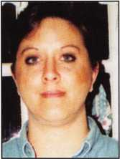

Led Herndon

I enjoy working. I have been driving for North American Van Lines for 21 years and have accumulated 1.8 million miles of safe driving on my record. I love to work with my hands and I love the challenge of any type of repair work.

***July 2001***

***Keynotes***

s c h o

I o

r

ships

Jolene Brown

■ I was employed as a package car  
eight years, four as a preloader. I felt

j, always been of interest to me. I feel I  
can be a very good locksmith. I also  
feel that being female could be an asset to a lot of other  
women who might need these services.

Adam Wilson, RL

I am 25 years old, married and have two young boys. I have been a locksmith for almost four years and have learned much about the industry. I became a locksmith because I wanted to become a part of an industry that I knew and would continue to grow and develop. I see the computer and technology generations devouring so many professions; however, the locksmith industry has remained intact, even flourishing with technology. I hope to attend this year's convention in hopes of fur­thering my education and in addition, feel that it will prepare me better to obtain high PRP levels.

Kennith Moore

It has been over two years since I  
have been able to train as a lock-  
smith. I sincerely regret this because  
I feel all locksmiths should try their  
best to stay as up to date as possible  
on all of the new technology. It  
means a lot to me for anyone to  
entrust their security to me. I feel  
responsible and want them to have

:he best protection available. I don't have the financial  
•esources to attend the ALOA convention this year. I have  
*one in the past have benefited greatly from them.

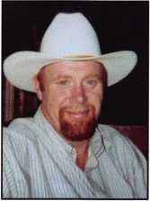

Bob Kupfer

I have been apprenticing since early 1999, and after being a self-employed musician for the past 25 years, this has been a total career change. Although being self employed taught me the importance of integrity, cus­tomer relations and a sense of "good business" in general, my technical knowledge is limited to graduation of the Foley Belsaw course and apprenticing in the shop. I have always believed in the importance of education in any field and would appreciate the opportunity to take some specific courses. I'm looking forward to going to my first convention in Baltimore.

Jamie Fuller

I have been in locksmithing for over two years, and am working foi my father at Coastal Locks in Havelock, NC. I am married and have two children. I am very interested in all aspects of locksmithing and look forward to taking over for my father when he retires. I am proud and honored to have been awarded the ALOA scholarship. See you in Baltimore.

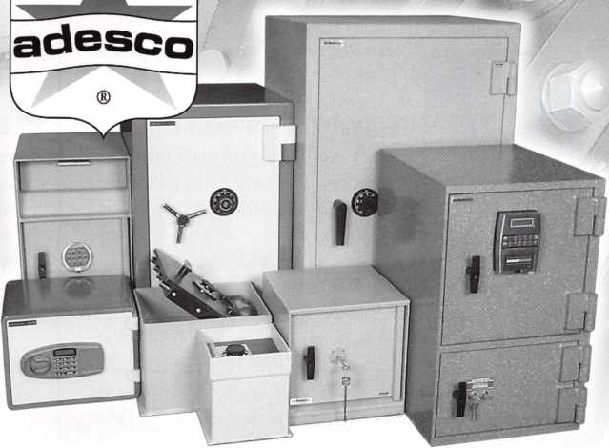

Associated Lock & Supply (800) 668-7161 Fried Bros., Inc. (800) 523-2924 IDN-Acme, Inc. (800) 788-2263 IDN-Hardware Sales, Inc. (800) 521-0955 IDN-H. Hoffman, Inc. (800) 323-1918 IDN-West, Inc. (800) 525-3131 K-D-L Hardware Supply (800) 926-7716 LV Sales, Inc. (800) 894-5397 McDonald Dash Locksmith Supply (800) 238-7541 Southern Lock & Supply (800) 237-2875 Wilco Supply (800) 745-5450 Worldwide Lock Supply, Inc. (800) 729-5444

Or contact adesco for your copy of our  
2001 Dealer Catalog and Retail Price List.  
Call (800) 821-6803 or email [sales@adesco.com](mailto:sales@adesco.com)

©2001 Adesco Safe Manufacturing Co. [www.adesco.com](http://www.adesco.com)

Adesco: At a  
Phone Near You!

***July 2001***

***Keynotes***

Dale Bowman, RL

While still in high school, I worked part-time at Medeco. I became very interested in the manufacturing process and in the mechanics of the products. I enlisted in the U.S. Marine Corps Reserves, keeping my interest and enthusi­asm for the security industry. I have been back at Medeco now for over two years, and have taken several ALOA sponsored classes. I'm working toward a degree in business management. But first, I want to become a CML and to one day start my own locksmith business. The information gained at ALOA will greatly help me in this area and would drive me on to my goal of becoming a locksmith.

Curtis Lee Kramer

I started my own small locksmithing  
business of C&M Locksmithing in  
Minverva, OH, in 1994. It's only a  
part-time business at the present  
time. I work construction full-time.  
My locksmith business has doubled  
each year in the past two years. We do  
automotive, residential and commer-  
cial work and I find it all very chal-

lenging and interesting. We are centrally located in a  
three-county area, with mostly rural and small towns.

I joined the Penn-Ohio Locksmiths Association in 1994  
and I joined ALOA this year. My first experience in the  
industry. This girl locked her keys in her VW Bug at  
church. She asked everybody there if they could open the  
car for her. No one was able to, and then she asked me if I  
could. I tried and I had it open in short order. Well, we  
got married two months later. I didn't know then that I'd  
be doing locksmith work 20 years later. She has gone out  
on several calls herself. We have seven children, and will  
be grandparents in August. All five of my boys are inter-  
ested in learning and they participate in the locksmith  
business.

Anthony Reed

Upon graduating from high school in 1989, I began  
working for a company as an industrial maintenance  
mechanic. I worked up to a supervisor position. After 10  
years I felt there was no further advancement and chal-  
lenge. I began working for Channel's Locksmith Shop in  
August of 1999- Under the direction of Myron Bird,  
CML, I have had a positive experience. I've taken several  
classes and still have worked more steady hours, which  
has given me more time with my family. My goal is to be  
a Certified Master Locksmith, a Certified Master Safe  
Technician and to own my own business.

Mark Hinkle

I enjoy my work and have a desire to expand my skills and knowledge of the profession. I want to help people in all types of situations and truly understand the inner workings of this profession. With expanded awareness and knowledge, I would be prepared to help my company and our customers in a variety of ways. I want to share my gained knowledge with co-workers and with newly-acquired locksmiths at the company. For my personal enhancement, for the company's improvement, and for the opportunity to help others, I would like this scholarship.

Cary McFarland

I have always enjoyed working with my hands ever since watching and helping my father and grandfather doing dif­ferent things. I have worked in a couple of hardware stores, helping people and selling a variety of things like hardware, plumbing and electrical systems. I like to help people fix problems in their homes. When I was asked by my uncle to work as a locksmith, I was excited to do something to help people secure their homes, vehicles and businesses. I have learned quite a bit in my time here, but I want to learn more so I can help on more advanced locksmith jobs.

Joe Genn

I have been in locksmithing 11 years as an institutional locksmith. I started my working career as a carpenter, but due to the slowdown of construction, I went to work in a hospital in the maintenance department. As in many med­ical facilities, the carpenter is also the locksmith. The lock­smith before me took the hospital from a shoebox key con­trol to a working master key system. It has been quite a job maintaining a key control program with 500 employ­ees and over 1000 keys in circulation. The challenge of locksmithing is very rewarding. We are starting to install electronic locksets now. I hope to move the hospital into the 20th century with more electronic access control. I have three sons and have been married 27 years.

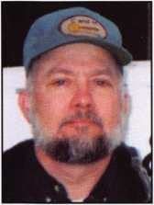

Keynotes

July 200**7**

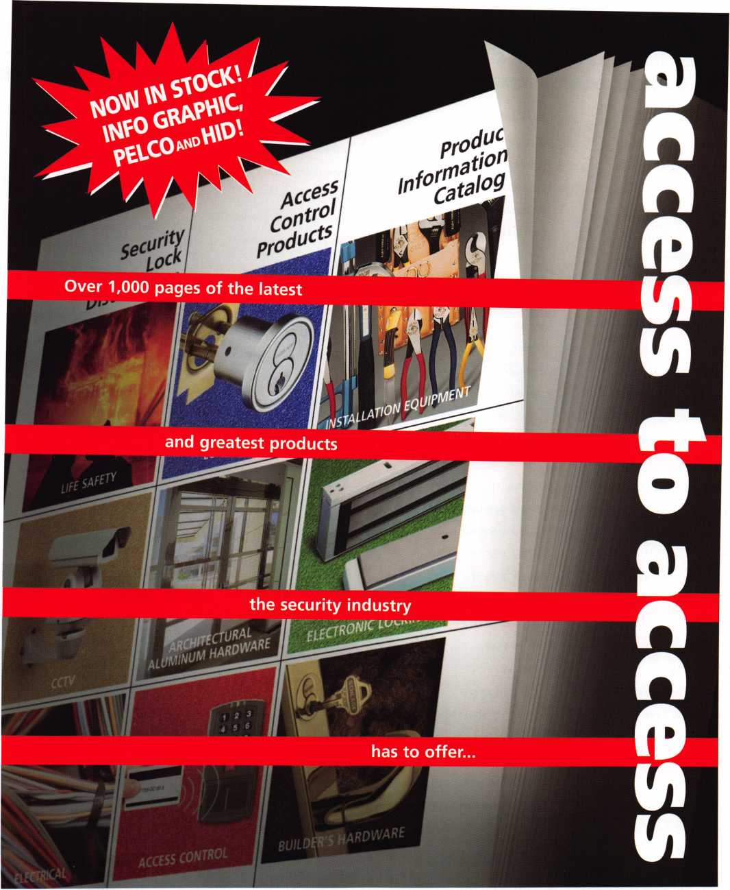

In an extremely easy-to-use format, our latest catalog contains detailed specifications on the best electrical and mechanical products in the industry.

tail 1-800-847-5625, fax; 800-878-6400,

Of

LOCK **distributors**

——



WITNESS THE UNEXPECTED ATTHE BALTIMORE CONVENTION CENTER JULY 15 - 22

A & B Safe Corporation Aable Locksmiths Abloy Door Security Abus Lock Company Access Hardware Supply Accredited Lock Supply Co. Ace Lock & Security Supply Adams Rite Mfg. Company Adesco Safe Mfg. Company ADI, Inc.

Adrian Steel Company Advanced Security Products Alarm Lock Systems, Inc. Alarm Warehouse Alden

Allstate Insurance Company ALOA Booth

American Eagle Lock Co. American Lock Company American Security Products Architectural Control Systems Arrow Lock ASP, Inc.

ASSA Inc.

Avco Key Supply Baton Lock & Hardware Co. Bell's Security Sales Bev Key

Blackhawk Products Burg-Wachter BWD Automotive Alabama Cal-Royal Products Camden Mfg Cansec Systems CCL Security Products Clark Security Products Clear Star Security Network Commercial Van Interiors Compx Security Products

Craftmaster Curtis Industries Defiant Safe Co.

DETEX Corporation

DIDA (Wuxi Yangjian) Locks Co. Ltd.

Don-Jo Manufacturing Inc.

Doorking, Inc.

Dorma Architectural Hardware Dugmore and Duncan, Inc.

Dynalock Corporation Eclipse Ind.

Emergency Road Service, Inc.

Emtek

ESP Lock Products Inc.

Fire King International, Inc.

Fried Brothers Frontier

Gardall Safe Corporation

Guardian Security Products

H.E.S., Inc.

Handi Disc/Bits

Hayman Safe Co.

High Tech Tools

Howard Keys

HPC, Inc.

IDN Corporation

llco Unican/MAS Hamilton

Ingersoll-Rand Company

Innovative Moving Systems, Inc.

Institutional Locksmiths Association

International Association of Investigative Locksmiths

Jackson Corporation

Jet Hardware Mfg.Company

KABA High Security Locks

Keedex Manufacturing

Keri Systems, Inc.

KEY-BAK/West Coast Chain Mfg

KSP

Kustom Key

La Gard Inc.

LAB Security Lockey Corporation Lockmasters, Inc.

Locksmith Ledger International Lucky Line Products, Inc.

M.A.G. Security Major Manufacturing, Inc.

Markar Products Inc.

MARKS, U.S.A.

Maryland Locksmith Association Master Lock Company Maxtech America Inc.

Mayflower Sales Corporation Inc. MBA-USA, Inc.

MCS Communication Systems MDS Incorporated Medeco

Michael J. Walsh & Associates Midwest Wholesale Hardware MIWA Lock USA Monaco Lock

Monarch Tool & Mfg. Corporation

Mul-T-Lock USA, Inc.

National Auto Lock Service

National Locksmith Association of Canada

Nostalgia

Olympus Lock Company Omaha Wholesale Hardware OS I Security Devices PDQ Manufacturing PFH

PLUS Group

PRO-LOK

RA-Lock Company

Rodman & Company

ROFU International Corporation

RSR Group Inc.

Rutherford Controls Inc.

S. Parker Hardware Mfg.

Sargent & Greenleaf, Inc.

SARGENT Manufacturing Company

Schwab Corporation

Secura Key

Secure Industries

SecureRite.com

Securitech Group, Inc.

Securitron Magnalock Corporation Security Distributors Inc.

Security Door Controls Security Lock Distributors Security Resources Inc.

Select Products Limited SentryLok, Inc.

Siedle Communications Somerset Security Products Southern Lock and Supply Company Southwest Specialty Products Speedypik

Stone & Berg Wholesale STRATTEC Security Corporation Strong Arm Security, Inc.

Sun Safes Mfg.

Supra Products, Inc.

Taylor Security & Lock The National Locksmith Turn 10 Wholesale U.S. Lock Corporation Van Lock Company Videx

Visonic Inc.

Wide Perspective Design Wilson Bohannan Company Wilson Safe Company W-Lok Corp

Yale Security Group, Inc.

Zipf Lock Company



z. V u iL

rosemont,illinois

Reflecting tomorrow July **19-28,** 2002

Rosemont Convention Center • Hyatt Resency O'Hare

t

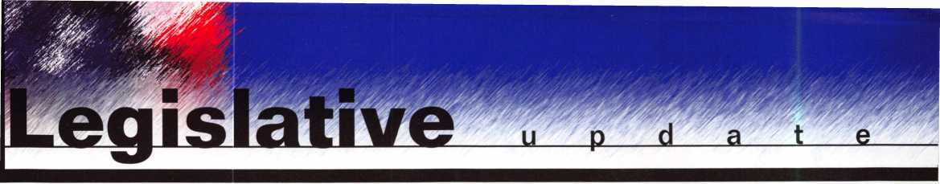

RECORD NUMBER OF ALOA MEMBERS JOIN THE  
LEGISLATIVE ACTION NETWORK

**ARE YOU ONE OF THEM YET**

Over 400 members partake in ALOA's Legislative Action Network (LAN). LAN members are our best resources at the grassroots level for effecting legislative change. They monitor each state legislature for bills affecting the locksmithing profession, including related industries. They organize media contact which helps the public understand our profession. Members speak state legislators; organize letter writing campaigns; and keep everyone informed in state and regional locksmith associations. Members assist the national ALOA office with state fundraising campaigns in situations where our profession is faced with detrimental legislation and a lobbyist is deemed necessary to assure success.

You can join today for as little as $25. Members in bold type gave $100 or more during the 2001 legislative session and are members of the Legislative Action Network Council. To join, simply email Government Affairs Manager, Tim McMullen at [tim@aloa.org](mailto:tim@aloa.org) for a pledge card, or mail in your pledge card from the recent mailing. You can also join at the Legislative Booth during the 2001 ALOA Security Expo in Baltimore, July 19 - 21, 2001.

|  |  |  |  |  |
| --- | --- | --- | --- | --- |
| ALASKA | Gregory L Perry CML, CPS | Irving Isicoff | Donald E Brown | Don E Stowe |
| Christopher B Cooney | Sharon L Roper | Norbert King RL | Charles E Carlson |  |
| Scott L Henke CRL, CPS | Elyse D Rothstein | Ken Kupferman CRL | Richard J Cmich | KENTUCKY |
|  | Charles E Skobrak Sr, RL | Frank A Lampone Jr, CRL | Michael Donigian | James A Brashear Jr |
| ALABAMA | Robert C Slama | David E Matthies | Michael Fallon | Michael H Gambill CRL |
| Dallas C Brooks | David L Stevens | Robert J Morrissette CML, CPS | Keith R Fisher CRL | Donald L Gardner |
| Charles Farkas Jr | Roy W Stinson | Tom W Olson | Gary L Goffinett | Gilbert G Herbig CPL |
| Keith R Lewis CML | Channing W Tucker CPL | Bruce M Ratner | John J Greenan CML, CPS | Thomas B McKinney |
| John P Luhrs CRL | Richard E Vanina | Robert G Reid CRL | Gerry J Griffin |  |
| Paul A Przyborski | Adam Weinraub | Van R Schneider CRL | James E Gruber CRL | LOUISIANA |
| David G Rosengarten |  | William P Smith | Eugene Gyure | Rodney P Blanchard CRL |
| Steve H Sills | COLORADO | Michael J Sullivan | Jim D Hamden CRL | Carl M Braun Jr |
| William C Singleton | Dean I Carpenter | Thomas W Tate | Edward J Henning CPL | Jerry K DeLano CRL |
| James D Turner Jr, CPL | Richard L Dyer CRL | Brad R Volpe | Robert J Henning CPL | John A Morovich |
| C L Wiggins CPL | Thomas R Gonzales |  | Richard A Holliday | Leo E Pahlke Jr |
| Roger G Williams RL | Gordon R Racine CML | GEORGIA | Sylvester Jones Jr, RL | James L Queen CML |
|  | Christopher B Wells CRL | Breck H Camp CML | Carlos U Lopez |  |
| ARKANSAS |  | Larry C Cook CRL | John W Murphy CRL | MASSACHUSETTS |
| George Brumley RL | CONNECTICUT | Michael T Day CPL | Arthur T Pankhurst | Irwin M Alfred |
| George Freeman | Paul D Cirillo | Joe Earley | William H Pulley CRL | George D Condon III |
| Ronnie R Hisaw | Thomas J Demont CML, AHC | Patrick A Filholm CPL | Judson B Saas CPL | Stephen L McKinney |
| Randy L Marler CRL | Robert T Dunsmore CRL | Robert C Gilmer CRL | Frank A Schlesser | John H Perron RL |
| James T Tucker | Robert A Gabris Jr | John T Grist CML | Lee E Schreiber | Daniel J Rackliffe CML |
|  | Lester H Harris | Harold L Hardy CRL | Larry E Smith CPL |  |
| ARIZONA | Phillip H Hobbs CPL | Maurice W Hatfield RL | Joseph W Stevens CML | MARYLAND |
| Robert A Arthur RL | Jack Hobin CPL | Joseph H Peek | Steven A Wade | William V Breazeale CML, CPS |
| John Ilk CRL | Andrew J Karwoski CRL | Michael D Robinson CRL | Michael W Williams | Lester S Brodsky |
| Lester J Frederick | Ward L Kaye |  | Phillip M Witkovsky | Robert D DeWeese CML |
| Anthony M Harris CML | Richard A Labbe | HAWAII | Kathy A Zaniolo CPL | Raymond P Grueninger |
| William Lee | Roger S Wechter CPL | Joaquin P Freitas |  | James W Mullins CPL |
| Nicholas A Monaco CRL | Mark S Wistrand CRL | Herman Salz CPL | INDIANA | Eric Roes CRL |
| Joe Pielech CRL, CPS |  |  | Marvin A Brodfuehrer | Philip A Rovenolt CPL |
|  | DISTRICT OF COLUMBIA | IOWA | John W Emey | Richard C Shellhom CML, CPS |
| CALIFORNIA | Ernest Twyman | Sharon J Bradford | Ralph J Gaw RL | John A Speakes |
| Timothy Braun |  | Philip J Heath | Lucian L Hayden | Michael E Stang CML |
| Donald L Brown CML | FLORIDA | Kenneth R Novey CRL | Cynthia M Scheuer | Walter N Ussery |
| Paul F Chandler CRL | Philip T Alber CML | Marlin R Pearson CPL | David P Snyder Sr |  |
| Fred L Chiappe | James R Bamhardt RL | Donald G Sharp CML | James G Tinder | MAINE |
| John H Cosby CPL | Michael L Belden CRL, CPS | Richard R Walther CPL | Jonathan C Wursthom | David P Hallee CRL |
| Daniel S Enriquez | Rolando Bouza | Adalbert Wendt | Gary P Zuchowski RL |  |
| Louis R Esparza | John E Cawby |  |  | MICHIGAN |
| Neil A Harding | Thomas M Connelly | IDAHO | KANSAS | James J Belcher |
| Frank D Hartung CML | Alex M Domsky III, CRL | Carvel G O'Dell | Doug G Ackerman | Mark E Blum CML, CPS |
| Wilbur E Jeffrey | Michael W Dorn |  | John P Campbell CRL | Richard D Dozier |
| Neil A Jehning CRL, CPS | Nicholas W Flieger | ILLINOIS | Daniel M Graffeo CRL, CMS | Salvatore J Dulcamara CML |
| John H Linn | Jeffrey M Gater CPL, CPS | Kevin E Ahrens CRL | Michael R Graves | Kenneth A Griffin CML, CPS |
| Jay E Long | Patrick M Gatward | Lawrence I Barrett Jr | Denver R Oliver | Jeffery J Hobert |
| Wilbur O Mann CRL | Curtis W Himelright CRL | Lawrence I Barrett Sr, RL | Brenton K Sloan CRL | Frances C Katz |
| Bruce S Nemec CML | Barbara J Hogan | John C Bosworth |  | Jimmy L Mowry CML |

ALOA LEGISLATIVE  
ACTION NETWORK  
MEMBERS  
(as of June 1, 2001)

i

***Keynotes***

***July/August 2001***

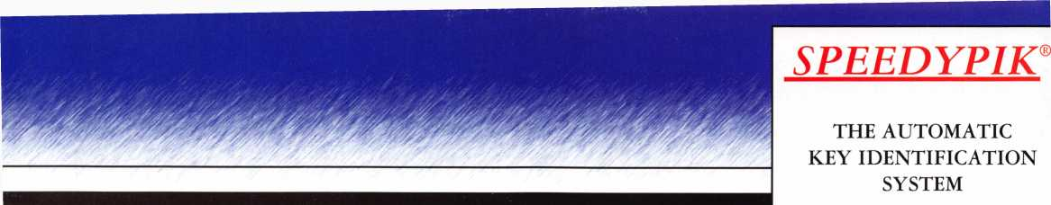

Thomas J Peloso Jr, CML Michael R Schleyer CPL Frank W Tellerico John H Williamson CRL

MINNESOTA

Terrance L Blue

Thomas J Brannan CRL

Michael Childs

Paula L Hall CPL

Paul M Justen

Michael S Karch CPL, CPP

David A Paulsrud, Sr, CML

Cory L Schmidt

George W Thomas RL

Lowell Torkelson CRL

MISSOURI James A Ayers Sr Bob Bever CRL Harold M Franken RL Jeanne B Hendricks Edward A Hite CML Doug K Martin CRL Richard A Miller CPL Mark Weaver

MISSISSIPPI Bruce J Tarbet CML, CPS Donald E Rule CML James D Wilkins James W Green CRL Ronald G Ferrill

MONTANA

James M Watt CML, CPS

NORTH CAROLINA Paul W Atkinson CPL B O Bill Wright William B Britt Adrian D Busse CPL Dewey P Busse Jeanette S Busse Laura J Busse CRL Tomas Camacho Dale E Dalton Brian Donohoe CRL David B Helms Christopher T Picemo CRL Gary A Smith Dennis L Verzaal CPL Michael T Wright CRL

NEBRASKA R D Christoffersen Dorothy G Friend CML Jerry L Miller

Kevin H Mann CRL Robert E Mock Gregory A Pitt Peter Sarailian CRL Tracy C Shaw George W Sona Sr Jose S Veliz

NEW MEXICO David E Bennett Stephen W Smith

NEVADA David C Morby Lazaro Reigosa

NEW YORK

John S Becker Sr

Carl F Campbell CPL

Joseph J Carracino CML, CPS

Charles J Gladd CML, CPS

Mark W Jackson CRL

Lawrence F Kerwin

Elliot Leibowitz

Gerard F Mangione

John W McCoy

Richard R Peterkin CPL

William C Ryan CRL

Barry Spool CPL

Walter H Stiering RL

Kenneth J Weiner

Andy G Wu

OHIO

Ronald G Betschman CML

Kristin L Carey-Brickler RL

Donald D Decker CML,CPS

Richard E Johnson

Charles E Kaiser

William L Mandlebaum CPL

John A Marshall

William J McElheney CML

Timothy J Moore CRL

Anthony E Parrish

Anthony J Ramunno CML, CPS

Richard H Seidel

Lawrence F Smith Jr, CML

James H Stahl RL

Norman C Sterzenbach

Robert R Turner

Allen L Tyson

James M Young

OKLAHOMA Larry L Goodson CRL Frederick D Stover

OREGON

William L Young CML

SOUTH CAROLINA

Larry H Bachman CML

Robert P Nisbet

Kevin R O'Toole

Kenneth W Roberts CML, CPS

TENNESSEE Raiford M Ball CRL Robert J Bosi Jr, CML,

Vincent L Formon CML, CPS Thomas G Gillingham Jr, CPL Raymond T Mason Gary S Mooney Thomas C Sherwood Chris L Shook Marian M Swann CRL Richard A Thurman Samuel Williams

TEXAS

Craig T Bednar

Ruben Beltran

Don Bradford

Gorman Brewer CML

Starlin M Clifford Jr, CML

Olen CothronCRL

Steve L Cothron

Robert E Epps CRL

Steve E Ford CRL

Charles W Gibson Jr CAE

Steven N Graham CML

Michael J Gray CRL

David M Hetherington Jr

Darrell Howard

Howard H Johnsen

Henry J Lachausse IV, CRL,

Clifford D Lipscomb CML, CPS

Allen B Long

David M Lowell CML, CMST

Tim McMullen

Ann L Mikesell

Mike R Mikesell CPL

Michael L Peurifoy CPL

John D Ray

Robert D Sharp

Randy L Simpson CML

Thomas F Stem

Walter F Taylor

Zack Taylor CPL

Harold D Tedford

Pete N Wadleigh

Kellan A Warren

UTAH

Roger C Yost CML, CPS

WASHINGTON Harry A Boyd Annsianne S Burdick Harold E Petersen Charles C Robertson CML Jamie J Vos

WISCONSIN William A Cochran CRL Roger F Coenen John S Dorsey CML Billy B Edwards Jr, CML Steve Engel CML, CPP Laurel M Grant Martin J Kitelinger CPL John D Oslund Tom Ripp

William J Smith RL Tim A Sterr Len Swanberg Richard J Wilczynski CRL Wayne O Wilkerson

WYOMING Tracey B Norviel CRL

ARMY EUROPE Richard E Leone

AUSTRIA Joaquin S Garcia

CANADA Doug A Bohnet Stephen R Conner CRL Ernie P Derksen David R Kennedy Leonard J Passarello CPL

HONG KONG Yuen-Cheung Chow Chan K Chu Yiu-Ping Lam

JAPAN

Yoshihisa Baba Hideki Honda Chinaru Inaba Kunihide Kanbe Yoshihisa Osawa Toshihiko Tsukaguchi CRL Hiroshi Watanabe

KOREA

Kyoung Oh Chang

* Preprogrammed database with full side view
* Automatic inventory control and reorder program
* Create your own database(s) to match your keyboard
* Hire inexperienced personnel without training

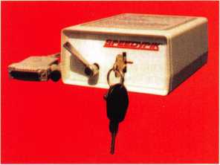

THE AUTOMATIC  
KEY DECODER SYSTEM

* Eliminates measuring each cut in a key
* Eliminates looking in pinning charts
* Portable, hand-held, battery-oper­ated
* Connects to your computer (serial port)
* Complete scan & readout in seconds

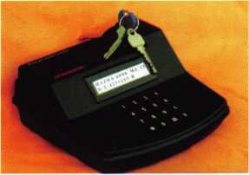

NEW JERSEY  
Timothy B Amsden  
Reginald R Burrell  
John A Dougherty  
John F Dougherty  
Edward H Fugee Jr  
Eugene R George Jr, CRL  
Robert D Hiler CPL  
Ralf D Hillesland  
Michael J Hitman CRL  
Vernon P Kelley CPL

James G Jennings CRL

Rodney E Thompson CPL

PENNSYLVANIA Dana L Barnum CML

Richard A Carr Michael E Cogan RL Nelson T Dayton CML Sven K Hellwig Sr William O Highouse RL Henry R Lucier Jimmie G McKahan

VIRGINIA

Gary R Baldino CML

Robert Barton

John D Cannon CML, CPS

Faith H Dunlap

Raymond B Fox CPL

Edward J Miller

James R Parker

Richard D Rebori

NORWAY Frank Sorensen

SINGAPORE Yuen Tiong Lee Ho J Sheng

UNITED KINGDOM Michael Comet

Phone: 617-567-1111  
Fax: 617-277-7777

E-Mail: SPEEDYPIK @  
AOL.COM

[www.SPEEDYPIK.com](http://www.SPEEDYPIK.com)

IWMwtCRL \m hcckdii

Jack C Magee III Craig A Toocheck

VERMONT

David A Keenan CRL

***hily/Auaust 2001***

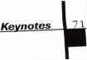

**■** EMPLOYMENT

Service Tech Wanted

Long Beach, CA. area experienced in all phasis required. Camera Technician a big plus!

Call Jack at (562) 597-8888

SAFEMASTERS

a nationwide industry leader, has several opportunities

available for experienced technicians knowledgeable in any of the following specialties: Access Control, CCTV, Safes, or General Locksmithing. As an innovative Family Friendly employer our employees enjoy flexible scheduling, 401(k) and company match, health, dental and vision insurance, Long and Short Term disability insurance, company vehicles, opportunities for advancement, company paid training pro­grams, technical skills updates, new prod­uct training, trade schools and college courses, generous leave programs, etc. We are committed to our associates and their families as we stand side by side in sharing the rewards of hard work and customer friendly professional service, with all our associates. Our team effort makes Safemasters an enjoyable career experience which provides many opportunities to advance your career, your skills, your per­sonal life. We hold our associates in the highest esteem because we know they are the best in the industry and take pride in a job well done. It is through this dedica­tion and loyalty that we continue to grow and expand offering all associates the sta­bility of a company with over 60 years of experience, a committed team of support personnel to assist you in doing what you do best and a realistic approach to balanc­ing your work and home life. We have locations in Maryland, Virginia, Wilmington (DE), Philadelphia,

Pittsburgh, Boston, New Jersey,

Indianapolis, and Chicago. Stop by one of our offices and talk to the manager about your needs and how we can fill them or mail to our Headquarters at:

Safemasters, 2700 Garfield Avenue, Suite 200, Silver Spring, MD 20910, to the attention of Human Resources or email us at [hr@safemasters.com](mailto:hr@safemasters.com) .

WANTED: SALES SUPERSTAR

Here We Grow Again! Bass Security Services, Inc. is looking for the best of the best. If you are an experienced, moti­vated, and no-nonsense sales professional with an extensive background in the security industry, we want YOU! All candidates must have a minimum of 7 years in the locksmith / security field, with a background in sales and customer service. We offer: Top wages with excel­lent incentives, 40lk, paid vacation and holidays, health benefits, and continued industry education. Re-location assistance may be provided.

Contact:

Bass Security Services, Inc.

Ph#216-755-1200 Ext#128

Fax#2l6-755-1220

e-maill [rmesnick@bass-security.com](mailto:rmesnick@bass-security.com)

Building Maintenance Worker III / Locksmith, Physical Plant

Under broad supervision, the incumbent is responsible for performing maintenance improvements, installations and repairs for the buildings at the Lowell Campus. Primary emphasis will be on locksmith duties, door hardware and controlled access, as well as supporting the depart­ment with interior signage and other building trades. The position requires a valid Colorado driver's license, license and bondable locksmith credentials and four years of progressive experience in lock and controlled access trade. Also, a GED or High School diploma needed.

Regis University Offers an excellent bene­fits package for full-time employees including 100% tuition for employee, spouse and dependents. EOE E-mail resumes to [resumes@regis.edu](mailto:resumes@regis.edu) or fax to 303-964-5498

Experienced Locksmiths Wanted

Do you love the trade of Locksmithing?

Are you hard working and self motivaed? If you are, we are the company for you. A growing locksmith company in California are looking for tech that work with auto­motive, commerical and resdential. Looking for tech that has a min. of 2 yrs. of exp. We offer full benefit package,paid vacations and bounus pay biweekly. Trucks and tools are provided and after a year of service stock options are avaliable. Clean driving record and Bondable is a must. High salary is payed to top techni­cians, average 5OK to 70K. Take pride in where you work and come aboard on a winning team Locksmith Central 15934 Hesperian Blvd.

Suite 264

San Lorenzo, Ca 94580 Voice: 1.888.81.LOCKS Fax: (510)317.6860 <mailto:Lcentral@msn.com>

Wanted:Experienced Technicians

Lock into your future now! If you are an experienced, intelligent technician, and desire a secure future, come join our team. We are a full servie commercial/ residen­tial security service (locks, keys, safes, cctv, access control, door related hard­ware). We offer: large sign on bonus, top wages, company vehicle, 40IK, paid vaca­tion, paid holidays, health benefits, new uniforms, cross-training, and JOB SATIS­FACTION. We are looking for the best tech’s who ae ready to be treated and com­pensated as professionals. Contact:

Bass Security Services, Inc.

(216) 755-1200 Ext:128

(216) 755-1220 fax

e-maill [rmesnick@bass-security.com](mailto:rmesnick@bass-security.com)

**■** WANTED TO BUY/SELL

Wanted: Auto Key Blanks

Old auto key blanks wanted - Hurd, Briggs and Stratton, Yale. Will pay $1 each.

Contact Douglas Vogel, 4779 Meadowlark Ln., Dexter, MI 48130.

***Keynotes***

***Ju/y/Auaust*** *2(101*

For Sale

Buy things you need from my inventory and save 50 percent off wholesale.

Call the Post Key Co toll free at 888/949-7089.

■ BUSINESSES FOR SALE

Business Opportunity

Associated Locksmith Network, Corp. is looking to subcontract locksmith compa­nies around the nation and in the Caribbean. If interested, request an appli­cation now at New Accounts (AL0100) at P.O. Box 771296, Miami, FL 33177-9998

Business for Sale

Successful locksmith business in northern California. Two offices. One in Eureka, the other in McKinleyville. Largest volume in the area. Time to retire. Gross volume last year was almost $300K. Includes latest equipment, all fixtures, all tools and three vehicles. $199,000.

Call Bill Davidson, 707/441-1800.

Business for Sale

We are a busy, well-established company located in suburban New Jersey. We have many commercial accounts in addition to residential work and store sales. We offer complete locksmith services as well as CCTV, access control systems and bur­glar/fire alarm systems. Gross sales were over $340,000 for 2000 with an annual growth since 1994 of over 20 percent. The sale of the business will include stock, office equipment, service van, fixtures, dis­plays ind many key machines. The owner can stay on for a period of time to help smooth the transition and to train the new owner. Please, serious inquiries only. Call 973/417-6074 and leave a message or con­tact us by e-mail at [lockbizforsale@aol.com](mailto:lockbizforsale@aol.com).

**Classified Advertising Policy**

Classified advertising space is provid­ed free of charge to ALOA members, and for a fee of $.60 per word, $15 minimum for non-members. Classified ads may be used to advertise used merchandise and overstocked items for sale, “wanted to buy” items, busi­ness opportunities, employment opportuni­ties/positions wanted and the like. Members or non-members wishing to advertise servic­es or new merchandise for sale may purchase a “Commercial Classified Ad,” for a fee of $1.30 per word, with a minimum of $40. Each ad will mn for two issues. For blind boxes there is a $5 charge to members and non-members. All ads must be submitted in writing to the ALOA office by the fifteenth of the month, two months prior to issue date. Send to Keynotes Classifieds, 3003 Live Oak St., Dallas TX 75204-6186. ALOA reserves the right to refuse any classified advertise­ment that it deems inappropriate according to the stated purpose of the classified adver­tising section.

THE HINGE DOCTOR

Corrects Door Sagging by *Straightening* Bent Hinges

* Slip Tool Over Hinge
* Open Door
* Presto! It's That Easy!
* Door Is Fixed.

An Easy Tool Which Will Add Profits  
To Any Locksmith's Arsenal

**—** GKL Products —

800**-**924-5397

[www.hingedoctor.com](http://www.hingedoctor.com)

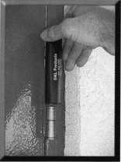

SAFE CORPORATION

MANUFACTURES OF QUALITY DEPOSITORY SAFES AND CHESTS

DISTRIBUTING FROM

WAREHOUSES IN

* LOS ANGLES, CA
* CHICAGO, IL
* GLASSBORO, NJ

A & B is now a stocking distributor

for Mutual Safes

featuring

We ship your order within

24 hours

AB-43035 AB-9FL WS 10-2

Chose from over 75 models in stock

See us

*at [www.a-bsafecorp.com](http://www.a-bsafecorp.com)*800-253-1267  
Fax 856-863-1208

CALL FOR YOUR

CATALOG TODAY

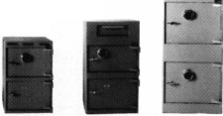

**MANUFACTURERS**

•A & B Safe Corp.

(800) 253-1267 FAX (856) 863-1208

•Abloy Door Security

(514) 335-9500 FAX (514) 335-0430

•Adams Rite Manufacturing Co.

(909) 632-2300 FAX (562) 699-5094

•Adesco Safe Manufacturing Co.

web: [www.adesco.com](http://www.adesco.com) (800) 821-6803 FAX (562) 408-6427

•Adrian Steel Company

web: [www.adriansteel.com](http://www.adriansteel.com) (800) 677-2726 FAX (517) 265-5834

•Alarm Lock Systems, Inc.

(800) ALA-LOCK (516) 789-3383

•American Lock Co.

(708) 534-2000 FAX (708) 534-0531

•American Security Products (AMSEC)

(800) 423-1881 FAX (909)685-9685

•Baldwin Hardware Corp.

(610) 736-4012 FAX (610) 796-4493

•Buddy Products

1 (800) 886-8688 FAX (312) 733-8536

•BWD Automotive

9(334) 874-9001 FAX (334) 874-6011

•COMPX Security Products

864/297-6655

864/297-9987

•Curtis Industries

1(800) 555-5397

•Cygnus Business Media, Inc.

770/886-0800

770/889-7703

•DETEX Corporation

800/729-3839 830/620-6711

•DORMA Architectural Hardware

717/336-3881

717/336-3500

•Don-Jo Manufacturing, Inc.

978/422-3213

978/422-3467

•Doyle Security Products

800/333-6953

612/521-0166

* DSC Group of Companies

(905) 760-3000 ext. 2200 FAX (905) 760-3040

•Door Controls International

(800) 742-3634 FAX (800) 742-0410

•ESP Lock Products, Inc.

(978) 537-6121 FAX (978) 534-9109

•Ewert Wholesale Hardware

800/451-0200

708-597-0881

* Fairway Supply, Inc.

214/350-0021

214/352-4299

* H.L. Flake Co.

•HES, Inc.

623/582-4626

623/582-4641

•Hardware Agencies, Ltd.

416/462-

•Hongtai Lock Co Ltd.

137-238-1414

208-793-3856

•llco Unican

(252) 446-3321 FAX (252) 446-4702

•Intellikey

(800) 226-0703 FAX (407) 724-0811

•Jet Hardware Mfg. Co

(718) 257-9600 FAX (718) 257-0973

•KABA High Security Locks

(860) 621-3601 FAX (860) 621-9727

•KEY-BAK; Div. of W. Coast Chain Mfg.

(909) 923-7800 FAX (909) 923-0024

•Knaack Manufacturing Co.

(800) 456-7865 FAX (815) 459-9097

•LAB Security

(800) 243-8242 FAX (203) 583-7838

•LCN Closers (Division of Ingersol)

(815) 875-3311 FAX (815) 875-3222

•La Gard, Inc.

(310) 325-5670 FAX (310)325-5615

* Lucky Line Products

(619) 549-6699 FAX (619) 549-0949

* M.A.G. Engineering & Mfg. Inc.

(714) 891-5100 FAX (714) 892-6845

•MARKS USA

(516) 225-5400 FAX (516) 225-6136

•MARRAY ENTERPRISES

(408) 970-0213; FAX (408) 970-8767

•Master Lock Company

(414) 444-2800 FAX (414) 449-3114

* Medeco Security Locks

(540) 380-5000 FAX (540) 380-5010

•Meilink Safe Company

(800) 634-5465 FAX (800) 896-6606

•MMD Inc.

602/453-3169

602/438-1690

•MCS Communication Systems

865/428-3611 865/453-4136

•Massglass & Door Service

888/742-8837

818/991-5742

•Monaco Lock Co.

800/526-6094

800/845-5625

•ROFU International Corp.

(800) 255-7638 FAX (253) 922-1728

•Rutherford Controls Int'l. Corp.

757/427-1230

757/427-9549

•SARGENT Manufacturing Co.

800-727-5477

888-863-5054

•STRATTEC Security Corp.

(414) 247-3333 FAX (414) 247-3329

•Sargent & Greenleaf, Inc.

(606) 885-9411 FAX (606) 887-2057

•Schlage Lock Co.

(800) 847-1864 FAX (800) 452-0663

Aewyotey

Ju/v/Au***aust ?nm***

•Schwab Corporation

(765) 447-9470 FAX (765) 447-8278

•Securitron Magnalock Corp.

5(800) 624-5625 FAX (702) 355-5636

•Security Door Controls

(805) 494-0622 FAX (800) 959-4732

•Security Solutions

(405) 376-1600 FAX (405) 376-6870

* Sentry Group

(716) 381-4900 FAX (716) 381-8559

•Somerset Security Products

800/881-5206

800/206-9949

* Sully Tools Inc.

(703) 689-3416 FAX (703) 787-0869

* Sun-IL Gum Go

823-194-59300

823-194-59400

•Taymor Industries, Inc.

(800) 388-9887 FAX (800) 288-8133

•The National Locksmith

630/837-2044

630/837-1210

•Trine Products Corporation

(718) 829-4796 FAX (718) 792-9127

•Videx, Inc.

(541)758-0521 FAX (541) 752-5285

•W-Lok Corporation

(616) 355-4015 FAX (616) 355-4295

•Yale Security Inc.

(800) 438-1951 FAX (800) 338-0965

**DISTRIBUTORS**

•Accredited Lock Supply Co.

(800) 652-2835 FAX (201) 865-5031

• Ace Lock & Security Supply Co.

(800) ACE-LOCK (800) ACE-FAX4

•ADI

(516) 692-1000 FAX (516) 692-3457

•Andrews Wholesale Lock Supply

(717) 272-7422 FAX (717) 274-8679

•Boyle & Chase Inc.

(800) 325-2530 FAX (800) 205-3500

•Clark Security Products, Inc.

(800) 854-2088 FAX (619) 974-5284

•Cook's Building Specialties

(505) 883-5701 FAX (505) 883-5704

•Dire's Lock & Key Co.

(303) 294-0176 FAX (303) 294-0198

* Direct Security Supply, Inc.

(800) 252-5757 FAX (800) 452-8600

•Doyle Security Products

(800) 333-6953 FAX (612) 521-0166

* Dugmore & Duncan Inc.

(888) 384-6673 FAX (888) 329-3846

* E. L. Reinhardt Co., Inc.

(800) 328-1311 FAX (612) 481-0166

•Foley-Belsaw Company

(800) 821-3452 FAX (816) 483-5010

* Fried Brothers, Inc.

(800) 523-2924 FAX (800) 541-3489

* HS&S Wholesale Distributors

1(800) 521-2202 FAX (313) 342-7580

* Hans Johnsen Company

(214) 879-1550 FAX (214) 879-1530

•Howard Keys

(704) 598-2291 FAX (704) 598-9110

* IDN, Inc.

(817) 421-5470 FAX (817) 421-5468

•Intermountain Lock & Supply Co

(800) 453-5386 FAX (801) 485-7205

•Jo-Van Distributors Inc.

(416) 752-7249 FAX (416) 752-3845

* Lockmasters, Inc.

(800) 654-0637 FAX (859) 885-7093

•Locks Company

(800) 288-0801 FAX (305) 949-3619

•The Locksmith Store Inc.

(847) 364-5111 FAX (847) 364-5125

•M. Zion Company

(212) 349-8677 FAX (212) 964-0495

* McDonald-DASH Locksmith Supply

(800) 238-7541 FAX (901) 366-0005

* McManus Locksmith Supply, Inc.

(702) 333-9112 FAX (704) 332-8664

* MARRAY ENTERPRISES

(408) 970-0213 FAX (408) 970-8767

•Securite.com

(800) 241-3930 FAX (619) 974-5269

* Omaha Wholesale Hardware

(800) 238-4566

•Sentry Security Fasteners

(309) 693-2800 FAX (309) 693-2872

* Southern Lock and Supply Co.

(800) 237-2875 FAX: (800) 447-2299

* Stone & Berg Wholesale

(800) 225-7405 FAX (800) 535-5625

* Strauss Safe & Lock Company

(515) 288-9571 FAX: (515)288-9752

* Taylor Securtiy & Lock Co.

(301) 948-7670 FAX (301) 948-1029

•Timemaster, Inc.

(785) 232-8705 FAX (800) 798-8463

•Top Notch Distributors, Inc.

(800) 722-4210 FAX (800) 248-3620

* U.S. Lock Corporation

(800) 925-5000 FAX (800) 338-5625

•Webster Safe & Lock Company, Inc.

(901)332-2911 FAX (901) 332-2878

**SERVICE**

* Allstate Insurance Company

(847) 402-8196 FAX (847) 326-7509

***Keynotes***

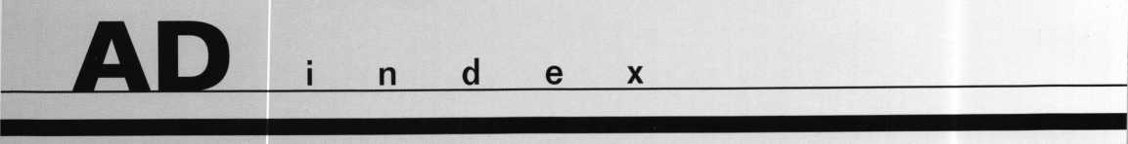

About the Authors

Aable

Advertiser Pages

21 KSP 57

Tom Lynch

Tom Lynch owns and operates Lynch's Locksmith Service in Tappan,

Abus

39 LAB

11

NY.

A & B

73 Marray 55

Clifford D."C.D."Lipscomb, CML,CPS

has been working in the physical security industry since 1974 as an  
institutional locksmith and currently as owner of a full service lock-  
smith business in Corsicana, Texas. An ALOA member since 1990,  
C.D. is an ALOA certified instructor and has taught for many lock-  
smith associations including the Texas Locksmiths Association and  
the Greater Dallas Locksmiths Association.. He also has held vari-  
ous offices in GDLA and TLA.

Sal Dulcamaro, CML

has been in the locksmith business for over 26 years.  
He is the president of All Pro Security, Inc. in  
Michigan and has been an ALOA member for 19  
years. A past president of the Locksmith Security  
Association of Michigan. Sal currently serves as

editor of the association newsletter. He was named Keynotes Author .  
of the Year” for 1996 and 1997. He is also a contributing edito  
for Keynotes.

Find Sal on the internet at: <http://home.earthlink.net/~lockwriter>.

Bob Arthur, RL

is an ALOA certified instructor who taught at the ALOA convention and at regional conventions in the United States. He owns and oper­ates Arthur Lock & Key in Phoenix, AZ.

|  |  |  |  |
| --- | --- | --- | --- |
| Adesco | 65 | MasterLink | 55 |
| ASSA | 29 | Security Lock | 67 |
| Defiant | 31 | Select Products Ltd. | 43 |
| GKL | 73 | Speedy Pik | 71 |
| GPLA | 15 | Stam Insight | 5 |
| Hickock | IFC | Strattec | 1 |
| HPC | 19 | Turn 10 | 57 |
| IntraLock | 7 | W-Lok | BC |
| JLM | IBC |  |  |

Claire L. Cohen**,**

the second woman to become a CML, has been in lock- smithing since 1977 and has been writing articles for Keynotes since 1987. She is also a contributing editor for Keynotes.

Greg Perry, CML, CPS

has been in the locksmith industry for 18 years. He's spent half of that

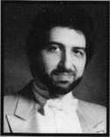

time as a field technician for Security Engineering in Ridgecrest, CA.

Paid F. Chandler, CRL

manages the electronic security products division of I.D.N. -Acme. Paul earned his journeyman electrician license in Massachusetts in 1983, and passed the PRP in 1987. He has experience in CCTV, alarms access control systems, high security locks and safes. Paul has written for several trade magazines and was the Keynotes Author of the Year for 1998. Paul's classes on access control and basic electric­ity have been enjoyed by locksmiths throughout the southwest.

Greg is also a past president of the Desert Counties Chapter of the California Locksmiths Association.

Bdly Edwards, Jr., CML,

is the Key Records Manger for Master Lock and the author of Master Keying by the Numbers. He is also a past recipient of the Philadelphia Award and serves as a co-chairman on the LIST Council

**J** Keynotes

***July/August 2nm***

**See a live demo nur website at**

Address |4»3 http: J/www. jlmwholesate. com/cgt-b*Viimr amp exe

***Welcome, New Customer to JLM Wholesale!***

**Click Here For: Door Hardware Access Control Washrooms Automation**

**Shipping Options**

€23) f All Vendors

31^

**Detailed Product  
Information.**

**Search capabilities  
on each page.**

**Check box to display  
only in stock items.**

**New quick links.**

**Extremely user friendly.**

**Downloadable interactive  
product catalog.**

**j *Customer Support:***

► Your Account <' View Order rr Grid Entry ► Login * Home

Atari* ***Featuring f***

I lies innovations

**WES's** new totally surface mounted electric strike.

Designed for rim exit devices.

Essex Electronics Wlegand keypads.

Easily integrates with access systems.

Coming Soon!

The new ***PDL3000*** proximity lock from  
Alarm Lock. Integrates with existing HD prox card

systems.

We are now stocking AL, D, B and L series locksets including electrified versions of the D and L series.

I "J-1 Back ' Search jj Favorites -^Htstory _J _J

-siS*J

3 ^Go Links

***JLM's Catalog is Now Available on Interactive CD Rom!***

**ADAMS RITE** • ALARM LOCK • ALTRONIX • DYNALOCK • ELK • ESSEX ELECTRONICS • FOLGER ADAM SECURITY • GLYNN JOHNSON

**ROTON • SCHLAGE •** SECURAKEY • SECURITRON

CABLE • TRIMEC • TRINE • VON DUPRIN

uce ,IC1 .1 rvi CLOSERS • LOCKNETICS SECURITY ENGINEERING, INC. • ROI H.tS.1 'Ll w*ccpt ppnnucTS • simplex• signm. .

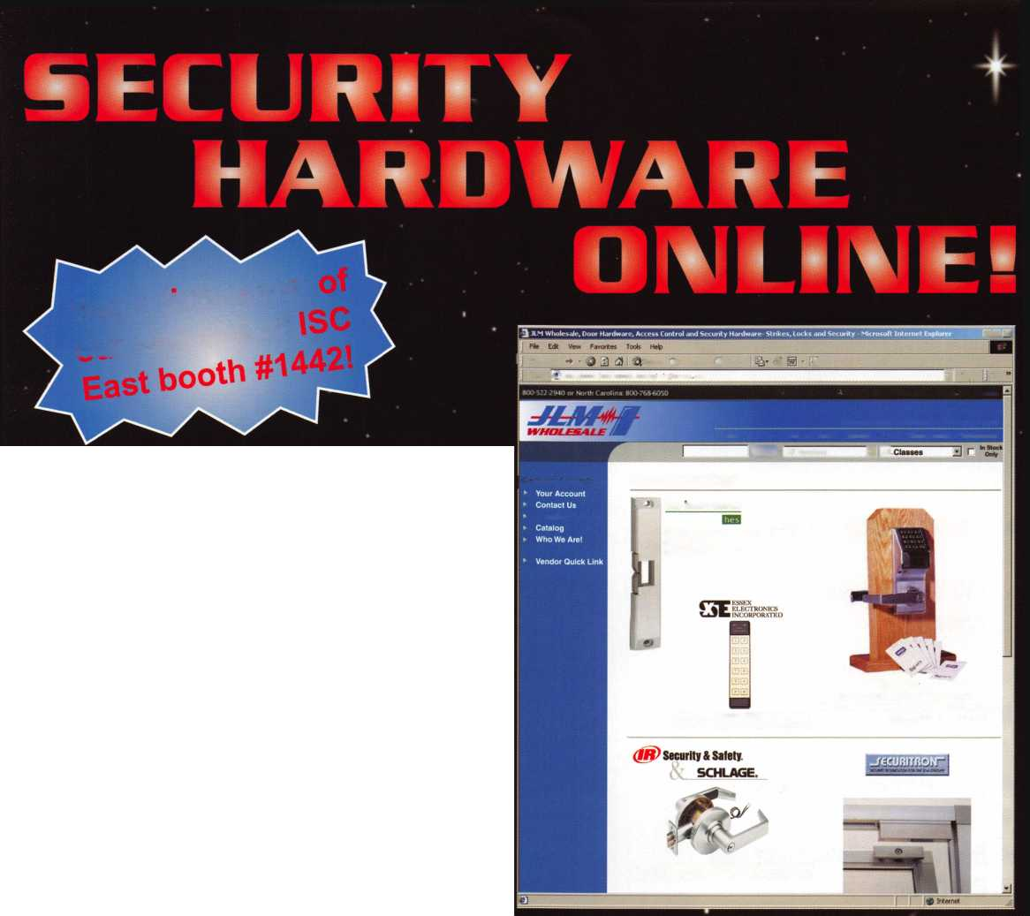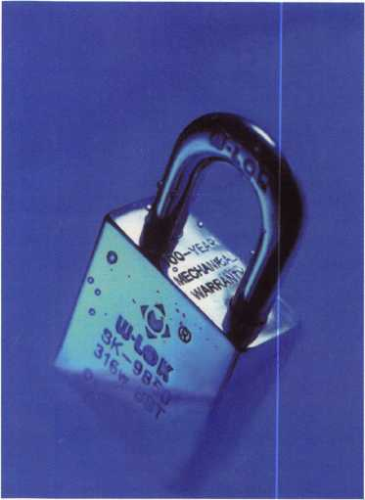

* 100% Stainless Steel
* 100 Year Mechanical Warranty
* Specially Hardened Cylinders
* Patent Controlled Keying
* Resistant to Environmental Conditions

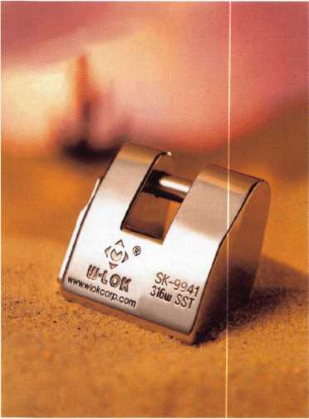

**UI-LOK**

Stainless Steel Security Solutions

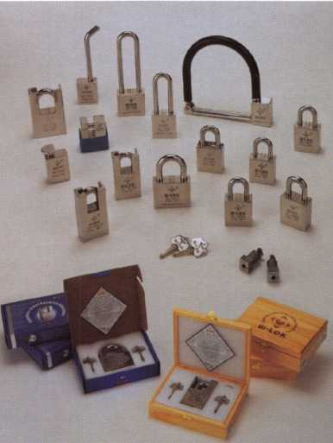

* Dealerships Available
* Representative
* Custom Designs
* OEM Capabilities
* Internet Partnerships

Booth #

W-LOK Corporation 715

S61 Productions Place  
Holland, Ml 49423

Ton Free: 877.3SS.W10K Fax: 616.3554295

Web: [www.wlokcorp.com](http://www.wlokcorp.com)

Email: [office@wlokcorp.com](mailto:office@wlokcorp.com)

